Department of Electrical Engineering and Computer Engineering (EECE)

**Smart-Phone Based Snoring Analysis System**

Corey Butts (Computer Engineering)

Bayley King (Electrical Engineering)

Dallas Phillips (Electrical Engineering)

April 26, 2018

Submitted in partial fulfillment of the degree of

Bachelor of Science in

Electrical /Computer Engineering

Team member: Corey Butts___________________________________________ Date:________

Team member: Bayley King___________________________________________ Date:________

Team member: Dallas Phillips_________________________________________ Date:________

Technical Advisor: Dr. Chong Ahn______________________________________ Date:________

**Dedication**

A special thanks to Dr. Ahn and his help and throughout the past year. Your guidance drove our interest and pushed us to work to our full potential.

Thank you to Dr. Purdy for the work she put into teaching the senior design course, and her frequent guidance throughout the semester.

Thank you to the EECE Department and all its faculty for their work in guiding us through the past five years. We have all grown immensely over our time as undergraduates, and our lives will forever be better for attending this University.

We also want to thank our friends and family for helping support us not only through the senior design process but throughout our whole college career.

**Table of Contents**

Abstract……………………………………………………………………………………..…………………………….…..4

**Introduction**

Problem Statement……………………………………………………………………………………………………….5

Current Solutions…………………………………………………………………………………………………….…...6

Our Solution…………………………………………………………………………………………………….……………7

Credibility……………………………………………………………………..…………………………………………...…7

Project Goals………………………………………………………….………………………………………………..…..9

**Discussion**

Project Concept……………………………………………………………………………………………………..…..11

Design Objectives…………………………………………………………………………………………………….…11

Technical Approach…………………………………………………………………………………………….………13

Standards……………………………………………………………………………………………………………………19

Budget………………………………………………………………………………………………………………………..19

Timeline………………………………………………………………………………………………………………..……20

Testing………………………………………………………………………………………………………………………..21

Encountered Problems…………………………………………………………………………………………….…22

Future Recommendations ………………………………………………………………………………………….24

**Conclusion**

References………………………………………………………………………………………………………………….28

Appendices…………………………………………………………………………………………………………………30

**List of Figures**

Figure 1…………………………………………………………………………………………………………………………5

Figure 2…………………………………………………………………………………………………………………………6

Figure 3…………………………………………………………………………………………………………………………6

Figure 4…………………………………………………………………………………………………………………………6

Figure 5…………………………………………………………………………………………………………………………7

Figure 6…………………………………………………………………………………………………………………………9

Figure 7……………………………………………………………………………………………………………………….10

Figure 8……………………………………………………………………………………………………………………….13

Figure 9……………………………………………………………………………………………………………………….14

Figure 10……………………………………………………………………………………………………………………..15

Figure 11……………………………………………………………………………………………………………………..16

Figure 12……………………………………………………………………………………………………………………..17

Figure 13……………………………………………………………………………………………………………………..18

Figure 14……………………………………………………………………………………………………………………..18

Figure 15…………………………………………………………………………………………………………………..…20

Figure 16…………………………………………………………………………………………………………………..…21

Figure 17……………………………………………………………………………………………………………………..22

Figure 18……………………………………………………………………………………………………………………..23

**Abstract**

Although there have been many improvements in medical testing, there is still a high cost and often complex time commitment associated with testing. Many medical conditions go undiagnosed because precautionary tests cost too much money for the average consumer. These precautionary tests are completed at most once a year, which isn’t frequent enough to accurately test someone’s day-to-day health. With an aging general population, the need for in-home care is also increasing greatly.

The computation power and overall use of smart-phones offers a unique solution to this issue. We propose smart-phones could be used to collect intermittent data and even substitute basic medical tests. There are already many devices and apps that currently track health statistics, like your heart rate, daily step counters, and daily nutrition intake. Right now, each of these sources work independently of each other. Creating a total all-in-one system that works together would allow patients to better track their daily health. Doctors could then use this data to better diagnose their patients, or maybe suggest further tests to be completed.

Having accurate, powerful, and mobile medical testing would allow for a major change in the current medical community. In-home care would be cheaper and easier for both patients and physicians. Being able to customize these systems to fit specific needs would allow for groups like Doctors Without Borders to test/diagnose in remote locations with just a cell phone. Combining all the previously mentioned issues with the creation of faster/cheaper IOT devices the need for smart-phone based biomedical testing couldn’t be greater.

**Introduction**

**Problem Statement**

We chose to pick a single and generally easily testable condition to focus on for this senior design project. Our advisor, Dr. Chong H. Ahn, suggested that we focus on sleep due to the current sleeping issues facing the general population. There are many possible traits of someone’s sleep that one could measure; the total time spent each night, the amount of times someone wakes up, or the amount of time in each sleep cycle. There are many devices (smart watches, Fit Bits, etc.) that currently do this to good accuracy. The one trait that Dr. Ahn suggested we try and measure was snoring. People sometimes are unaware that they snore, or only snore when they are sick. Although snoring isn’t necessarily a disease, it is often a condition/symptom of something worse.

Snoring patterns are not very complicated to measure objectively provided you possess the appropriate equipment. When participating in sleep studies in a lab, there are typically a myriad of sensors connected to you while you sleep which provides a good amount of data but can be very uncomfortable potentially disrupting sleep and requires that you sleep in a lab. You are able to diagnose snoring at home using a sleep apnea test kit, however this requires a bulky mask that keeps you tethered to a device while sleeping. Not to mention these solutions are designed for diagnosing snoring in general and are not practical for long term snoring pattern analysis. A better solution could be found if we considered the functionality of mobile devices.

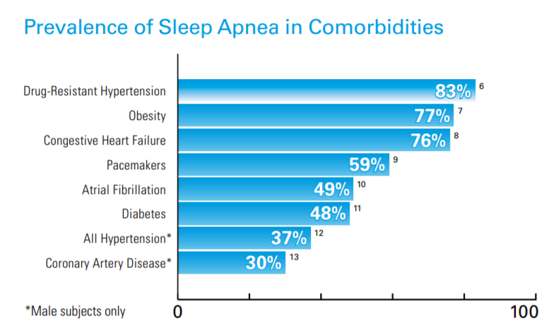

Although tracking someone’s snoring patterns can be helpful when looking into other diseases, we decided to expand further on the diagnostic aspect of our solution. **Sleep apnea** is a condition when the patient has short pauses in breathing or abnormally low breathing while asleep (Hansen). *Hansen* says most patients that have sleep apnea suffer from snoring, grunting, or gasping for air. Figure 1 shows how often sleep apnea occurs along-side other condition/diseases (ResMed). Although not directly related, snoring is often a symptom of sleep apnea, which we can use to our advantage. Since it is simple to measure and record one’s snoring pattern, tracking any interruptions in this snoring pattern would also be a simple implementation.

**Figure 1: Sleep Apnea in Comorbidities**

Advancements in smartphones and embedded technology has allowed for the emergence of the mHealth market. mHealth describes the use of mobile and wireless devices to improve health outcomes, healthcare services and health research. It already has numerous applications such as heart rate monitoring, water testing and cataract detection. However, sleep monitoring, more specifically snoring pattern monitoring, has yet to be explored in depth as an mHealth application. There are a few applications that utilize the mobile device’s microphone to detect snoring patterns, but the quality of the data is limited by the capability of the device. It also requires that you have the device within close proximity during measurement which can 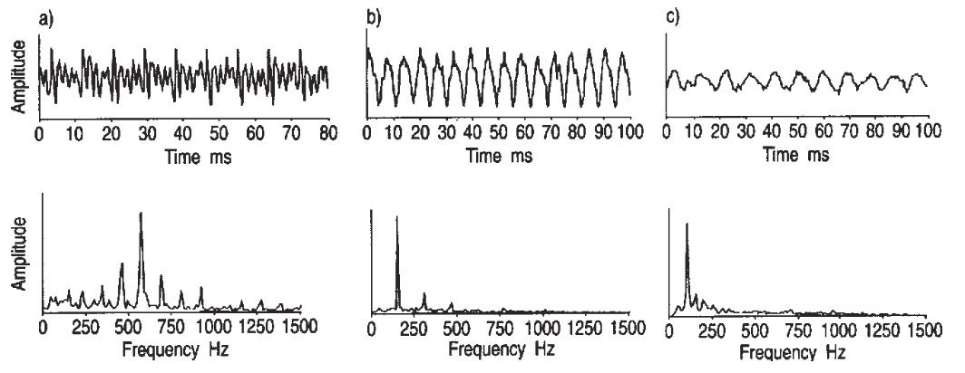be impractical if you charge your phone at night. Figure 2 shows sample snoring waveforms.

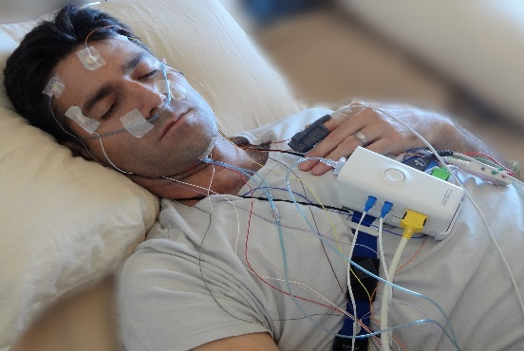**Current Solutions**

**Figure 2: Sample Snoring Waveforms**

Sleep Studies

Sleep studies are currently the main way to accurately test if someone has sleep apnea. The tests are expensive, with the cheapest tests being $600+ after an insurance deductible. The benefits of this solution are that they are the most accurate solution and that the data from the test goes directly back to the physicians that ordered them. The cons are that you have to sleep in a foreign environment with all of those wires/sensors hooked up to you, and of course the price. Insurance is different for each person meaning that the cost can possibility be high enough that those that need the test can not afford to have it

**Figure 3: Common Sleep Apnea Test**

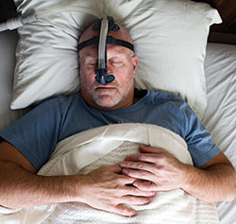

Test Kits

An alternative to the in-lab test are sleep apnea test kits. They are also expensive, with the cheapest coming in around $250. The benefit over an in-lab test is that you can sleep in your normal bed, but this comes with other cons. Although you are in your bed, you have to still hook-up lots sensors or wires that disturb your normal sleeping pattern. These devices are often also less accurate than an in-lab test.

**Figure 4: Sleep Apnea Test Kit**

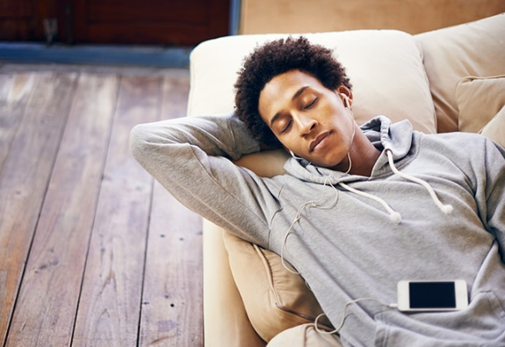Smart-Phone Applications

A third alternative that we found was using a smart-phone application to record your sleeping pattern. The application then determines your snoring statistics and plots them for you. The benefits are that some apps are free or relatively cheap. But the cons are that it is often very inefficient and heavily relies on the accuracy of the cell phone’s microphone. Also this greatly lowers the battery life of the cell phone, and would require you to keep it plugged in all night.

**Figure 5: Smart-Phone Test Kit**

**Our Solution**

We found pros/cons of each of the three previous solutions and wanted to implement parts of each. The major things that we decided upon were that our solution had to be

* Wearable
* Non-intrusive
* Inexpensive
* Low power
* Rechargeable
* Accurate
* Adaptive
* User friendly

The solution we propose is to design a small dedicated sensor, which can be adhered to the user’s face, that can record the sound waveform produced while snoring and transmit the data wirelessly to the user’s mobile device via Bluetooth. A mobile application will also be developed to allow users to record and store their snoring patterns so that we can then try and diagnose sleep apnea. We believe that this system will allow users to gain a better understanding of the quality of their sleep, and if they should seek further help.

**Credibility**

All three students assigned to this project are senior students in the Electrical and Computer Engineering College at the University of Cincinnati. The team consists of two Electrical Engineers and one Computer Engineer. The group has many unique qualities between themselves, but they also have lots of overlap in knowledge. This allows us to each focus on a specific aspect of the project but still be able to consult each other with any issues that we could have.

Corey Butts (Computer Engineer)

* Mobile Application Development
  + Android Studio
* Embedded System Development
  + PIC, MSP430, AVR and ARM chipsets
  + Embedded Linux
  + MQX RTOS
* Applicable Software Languages
  + C, Python, Java
* Database Management (InfluxDB)
* Analog/Digital Circuit Design
* Soldering
* 3D Printing (Solidworks)

Bayley King (Electrical Engineer)

* Software Languages
  + C, VBA, Python, MATLAB, R
* Data Processing / Management
* VLSI Design
  + VHDL, HSpice, IRSim, Magic
* Analog Circuit / Filter Design
* Power Systems
* Project Management Processes
* CAD Design
* Embedded System Design

Dallas Phillips (Electrical Engineer)

* Hardware
* Filter Design
* PCB Design
* Software Languages
  + C++, VBA, MATLAB
* Analog/Digital Circuit Design
* Embedded System Design

**Project Goals**

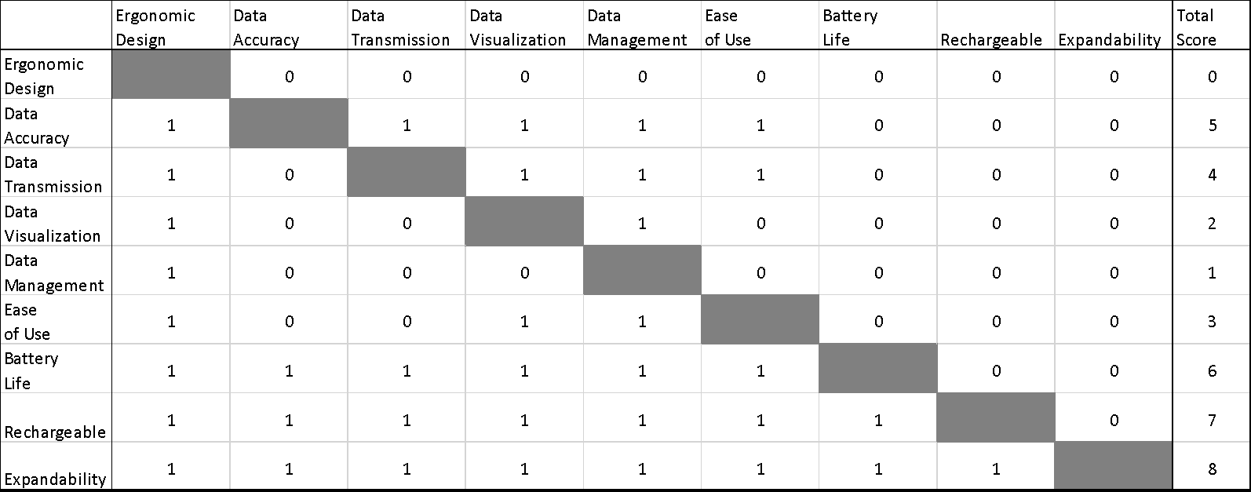Our original goals involved creating a fully adaptive sensor hub to be used with a mobile device. Our main final goal was to make an all-in-one mHealth system that utilized our own set

**Figure 6: Original Pairwise Comparison Chart**

communication protocol that could allow future expansions to a variety of sensors that followed our protocol. After discussion with our advisor Dr. Ahn, we focused on one specific application of mHealth to show the possibilities of this field. We then had to re-layout our project goals, since the final product of the project had changed. Our original pairwise comparisons chart can be seen in the figure 6 above.

The first new goal that we set for our project involved the implementing the bullet points laid out in the *Our Solution* section of the report. Even though the specific preliminary designs for our system changed over the course of the past two semesters, we made sure that we stuck to these key points. We felt that these points are what would set our device above and beyond the other options on the market. Our new pairwise comparisons chart can be seen in figure 7 at the top of the next page.



**Figure 7: New Pairwise Comparison Chart**

The original chart states that we thought expandable, rechargeability and battery life were the three most important aspects. After we changed our final project goals our chart changed greatly. First off, we changed the overall goals of our project, so we updated these in our graph. Our new chart states that we think that non-intrusiveness, data accuracy, wear-ability, low-power and cost are the most important aspects of our system. This shows the main cons of the current solutions that we found were the main focuses of our final product.

**Discussion**

**Project Concept**

Our project is designed to be a primary example of why the field mHealth is so important and has lots of room for improvements. This is a large problem that would take more time/resources that are available to us for a senior design project to fully prove. We then chose to try and implement one specific medical test with our system, just to show the strengths of mHealth. Our system is designed to help someone who snores track if they exhibit sleep apnea conditions. We can take advantage of the fact that snoring is a periodic signal that is normally consistent for a user throughout the night.

We researched the current solutions to test for sleep apnea and found that they had many flaws. Mostly we found that other options were too expensive and impaired the user’s normal sleep pattern to a point where the test was measuring “bad” data. If you are hooked up to wires/sensors or in a different bed, your sleep pattern will be different than a normal night at home in your own bed. We want to implement a wearable, low cost, and non-intrusive device that connects to a mobile application so that any user could use the system at home in their own bed.

We designed this project to be more of proof-of-concept for mHealth, to showcase the possibilities of this field. If we can design a cost-effective, accurate and wearable solution to monitor one’s sleep, future work could be completed to further improve this idea. There will of course be further optimizations in regards to system performance, but there also could be more additions in regards to data analysis. If the aforementioned total mHealth system could be created, machine learning could be implemented to help try and find abnormalities in user data to help further diagnostic medicine.

**Design Objectives**

* Wearable
  + We want the device to be wearable because modularity, size, and efficiency are a major aspect of mHealth devices. Our system needs to be wireless and have some connection to a mobile application, we chose a cell phone
  + We chose to use an Android application and to send data over Bluetooth from an Arduino.
* Non-intrusive
  + One of the major cons of the current solutions to sleep apnea testing was that the tests are in a different sleeping environment then you are used to sleep every night. You are in a different bed while wearing wired sensors, where we believe that you are not getting a normal night’s sleep.
  + We wanted our solution to intrude upon the user’s sleep as little as possible so that the recorded data could be as close to their normal sleeping patterns as possible.
* Inexpensive
  + All the current solutions are very expensive costing over $250 for an at home testing kit or at least $600 for an in-lab test after help from insurance.
  + We want our solution to be affordable for any consumer who wants to better track their sleeping patterns without having insurance cover the costs of the device.
* Low power
  + We want this device to be battery powered and then rechargeable, which would require one less wire to be included with the system. Our plan was to then make the system as low powered as possible, to better increase battery life. We also need to design the system to last for at least one full night of sleep (8 hours).
* Rechargeable
  + We wanted to make the device as simple as possible, so we chose to use a rechargeable lithium ion battery which a charging protection circuit instead of using replaceable batteries.
* Accurate
  + Our system had to be accurate, otherwise our software would output incorrect results. Since we are using a microphone to record the user’s snoring patterns, there are many ways for the signals to get distorted. We needed to account for ambient noise levels and filter out anything that wasn’t snoring patterns.
* Adaptive
  + We want the system to be adaptive and work on any smart-phone. We decided to create an android application for the project due to the developer license and complexity of Apple development, but we want to still design the system with future expansion in mind.
* User friendly
  + We want the application and the device itself to be simple to set-up and use. The device should be simple to turn on and charge, while the application should be easy to navigate.

Figure 8 on the next page is the objective tree that we created to let us better account for these design objectives.

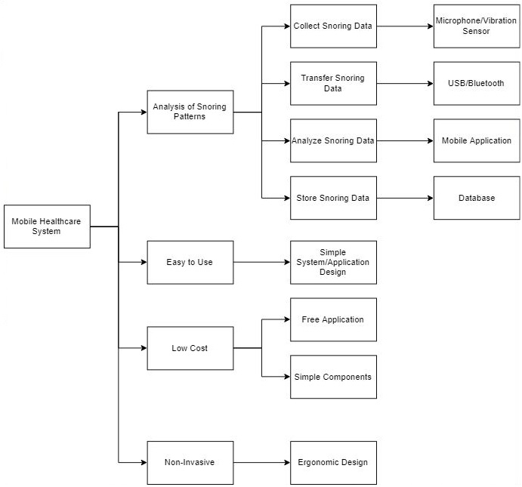

**Figure 8: Objective Tree**

**Technical Approach**

Initially, after considering our design objectives and wanting to create a project that the consumer could wear while sleeping that would provide reliable data that also would not disrupt their natural sleep patterns, and is inexpensive, which is not the case with most sleep studies on the market currently. We categorized each function of our system with several options and selected the most appropriate function fulfillment according to our design objectives and goals. These choices are summarized in our morphological chart (next page).



**Figure 9: Morphological Means Chart**

* A microphone was selected because this sensor was the easiest to implement for the initial prototype, as well as the cheapest option (considering the oxygen sensor is $100+).
* Bluetooth was the best choice for our project because this requires zero extra wires (wires could disturb natural sleep patterns). Wi-Fi was not chosen because it’s not guaranteed that everyone has a strong Wi-Fi signal, and can be unreliable at sometimes.
* SQLite was selected because this seemed like the easiest database to implement with Bluetooth, and there was documentation readily available to access and reference.
* Android Studio was selected because it is the easiest to implement on Android smartphones. Visual Studio can not be directly implemented on Android systems, and we strictly stuck to Android devices because developing apps on Apple would require a license.
* A 3.3V Coin Cell Battery was the option that offered the lowest power of all our means, as well as being wireless, offered rechargeability options, and was relatively small to incorporate into the overall system.
* The initial prototype was designed on a facemask, and because of time constraints an adhesive facial strip was not developed, but facial strips are the best option because they offer the closest proximity to better detect breathing, as well as the least disruptive of all our means.

After selecting the best means in which to fulfill each functional requirement of our system, individual components were selected to accomplish each function. The white box diagram and the specific decisions to select individual components are summarized below:

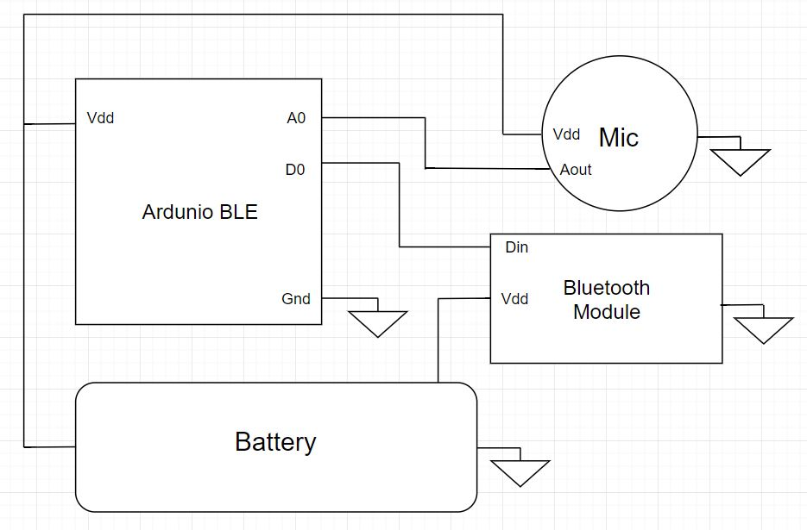

**Figure 10: Sensor White Box Diagram**

* *Arduino BLE* 
  + The microprocessor we selected for the initial prototype was the Beetle Bluno BLE. This is the smallest Arduino currently available on the market, which was ideal for our project since we needed components that would fit inside a facemask. This microprocessor also offers Bluetooth compatibility, which also aligns with our project function means.
* *Battery*
  + A Lithium 3.3V Coin Cell from *Illinois Capacitor* was selected as our battery of choice. The compactness of this battery allows for ample space to fit inside of the facemask, as well as offers rechargeability, which means no extra wires.
* *Battery Protection Circuit*
  + The battery protection circuit was originally adapted and design from samples online from previous projects (**See FIGURE 11**). This allowed for the battery to reliably be recharged without over-charging and over-discharging, which ultimately protects the other components within our system. However, for our initial prototype, we adapted the protection circuit board from a mobile battery pack.

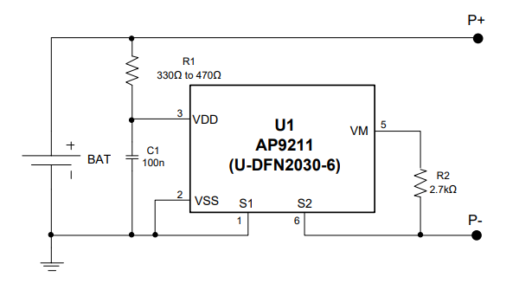

**Figure 11: Battery Protection Circuit**

* *Microphone*
  + Our initial choice of microphone had to be replaced because it was a surface mount component and was too small to be able to work with for the initial prototype. Instead, it was replaced with the SparkFun Sound Detector Board which has a built-in microphone and amplifier circuit on a circuit board. This was selected as our microphone of choice because we had this sensor from a previously purchased sensor kit.
* *Microphone Amplifier*
  + A bandpass filter and amplifier were designed for our microphone, based on examples from similar utilizations of microphones. The bandpass filter was designed for the range of 10Hz – 3kHz. These values were chosen because snoring frequencies are frequently in the range of 50Hz – 2kHz. Since the SparkFun Sound Detector Board already has a built-in amplifier, we decided to utilize that for our initial prototype (**See FIGURE 18**).
* *Algorithm*
  + Our algorithm uses three different factors from a user’s snoring pattern.
    - Period of the signal
    - Frequency (taken from a DFT of the signal)
    - 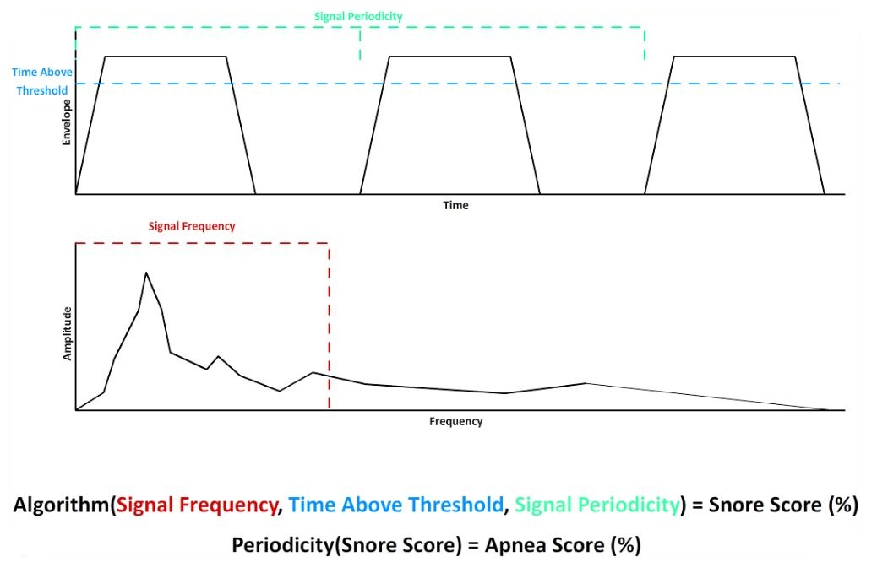Time signal is above a certain threshold

**Figure 12: Snoring Algorithm**

* + These three factors are used to calculate the snoring score of the individual. If a snoring score of 80% is achieved, then the application is confident that the user is snoring. This score is constantly being updated every second by new data, and points are averaged over time, meaning that its takes time for someone’s snore score to increase to a high percentage. This is used so that random spikes in noise, like a TV or a fan, will not be considered snoring by the algorithm because they will be averaged out from more measurements.
  + If the user currently has a snore score above 80%, then the application starts checking to see if there are any interruptions in the user’s sleeping pattern, thus signifying sleep apnea. A user’s sleep apnea score will increase throughout the night if they exhibit more interruptions in their snoring pattern, but only when their snore score is set above 80%. All of this is plotted in real time on the mobile application and is stored after the user wakes up in a SQL database.
  + On the next page, we show two plots that we have of two user’s results from using the application overnight. Figure 13 shows Corey’s sleeping patterns from one night, which he learned that he actually snores.
  + 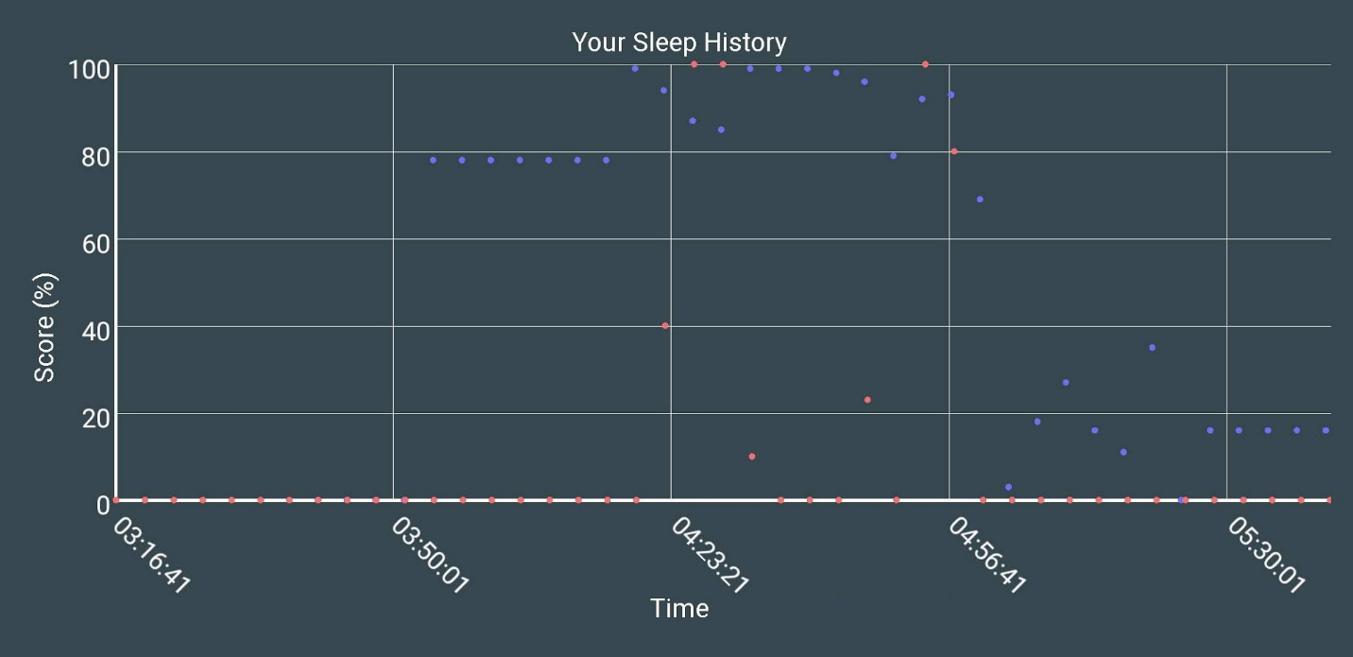The application started plotting data once he had a snoring score above 80% which was around 4 am, and then the application started looking for interruptions in his snoring, which rarely happened. The snoring score is the blue/purple dots while the sleep apnea score is the red dot. Although the application detected some lapses in his snoring, which spiked his apnea score, it then normalized his score very soon after showing that although he snored, he didn’t show signs of sleep apnea.

**Figure 13: Results of a User Snoring (Corey)**

* + 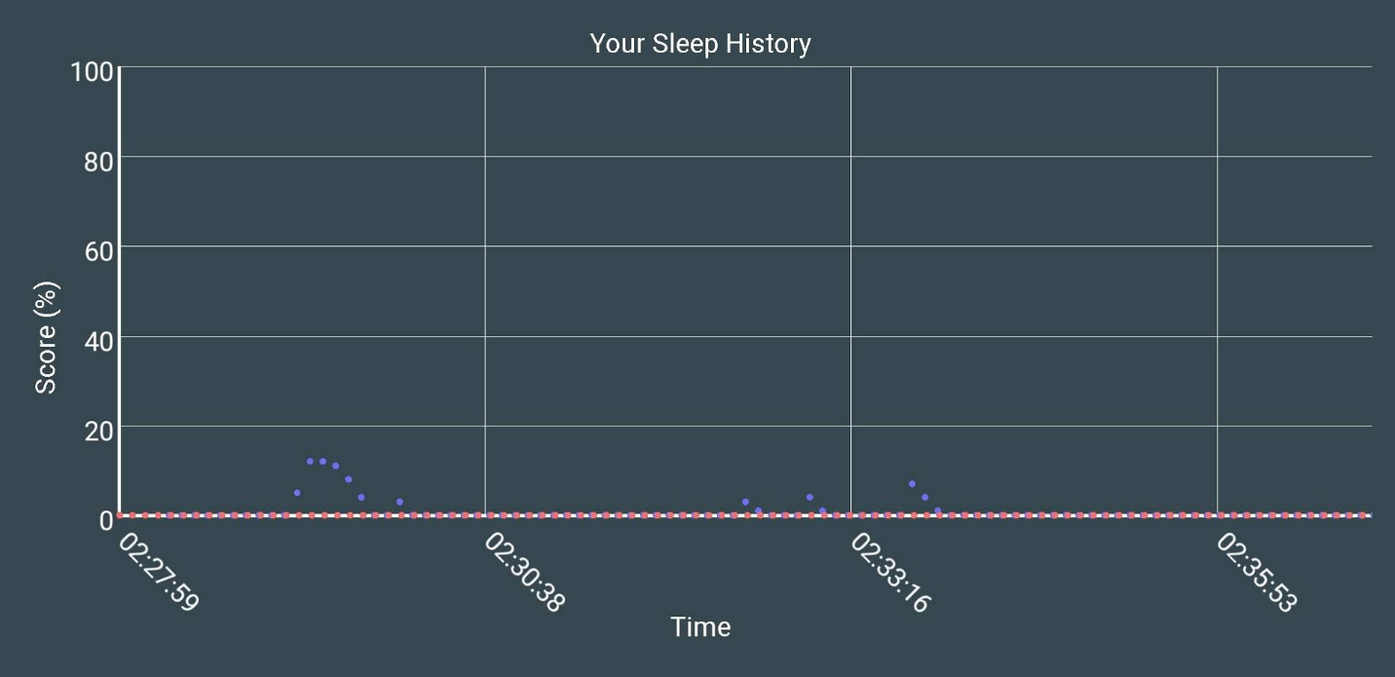Figure 14 is results of one of our roommates who we knew did not snore. This user’s snore score never went above 80%, it actually stayed below 20%, so it never increased their sleep apnea score.

**Figure 14: Results of a User Not Snoring**

* + We would love to test this on more subjects, specifically someone who has sleep apnea, but this project was designed to be a human testing project when we would have needed to apply for the appropriate licenses in the Fall semester. This will be covered more in the future recommendations section.

**Standards**

The only standard that we applied to our project was **IEEE 802.15-1-2002**. It is IEEE’s Standard for Telecommunications and Information Exchange Between Systems - LAN/MAN - Specific Requirements - Part 15: Wireless Medium Access Control (MAC) and Physical Layer (PHY) Specifications for Wireless Personal Area Networks (WPANs).

We used Bluetooth to communicate between our device and the mobile application.

**Budget**

* Microphone $5
  + SparkFun Sound Detector (Prototype Only) - $5
* Microprocessor $20
  + Beetle BLE - The smallest Arduino Bluetooth 4.0 $20
* Power $40
  + Illinois Capacitor RJD3555ST1 Lithium 3.7V Coin 35.0mm $35
  + TP4056 board: $5
* Other circuit components $5

**Total $70**

As we can see, our solution only cost us $70 for a prototyped device, compared to the other solutions which are all over $250. One of our future recommendations is to create this device on a single flexible PCB. This would lower the overall size and cost of the device which would make it more accessible to everyone.

**Timeline**

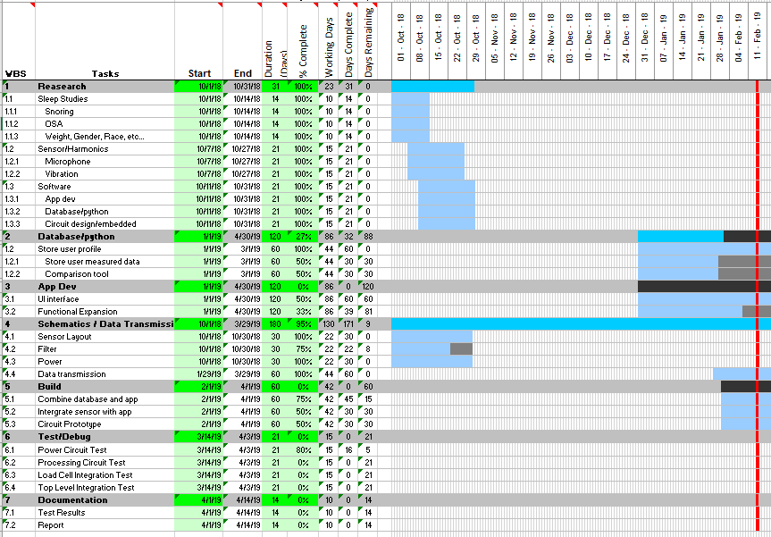Our timeline changed throughout the semester, mostly because our overall design changed. We originally planned on doing all of our data analysis on an outside source/server and then send that data to the cell phone, but we changed this to have our mobile application do all of this for us. This changed our whole section regarding our database and added complexity to our application.

**Figure 15: Original Gantt Chart 10-1-2018**

As shown in the final Gantt chart, on the top of the next page, most of our work was focused around the second semester of senior design. We were able to complete all our original hardware design and research in the first semester and did all of our building in the second semester. Our database greatly simplified while our application increased in complexity and size which is reflected in the changes between our Gantt charts.

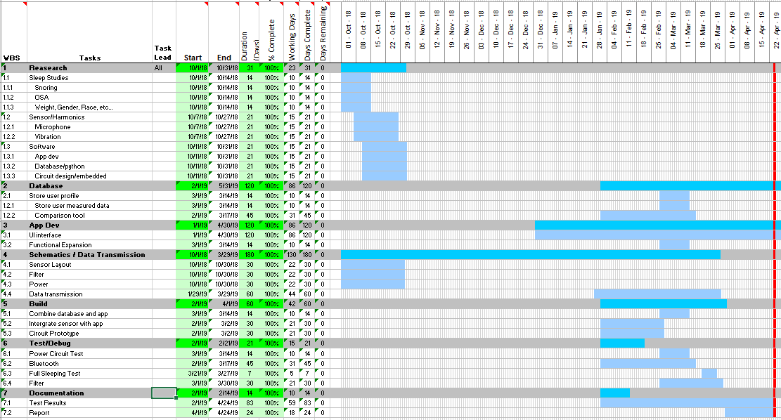

**Figure 16: Final Gantt Chart 4-23-2019**

**Testing Approach**

Testing for this project was approached as a consecutive integration process. This means we would test one process to ensure its functionality was working properly, then move on to the next test and integrate that into the system to ensure that, in the case something went wrong, we wouldn’t spend hours (or days) on trying to debug what part of our project was causing the issue. The project started with simple tests regarding getting the Bluetooth (BT) signal connected and sending data to the phone application. Once a good connection was established and the data was accurately and precisely being sent over BT, we were able to move on to testing the battery and output voltage to ensure our sensors, microphone and overall system was both receiving not only a safe level of voltage but the predicted voltage at we designed our system to operate. The voltage levels are crucial to test because a higher level of voltage could result in damage to components, and the system would not function as intended. Once voltages were confirmed at operating levels, a prototype could be developed and tested. The algorithm was changed several times in order to fine tune the precision of our sensor’s data by implementing different function libraries, mathematical techniques, and deleting seemingly useless snippets of code. Once the algorithm was at a reasonable level, through testing, we figured out quickly that background noise could be an issue based on the environment in which user is testing. Due to this, a calibration feature was added to our application which takes in the background noise in the environment, so that this data can be subtracted out of the data that enters the algorithm. Thus, ensuring only snoring signals are entering the algorithm. Within the final month of senior design, we focused on implementing and testing a battery protection circuit. This is to ensure the battery does not over charge/discharge. This was then tested by fully discharging the battery then charging it back to full. Finally, we tested the full system through an entire night, the result of this test was successful because there were no unreasonable spikes in the data, and data itself seemed to follow a natural sleeping pattern. For more detail, our timeline is shown below:

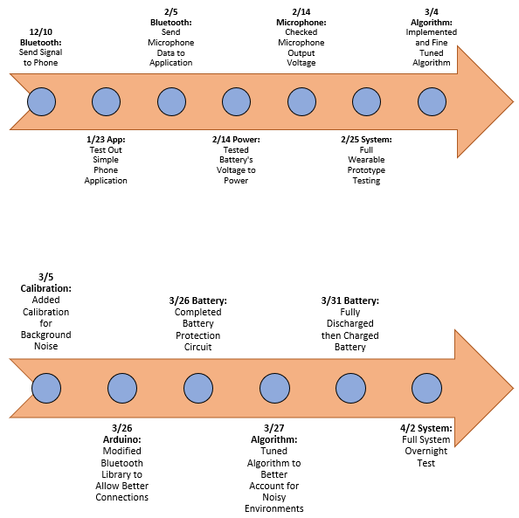

**Figure 17: Testing Plan Timeline**

**Encountered Problems**

*Audio Noise Interference*

One thing that was noticed relatively early in the prototype stage was the relative levels of data being sent over BT to the application. This was reflected most noticeably in our “Snore Score” and “Apnea Score” values. When testing on campus, these values were significantly higher than when tested in a bedroom environment. This was due to the differences in background noise. On campus, there are HVAC, Machinery, Electronics, Other students, etc. that all contribute to the overall noise levels in that environment. To combat this, we implemented an initial calibration of the system to listen to the background noise levels so that these could be subtracted out of the data that is sent into the algorithm. This ensures that the only data that gets processed is pure snoring (or lack of) signals.

*Bluetooth*

Bluetooth was for sure one of the biggest issues involved with this project. Although it was the best system for us to use, Bluetooth often had errors sending signal to the application. At first, this stopped all long-term data collection, which was fixed right away. The Bluetooth library that we used had to be modified to superficially work with our project to fix this issue. We tried may different ways to send our signals over Bluetooth, mostly with how often we sent information and what that information was. We found it quite inefficient to send the whole outputted signal from the sensor over Bluetooth, mainly because it was a waste of resources, so we instead sent the three conditions previously mentioned in the technical approach section. We also had issue connecting to our sensor, but modifying the Bluetooth library helped fix this issue.

*Microphone Amplifier*

From initial integration testing with the microphone into our system, we found that the gain for the microphone was set too low and was not accurately picking up the frequencies for which we had designed. We were able to design our own bandpass filter, keeping in mind that typical snoring frequencies are beneath 1-2kHz, as well as changed the gain of the microphone by referring to the datasheet and populating R17 (**SEE BELOW)** based on the gain we had calculated and designed.

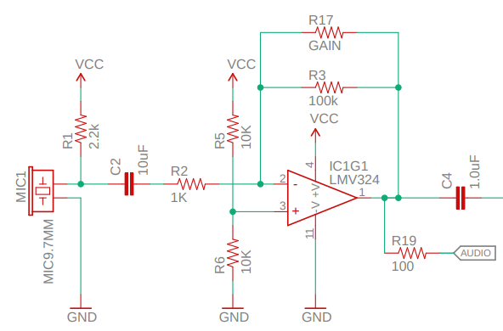

**Figure 18: Microphone Amplifier Circuit**

*Battery Protection Circuit*

Initially, we were most worried about being able to implement our system with a battery that is rechargeable, with the reason being that we wanted our system to be wireless in order to get a non-disruptive sleep test. It’s very common to have a charging circuit (**See FIGURE #**) hooked up to a battery, such as in a mobile rechargeable battery pack. This not only recharges the battery, but it can help protect against over-charging, over-discharging, or large current draws from the battery which could result in other components in the system to get damaged. Even though a protection circuit was designed specifically for our system, we were able to take a battery circuit from an existing battery pack to implement in our prototype. This protection worked perfectly, being able to charge/discharge our battery throughout overnight cycles without any issues.

*Data Plotting*

Originally, our application would store all the data, and then plot it all at the end, which sometimes caused some odd-looking graphs, we think from data corruption. We then plotted all our data immediately on the plot, but then the plots became very difficult to read and it often crashed the application. This issue was fixed by us adding the snoring score, and the sleep apnea score, which then required less data to be sent/plotted. This made the graphs easier to read and simplified the complexity of the Bluetooth transmission.

**Future Recommendations**

iOS Implementation

This prototype is implemented only as an Android Application in its current form. This is due to us having some previous experience with Android Studios, and no experience with iOS implementation. We designed the system to be easily adaptable to iOS, in regard to the used hardware, it would just take some time to create the new application. If this was to be created into a sellable product, we would want any user to be able to use it regardless of their phone type.

PCB Design

Our design is currently just on a sleeping mask, because it places the microphone as close to the nose as possible. Although a face mask worked great for a prototype, we don’t like forcing the user to wear something while they sleep, again referencing our initial design objective of being un-intrusive. Our idea is to then create a singular PCB design placed on a flexible PCB placed on the nose. One would need to change the layout of the Arduino, and re-place it on the flexible PCB but our original amplifier and filter design would be implemented in this design. The Arduino could also be removed in this case and a cheaper Bluetooth transmission option could be implemented on the new board. The presentation of the product would also look much better compared to the prototype.

This would take lots of more research into a company that could produce these chips for us, along with changes in the power system. Our current battery system would not work, due to the size of the battery, but changing the Bluetooth transmission system could greatly decrease the power consumption of the system thus reducing the needed battery capacity. More on this will be covered in the next section of the future recommendations.

Improved Battery Life

We designed our system to work for a single night’s sleep, 8 hours, but through testing our system was able to work for over 10 hours on a full charge. We would like to improve the system to let it run for a few nights on a single charge without increasing the capacity of the battery. The largest current draw of our system is by far the Arduino, followed by the microphone and its amplification circuitry. Like mentioned in the last section of the recommendations, if we changed the Bluetooth transmission to a simpler component, we could decrease the total power draw. Our current battery offers 500 mAh of capacity, which is great, but our battery is a little large for a wearable sensor.

It would take lots of testing and design to find the perfect balance between lowering power consumption while also decrease the physical size of the battery. One could also change how often our system sends data to our application. We couldn’t accurately measure if it drew less current to constantly send the output of the microphone to the application, or have the Arduino do some basic calculations and then send the data in chunks over time. We went with the first solution, thinking that keeping the Arduino doing a basic and consistent task would limit the total power consumption, but there could be more research and testing into this.

Signal Filtering

Our system in its current form will take around 10 measurements right after starting the application from the smart-phone that it considers ‘ambient noise’. Everyone sleeps in different conditions, and they often change throughout the year, so we measure this at the start of every night. We then use that to filter out the ambient noise from the transmitted signal, so that we are theoretically getting just the snoring waveform. This worked very well for our prototype and allowed us to test this even in loud environments, so we would for sure keep this feature.

With that being said, of course there can be improvements. Our system in its current form would have trouble telling the differences between two people snoring in the same room/bed. For example, if your partner also snored, the system might have issues distinguishing between the two of you. This is a unique problem, where we would think that software would be the major solution. Making sure that the system is placed close to the user’s mouth/noise should make sure that the user’s snoring patterns are the dominate factor of the signal, but it is always possible that your partner’s snoring overpowers your own signal. We will touch on a possible software solution in the next section.

Machine Learning

The natural progression of any project involving data is to include a machine learning aspect. We have many ideas for this, most of which we came up with near the end of our project after seeing some results. As discussed in our technical approach, our software reads three main factors of someone’s snoring; signal period, signal frequency, and the time the signal is above a threshold value. These values are measured and transmitted over time, giving us four total variables. Instead of using these in our current snoring algorithm, one could create a four-dimension vector space for data analysis. Analysis of the changes in the vector space would allow for a different way to analyze someone’ sleeping patterns and could open up a whole new way to analyze sleep.

We also suggest using machine learning to help solve the issue mentioned in the previous section, multiple people snoring in the same room. Unless your partner’s snoring is so loud that it overpowers your pattern, your pattern should still be the dominating aspect of the signal. The application could then save these characteristics, and then machine learning could then be implemented to check these characteristics compared to the current input. If the application was able to accurately distinguish your snoring from other noise, we could get a cleaner signal to use for data analysis.

Another pathway involving machine learning is searching for patterns in your saved data and checking to see the minor changes overtime. One would need to continue sleep analysis research and/or talk to a medical professional that focuses on sleep analysis to see what conditions that software should look for. If the app notices that your sleeping patterns now distinguish certain qualities, the app could possibly suggest further help for the user.

Other sensors

We decided to just use a microphone to record the snoring waveform and use our algorithm to verify if someone is snoring, but we could use additional sensors/hardware to also do this. We investigated using an oxygen sensor to analyze breathing patterns to verify that an individual is snoring, but the sensors we found were quite expensive and would have driven the cost of the system higher than we wanted.

We suggest more research into possible hardware solutions to better measure and verify if a person is snoring. One could try and measure the vibrations of the system, possibly verifying if a user’s nose was moving along with the snoring waveform. This could also help distinguish the noise between two people snoring, because the system could verify if the user was snoring at that given moment.

mHealth

This whole project is supposed to be a look into using mHealth practices to simple healthcare diagnostic needs, which we believe it did. We want more projects/research to be put into this field, because it serves the future needs of an aging population by using current technology. Future work could continue improving sleep analysis, but we suggest people look even further into other diagnostic tests, like blood test, nutrition, sweat analysis, or blood pressure readings. All of these tests use current sensors that exist on the market which if used in unison could act as an at-home diagnostic tool for the average user. Of course, accuracy will always be less than going to have a full medical workup completed in a hospital setting, but mHealth still has its benefits.

With the ever-improving state of technology, these mHealth tests will get more and more accurate along side more testing. Our original project idea of a full health-testing system could use the previously mentioned idea of machine learning to help analyze a user’s current health and possibly suggest further test to be done by a medical professional. This would also let medical professionals further practice at-home medical testing using just mobile equipment from their smart-phone. Needless to say, this topic can be greatly continued upon by anyone interested in future work.

Future Testing

We were unable to fully test our system with someone that is known to have sleep apnea, we were only able to test on ourselves. When we first planned this project there was no human testing planned, so we never got the associated licenses that were needed to do a human study. If someone wanted to continue working on this, they should plan to do full human tests with control subjects, and known subjects of sleep apnea.

**Conclusion**

**References**

[1] B. Wirsing. “Sending and Receiving Data via Bluetooth with an Android Device,” March, 2014. [Online Document]. Accessed 20 November 2018. Available: <https://www.egr.msu.edu/classes/ece480/capstone/spring14/group01/docs/appnote/Wirsing-SendingAndReceivingDataViaBluetoothWithAnAndroidDevice.pdf>.

This article provides instructions on how to communicate to an Arduino with a Bluetooth module and an Android application. Our project required wireless communication between the sensor and the user’s smartphone. Therefore this document showed us exactly how to implement this communication in Android Studio.

[2] Beck, R., Odeh, M., Oliven, A., & Gavriely, N. (1995). The acoustic properties of snores. The European respiratory journal, 8 12, 2120-8 .

We used this paper to assist with our research for snoring patterns, especially when constructing our detection algorithm. We also used some of their figures in our papers, and on our poster.

[3] Dafna E, Tarasiuk A, Zigel Y (2013) Automatic Detection of Whole Night Snoring Events Using Non-Contact Microphone. PLoS ONE 8(12): e84139. Accessed 12 September 2018. https://doi.org/10.1371/journal.pone.0084139

This article also served as a starting point in our research for the project. We used some of their statistics to as justification for our project, and frequently referred to their figures in other instances.

[4] H. Shin and J. Cho. “Unconstrained snoring detection using a smartphone during ordinary sleep,” *Biomed Eng Online*, vol. 13, no. 116, August, 2014. [Online Serial]. Accessed 12 September 2018. Available: <https://www.ncbi.nlm.nih.gov/pmc/articles/PMC4148548/>.

This article demonstrates the viability of a snoring sound classifier. They tested an algorithm that was developed by testing against a database of snoring and non-snoring sounds and implemented using a smartphone application and microphone. Within the article they mention the relative frequencies that are associated with typical snoring sounds. This gave us the idea to not only check the sound amplitude but also the frequency peaks when determining if the user is snoring.

[5] Hansen, Kathy. "The Difference Between Snoring and Sleep Apnea Explained." Simple Sleep Services. 22 Mar. 2017. Accessed 5 September 2018.

<https://www.simplesleepservices.com/snoring-and-sleep-apnea/>.

This article contains information into sleep apnea that we used in creating our algorithm for detection. It also served as one of primary sources in the beginning of our research. We looked at their sources and read through their articles as well.

[6] J.A. Pinto, D.K. Ribeiro, A.F. Cavallini, C. Duarte, and G.S. Freitas. “Comorbidities Associated with Obstructive Sleep Apnea: a Retrospective Study,” *Int Arch Otorhinolaryngol*, vol. 20, no. 2, March, 2016. [Online Serial]. Accessed 16 February 2019. Available: <https://www.ncbi.nlm.nih.gov/pmc/articles/PMC4835326/>.

This article is about a study whose goal was to determine a correlation between major commodities and obstructive sleep apnea. The conclusion of this article gave us more insight into the disorder and some data on the relationship between age groups and sleep apnea.

[7] J.H. Choi, M. Sun, U.G. Kang, and B.M. Lee. “SMART DETECTION ALGORITHM FOR SNORING AND APNEA,” February, 2017. [Online Serial]. Accessed 16 February 2019. Available: <https://pdfs.semanticscholar.org/f2c0/6a1b32e77710bc256a7c838c2c6383510f69.pdf>.

This article is about the implementation of a snoring detection algorithm into an embedded system. The system was made up of a Raspberry Pi connected to a myriad of sensors, one of which being a microphone, that would monitor the user while they slept. This was very integral in the creation of our snoring and apnea detection algorithm due to the fact that they were using the same microphone module that we were. It gave us insight as to what kind of signal could indicate snoring as well as how to get more resolution out of the data obtained by the microphone module.

[8] Lee, Li-Ang et al. “Energy types of snoring sounds in patients with obstructive sleep apnea syndrome: a preliminary observation,” *PloS one*, vol. 7, no. 12, December, 2012. [Online Serial]. Accessed 14 September 2018. Available: <https://www.ncbi.nlm.nih.gov/pmc/articles/PMC3534069/>.

This article investigates the energies of soundwaves generated by people diagnosed with obstructive sleep apnea while snoring. They outline the specific frequencies that on average showed more peaks throughout a night of testing that are associated with snoring sounds. We used these frequencies in our own algorithm to help distinguish snoring sounds from non-snoring sounds.

[9] Sparkfun, “Sound Detector Hookup Guide”, learn.sparkfun.com, [Online]. Accessed 20 February 2019. Available: <https://learn.sparkfun.com/tutorials/sound-detector-hookup-guide/all>.

This is a tutorial on how the sparkfun sound detector module works and how to modify it. There was an issue of data amplitude being too low to get any resolution from the FFT. This showed us how to increase the gain of the first stage of the microphone amplifier in order to get more resolution. It also helped us to understand the purpose of each of the output pins.

[10] T. Young, L. Finn, P.E. Peppard, M. Szklo-Coxe, D. Austin, F.J. Nieto, R. Stubbs, and K.M. Hila. “Sleep disordered breathing and mortality: eighteen-year follow-up of the wisconsin sleep cohort,” *SLEEP,* vol. 31, no. 8, August, 2008. [Online Serial]. Accessed 12 September 2018. Available: <https://www.ncbi.nlm.nih.gov/pmc/articles/PMC2542952/>.

This article contains information about the symptoms of sleep-disordered breathing, its causes and the risk of mortality in patients diagnosed with it. The content in this document was one of the primary issues touched upon in our problem statement and is a justification of why our project was necessary.

**Appendices**

**Full List of Tests**

|  |  |  |  |  |
| --- | --- | --- | --- | --- |
| Date | Type | Test Explanation | Results | Comments |
| 12/10 | Bluetooth | Send Bluetooth signal to phone | We were able to send a simple Bluetooth signal from our Arduino to our cell phone app | This was the first step for us in regards to app and system integration, which now allows us to separately developed each part before full integration. |
| 1/23 | App | Test out simple phone application features | No issues with our application. | This was more of a test of our knowledge of android studios, since it is new to us. |
| 2/5 | Bluetooth | Send microphone data to application then plot it. | We are able to send data, but our app will freeze up after long plots. | We code right now replots the graph every time new data is received, which will greatly slow down the speed. This was mostly for us to just make sure the app can properly plot data in general, we can still clean up the code for the future. |
| 2/14 | Power | Tested our battery's voltage to power prototype circuit | Our battery could fully run our Arduino and microphone at 3.3V | This will let us greatly increase battery life since it is a lower voltage than the standard 5V. We also can use our smaller physical battery design which will decrease physical layout. |
| 2/14 | Microphone | Checked microphones output voltage | Output signal is too low to work with | We need to increase the gain of our amplifier. We also need to get more microphones, because they are too small for our usage, and we believe they will have trouble picking up the sound levels we expect to hear. |
| 2/25 | System | Full wearable prototype testing. | The device collects and transmits data to our application as expected. We used an outside power source for this test, not our battery. | This is very promising, because now we can just fine tune the accuracy and power management of our system. Although we had to use a separate power source for this test, we have already tested our battery and verified that it works. We did not want to fully connect our battery to our system until we had the proper charging circuit created first. |
| 3/4 | Algorithm and Circuit | Implemented and fine-tuned our algorithm to better detect OBS | Our system is now more accurate. | We modified out amplification circuit to further increase the output from our microphone. With this now higher output signal, we modified our algorithm to better detect OBS. |
| 3/5 | Calibration | A new feature allowing the user to specify the environment they are using the system. When we tested the circuit in a 'new' environment, it greatly affected the data. | This further increased the accuracy of the read data. | Although we expect the user to wear this sleeping mask, we would rather not alter the user's sleep to a point where the system is not monitoring their normal sleeping pattern. This allows the user to not wear the mask, but still let the system work as intended. |
| 3/26 | Arduino | Modified the Bluetooth library for the Arduino to allow better connections | Bluetooth connections are now more consistent between the device and a cell phone. | This was a quality of life test for our system, and hopefully nothing else needs to be modified in this regard. |
| 3/26 | Battery | Completed our new overcharge circuit alongside our battery | The battery is able to charge. | We still need to test this circuit fully, making sure the battery stops charging whenever it reaches max capacity. We plan to let the battery full discharge, and then charge it back up to full. |
| 3/27 | Algorithm | Tuned the detection algorithm to better account for noisy environments | Accuracy was greatly increased | This was a major concern of ours going into the project, and although the algorithm isn't perfect, we believe that we have a more than viable solution for the scope of this project. We suggest that this gets fine-tuned more in the future. |
| 3/31 | Battery | Fully discharge then fully charge the circuit | Working as intended. | Our overcharge circuity worked as intended, and our system is able to be fully discharged and then fully charge |
| 4/2 | System | First full system test on overnight sleeping data collection. | The system functioned as intended | The system actually worked longer than we expected, going for over 10 hours, and it tracked Corey's sleeping patterns overnight. He actually found out that he snores. |

**End of Semester One Final Presentation**

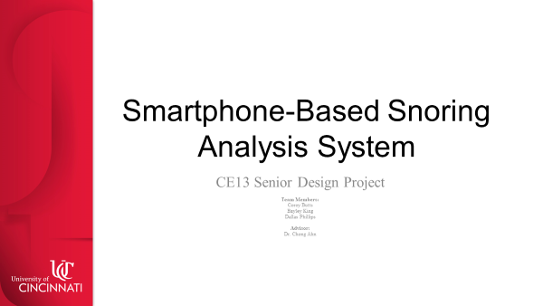

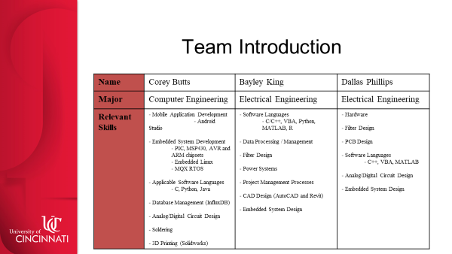 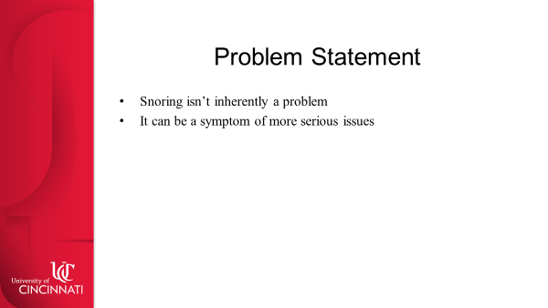

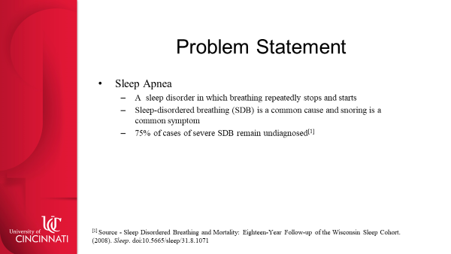 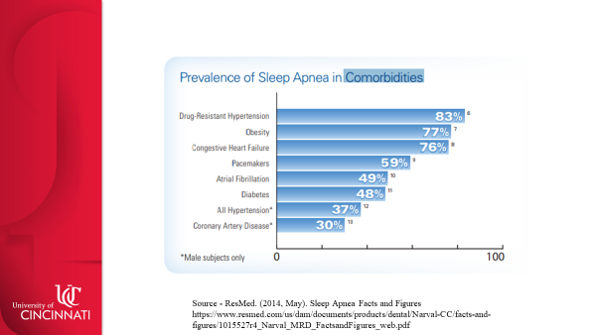 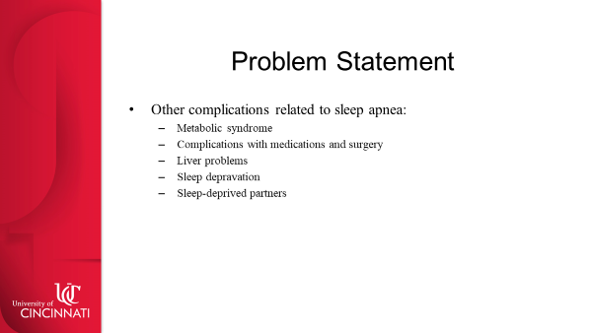

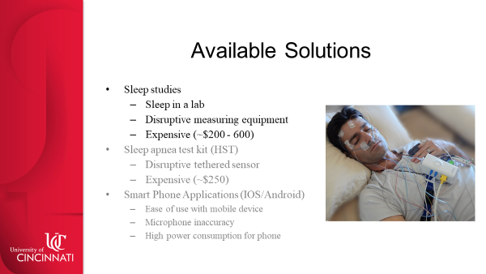 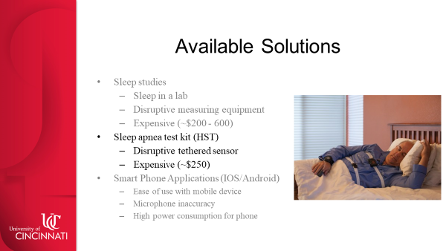 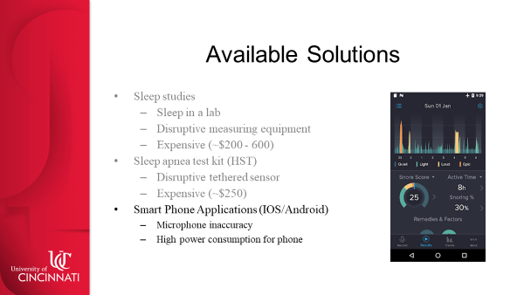

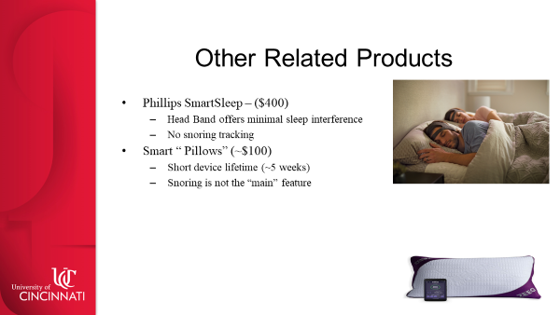 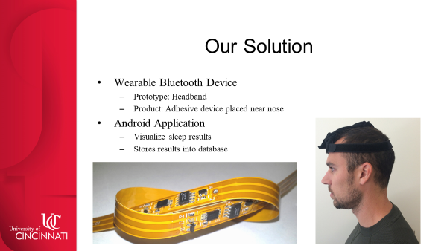 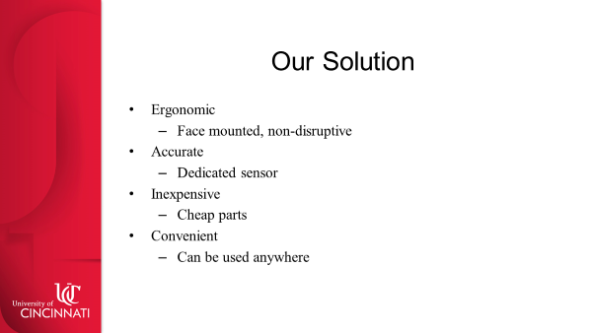

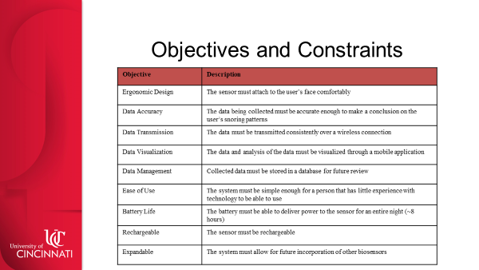 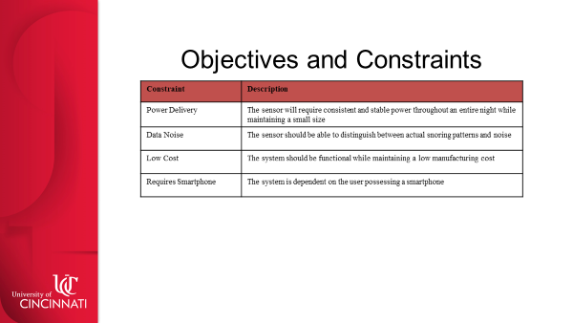 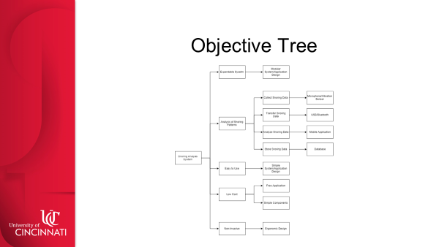

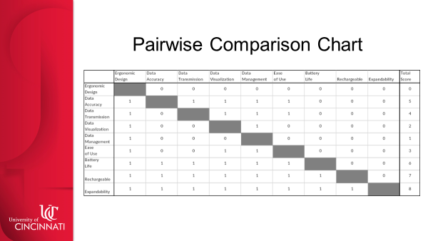 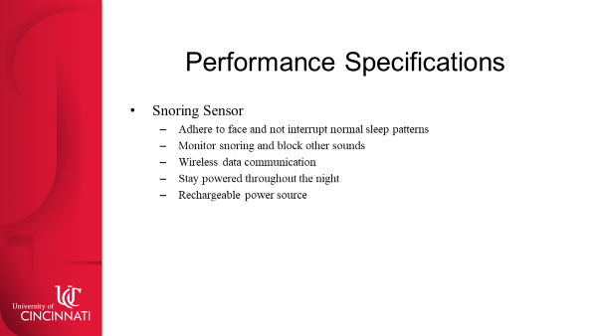 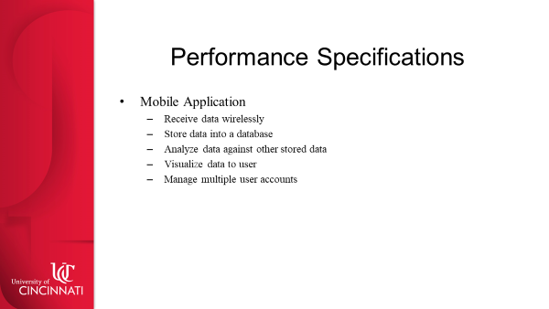

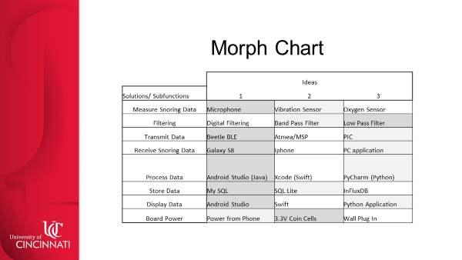  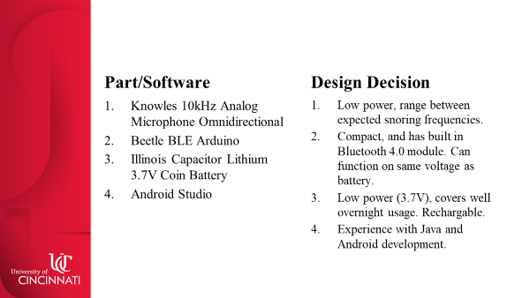

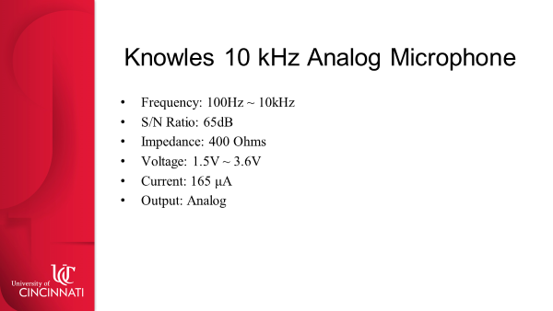 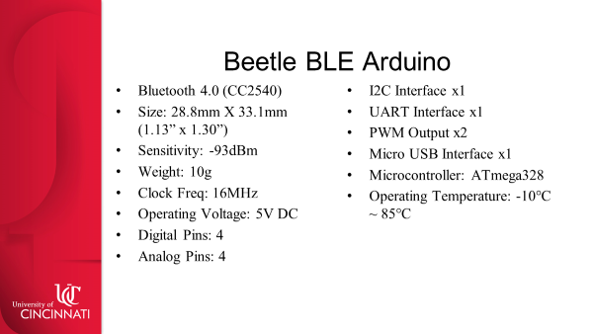 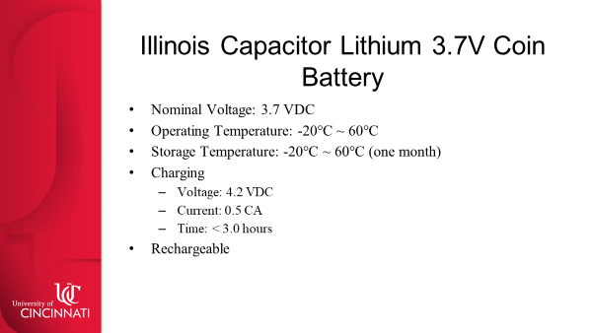

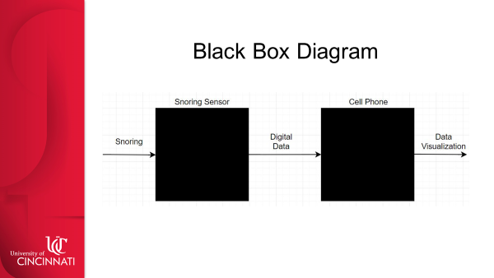 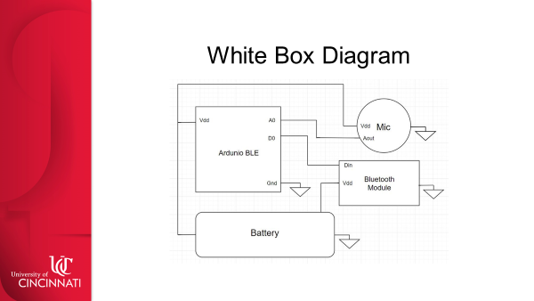 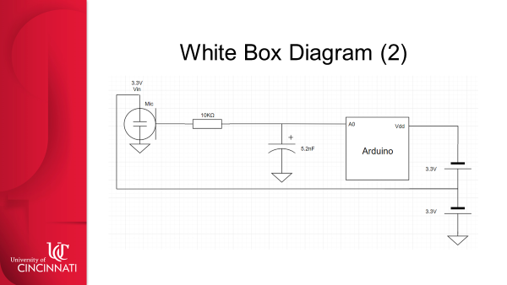

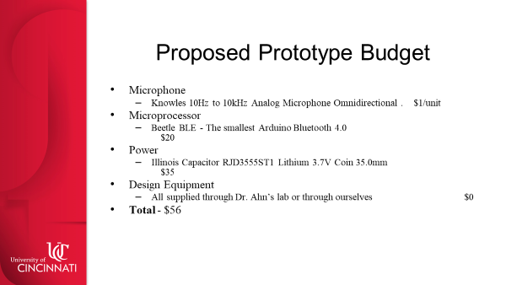 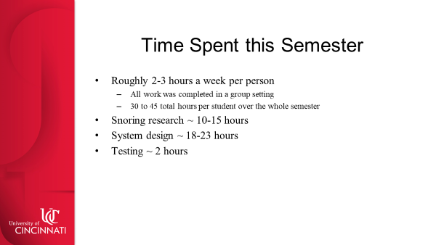 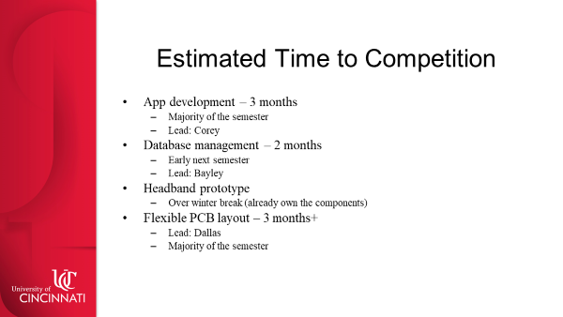

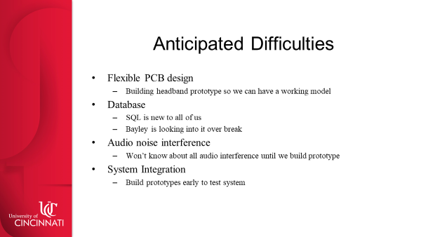 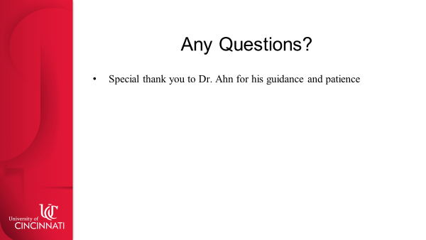

**Final Poster for the Senior Design Expo**

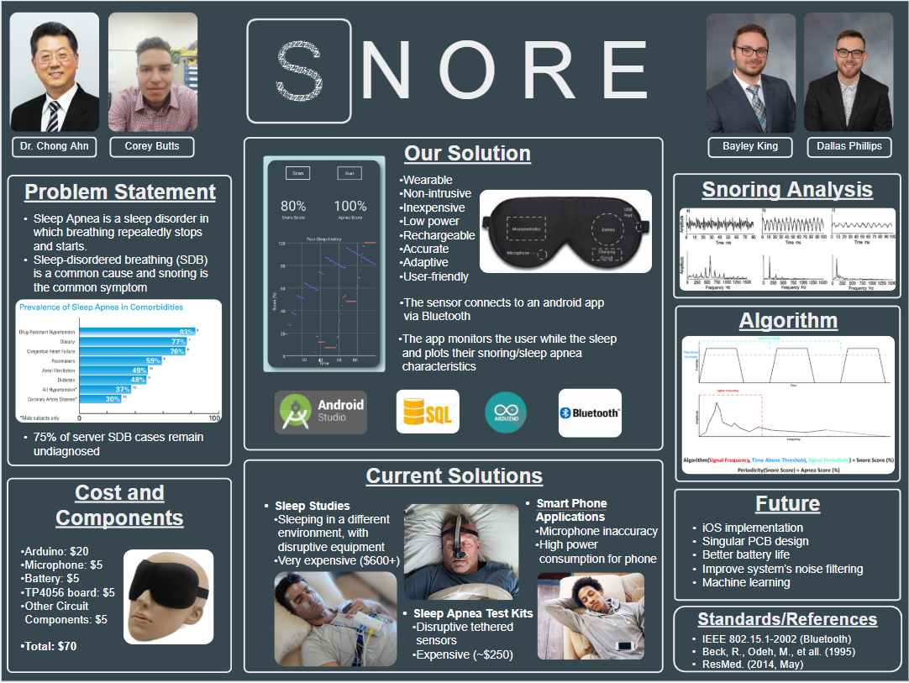

**Performance Specification Chart**

|  |  |
| --- | --- |
| **SNORING SENSOR** |  |
| **Functions** | **Performance Specifications** |
| Adhere to face | Must stay adhered to the user's face comfortably without disrupting sleep. Should be able to readhere to the user's face after removal |
| Monitor snoring | Must be able to measure snoring through some means (sound, vibration etc.) |
| Wireless communication | Must be able to communicate with the mobile device wirelessly |
| Stay powered | If the user has charged the sensor's battery to maximum capacity the sensor should be able to collect and transmit data throughout an entire night |
| Rechargable | Must be able to recharge the battery to full capacity |
|  |  |
| **MOBILE APPLICATION** |  |
| **Functions** | **Performance Specifications** |
| Receive data | Must be able to receive data wirelessly from the snoring sensor when in use |
| Store data | Must be able to store the received data into a database which can be accesed by the user who recorded the data |
| Analyze data | Once data from multiple users within the database, the application will compare the user's data against multiple others in order to give an assessment on their snoring patterns |
| Visualize data | The application should include a screen dedicated to a visualization of the user's data analysis summary |
| Manage user accounts | Must be able to add and delete user accounts. User's should be able to login to their accounts to store and view their snoring data |

**Morphological Chart**

|  |  |  |  |
| --- | --- | --- | --- |
|  | Ideas | | |
| Solutions/ Subfunctions | 1 | 2 | 3 |
| Measure Snoring Data | Microphone | Vibration Sensor | Oxygen Sensor |
| Filtering | Digital Filtering | Band Pass Filter | Low Pass Filter |
| Transmit Data | Beetle BLE | Atmea/MSP | PIC |
| Receive Snoring Data | Galaxy S8 | Iphone | PC application |
| Process Data | Android Studio (Java) | Xcode (Swift) | PyCharm (Python) |
| Store Data | My SQL | SQL Lite | InFluxDB |
| Display Data | Android Studio | Swift | Python Application |
| Board Power | Power from Phone | 3.3V Coin Cells | Wall Plug In |
|  |  |  |  |
| Design  Constraints (C) and Objectives (O) | 1 | 2 | 3 |
| C: Power | 1 | 2 | 3 |
| C: Smartphone type | 1 | 3 | 2 |
| C: Accuracy | 1 | 3 | 2 |
| O: Low Cost | 2 | 3 | 1 |
| O: Ergonomics | 1 | 2 | 3 |

**Code**

Our code can be found on the following GitHub link. It is far to large and extensive to include in this report.

<https://github.com/boreycutts/snore>

**Simulated Filter and Oscilloscope**

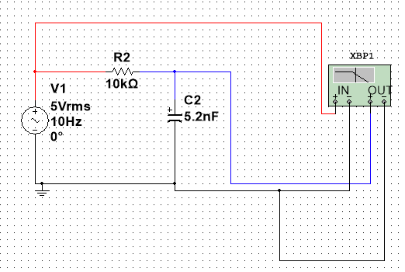

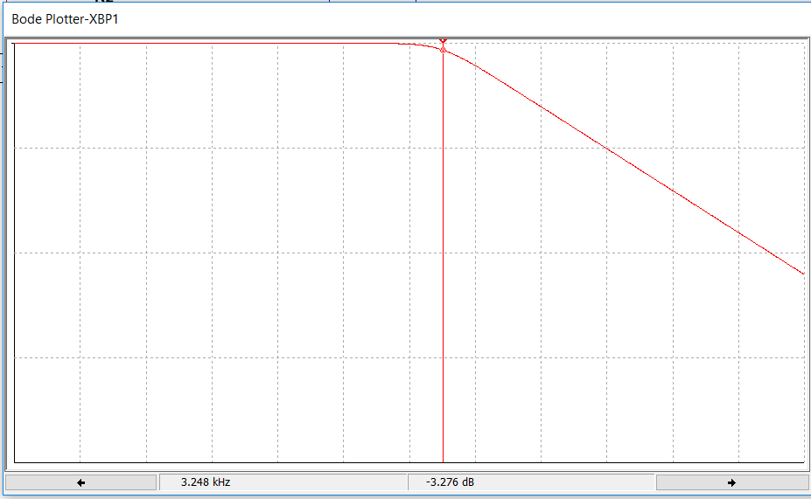

**Power Analysis**

Here are the power calculations that we did to determine the size of our battery.

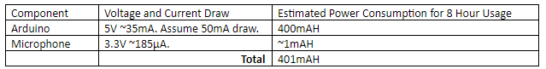

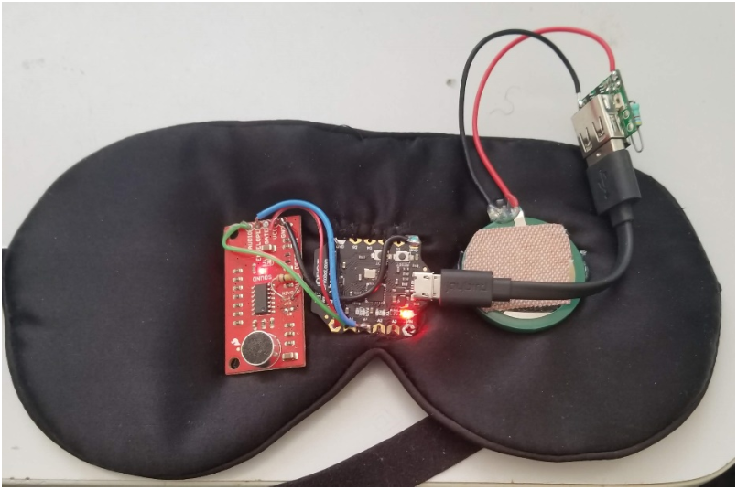**Image of Prototyped System**

**Data Sheets**

Arduino 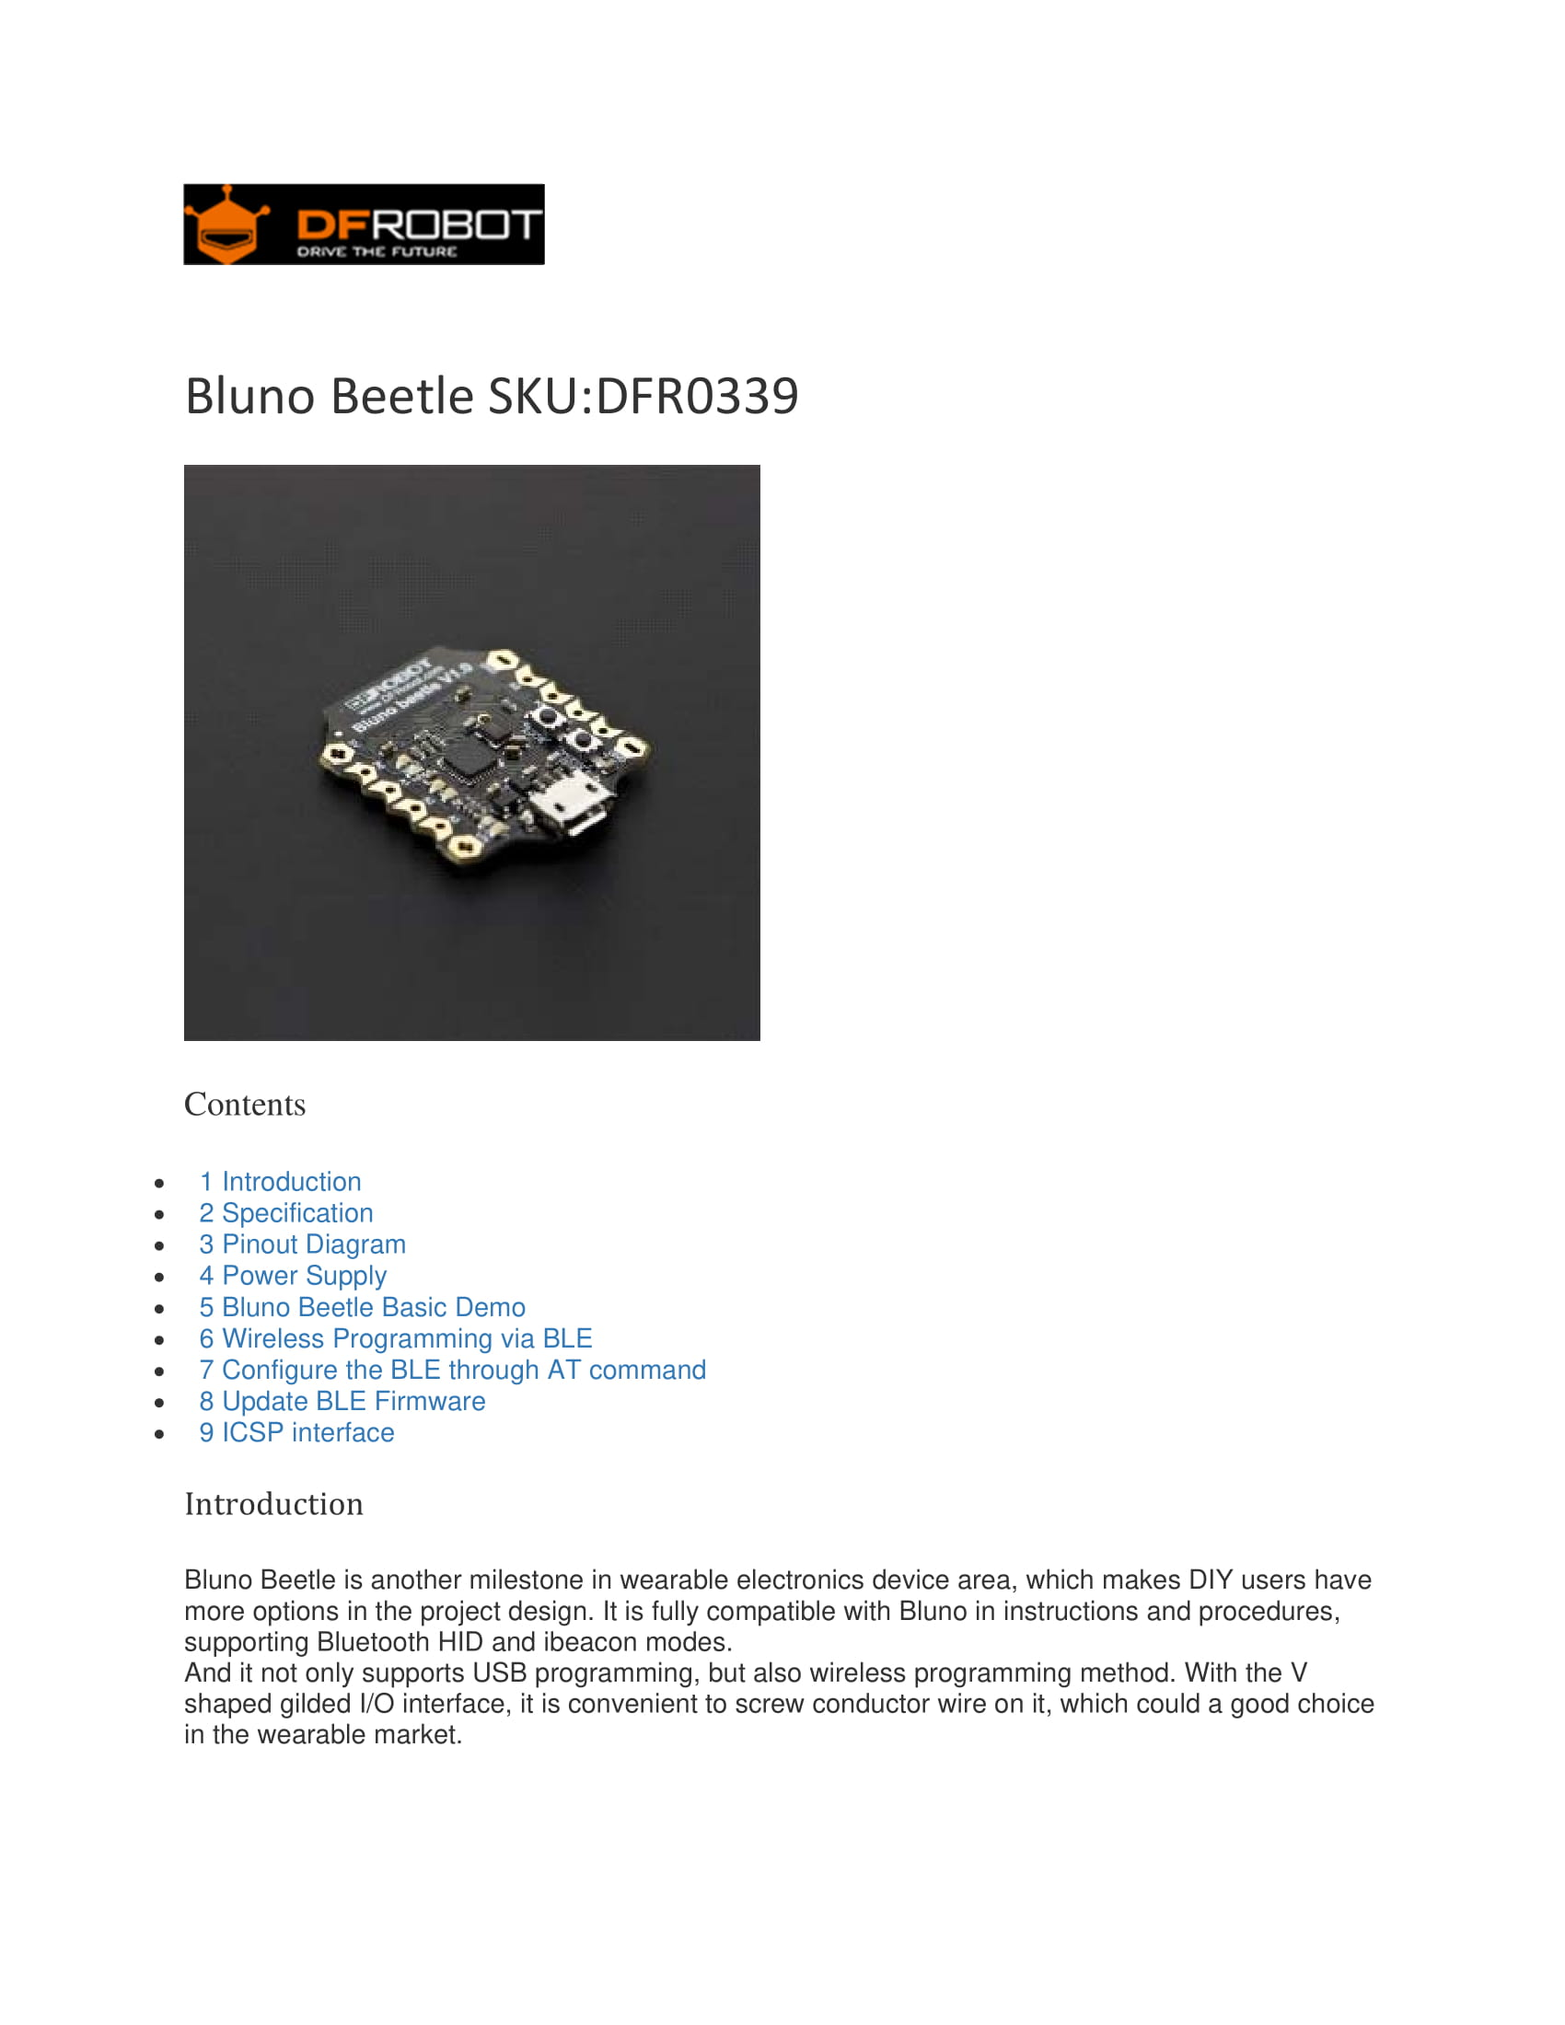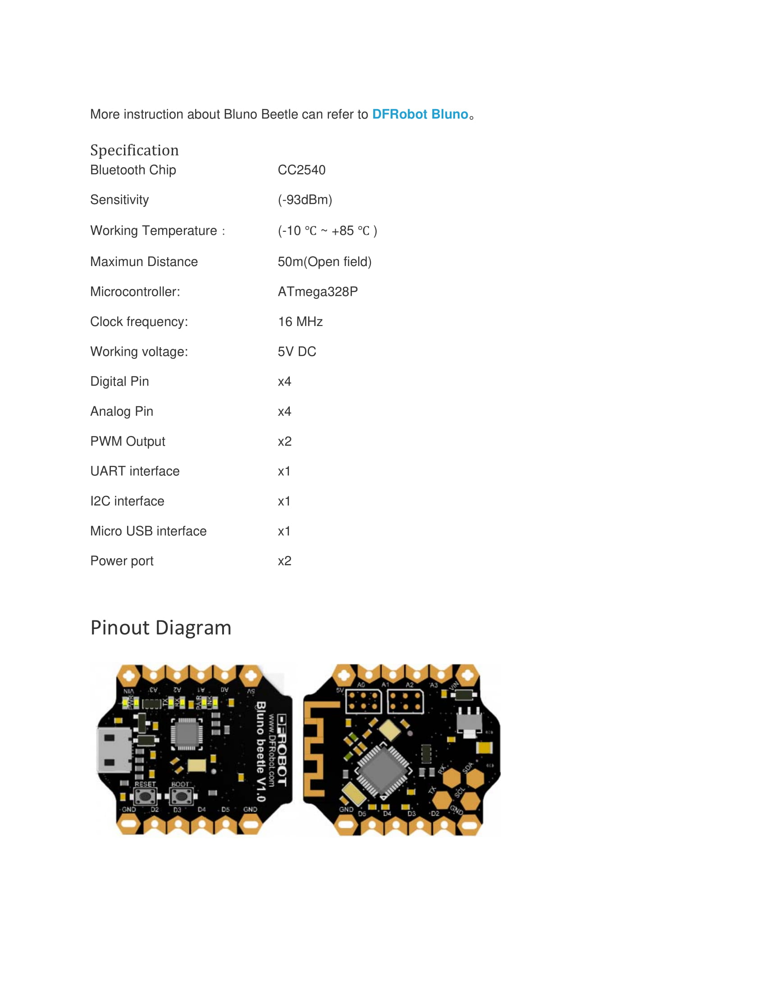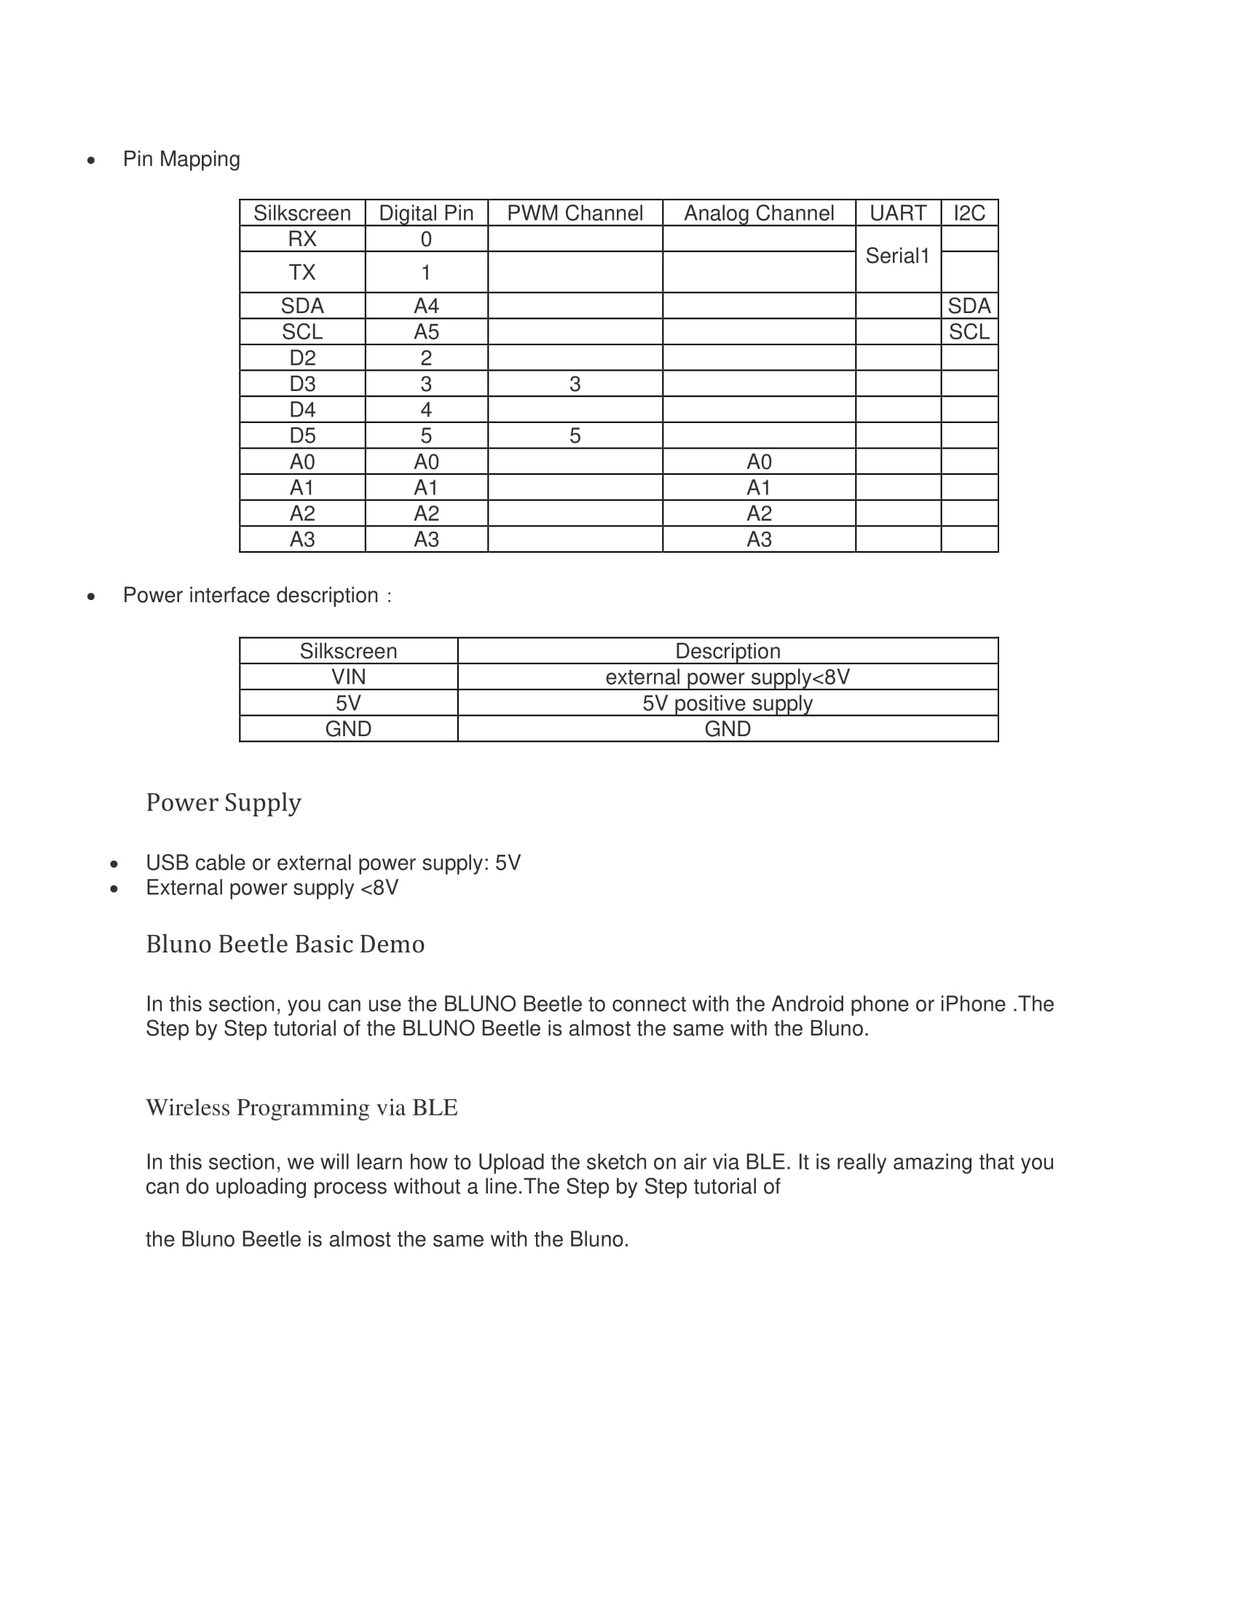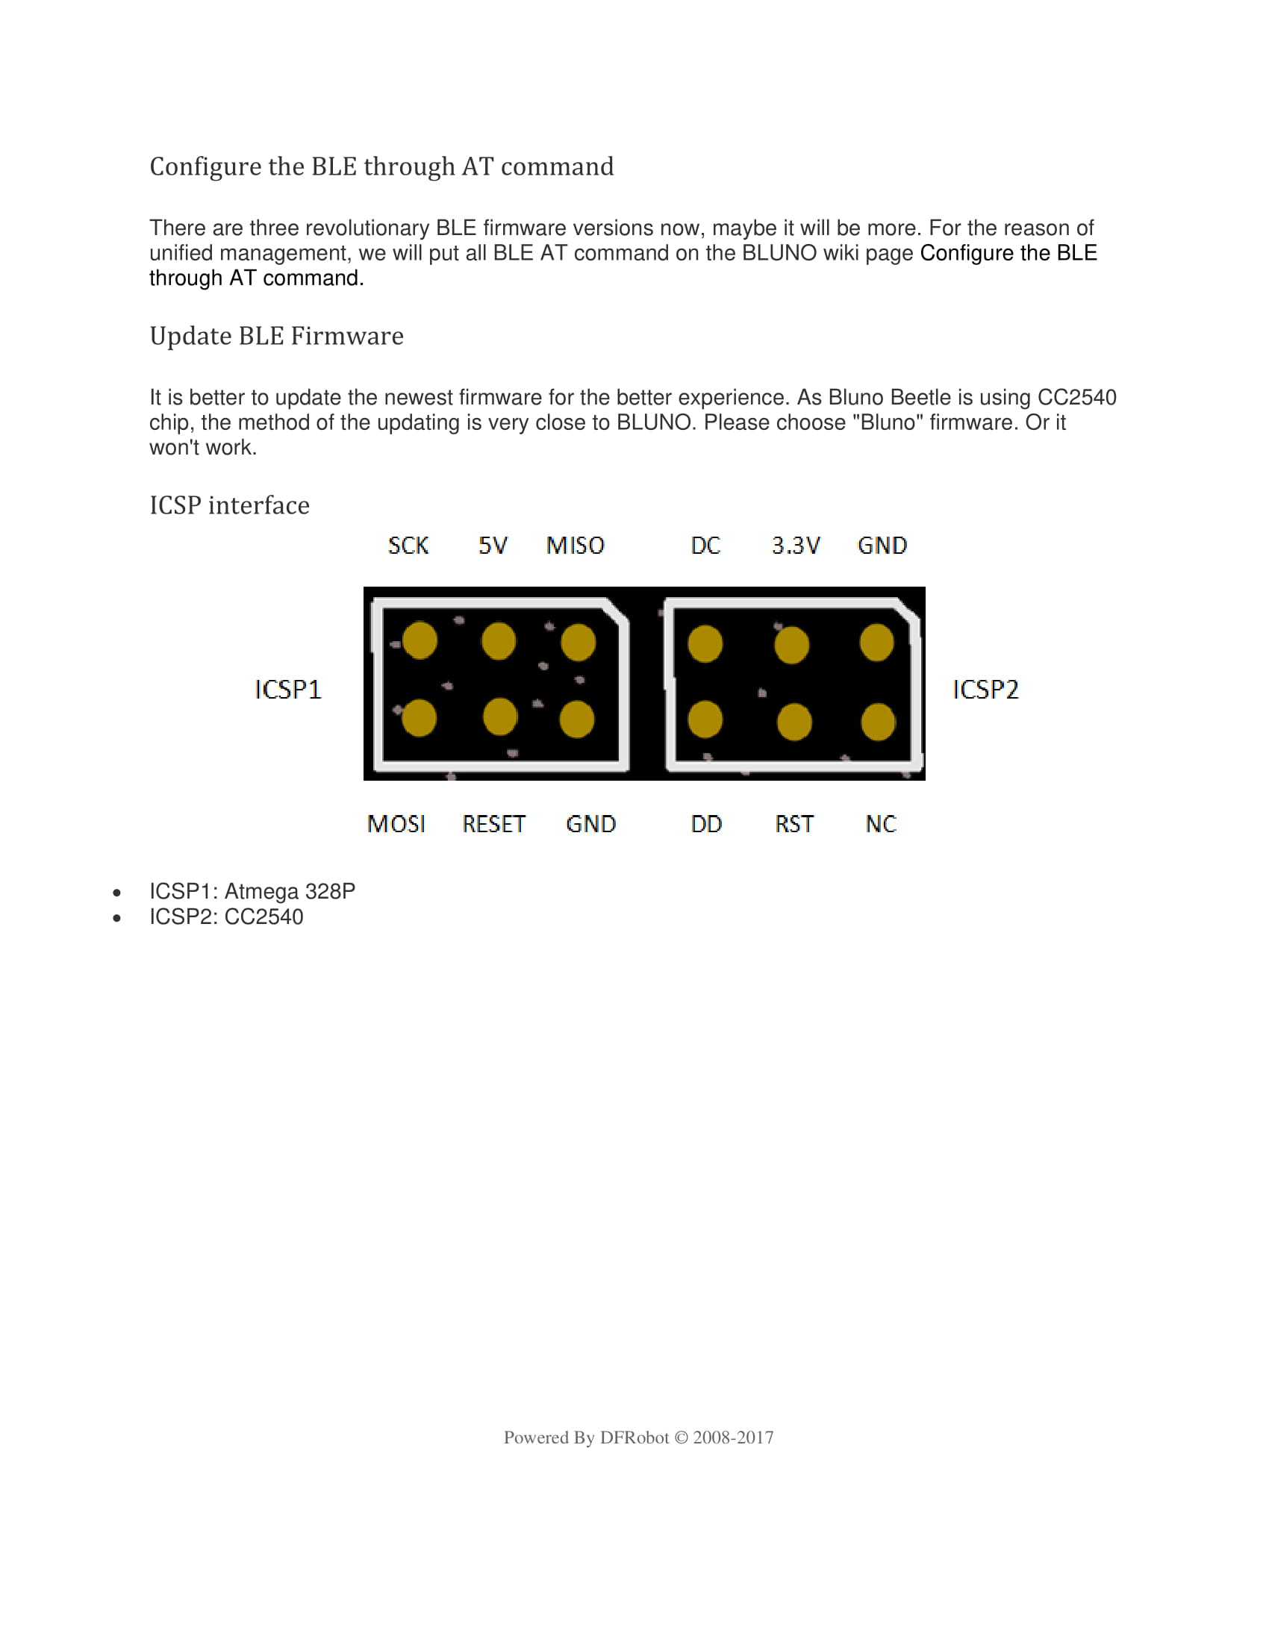

**Arduino Board Layout**

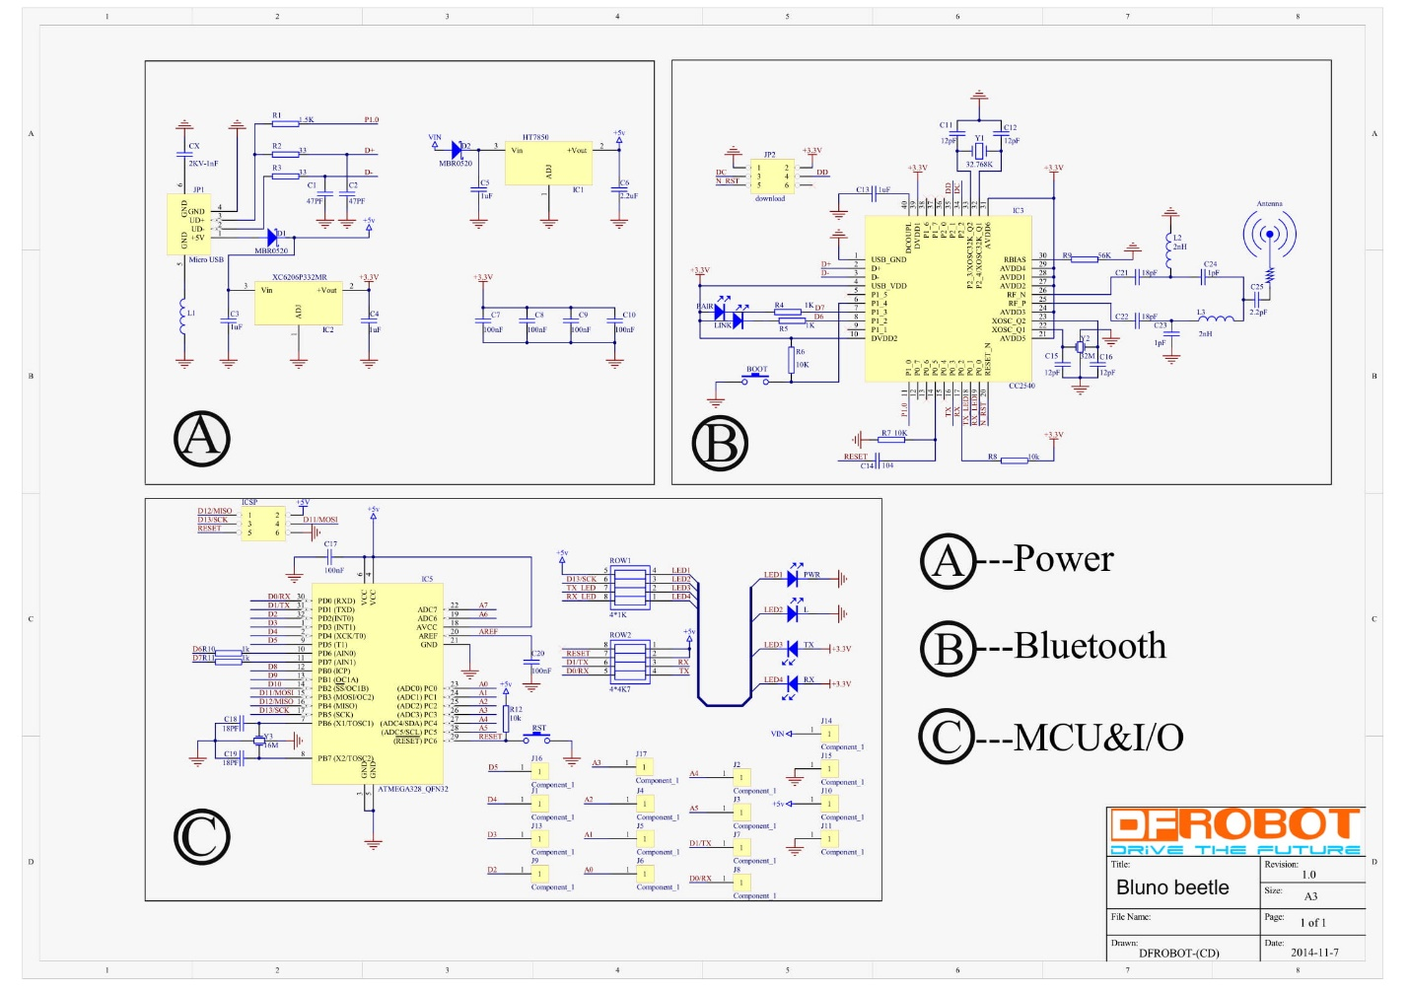

**Battery**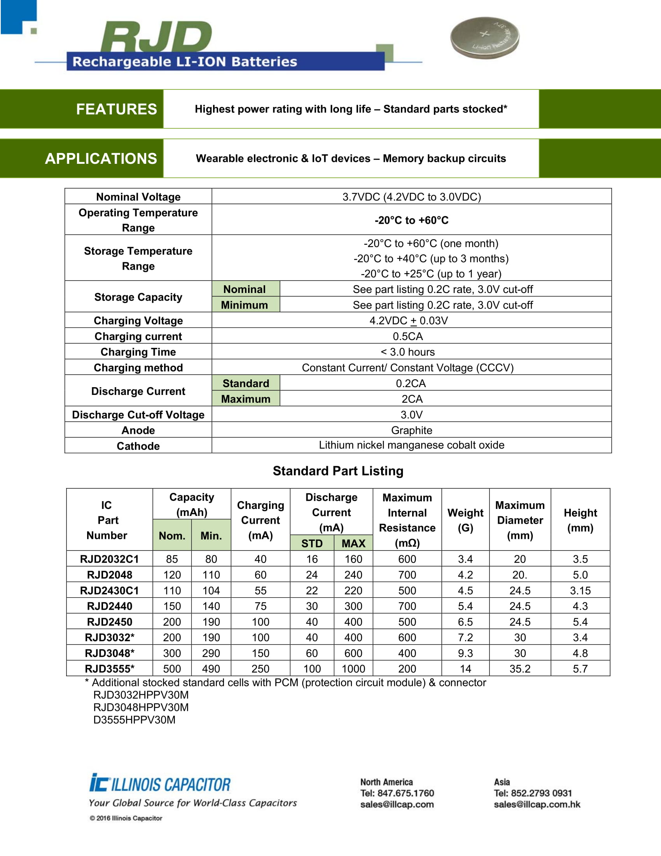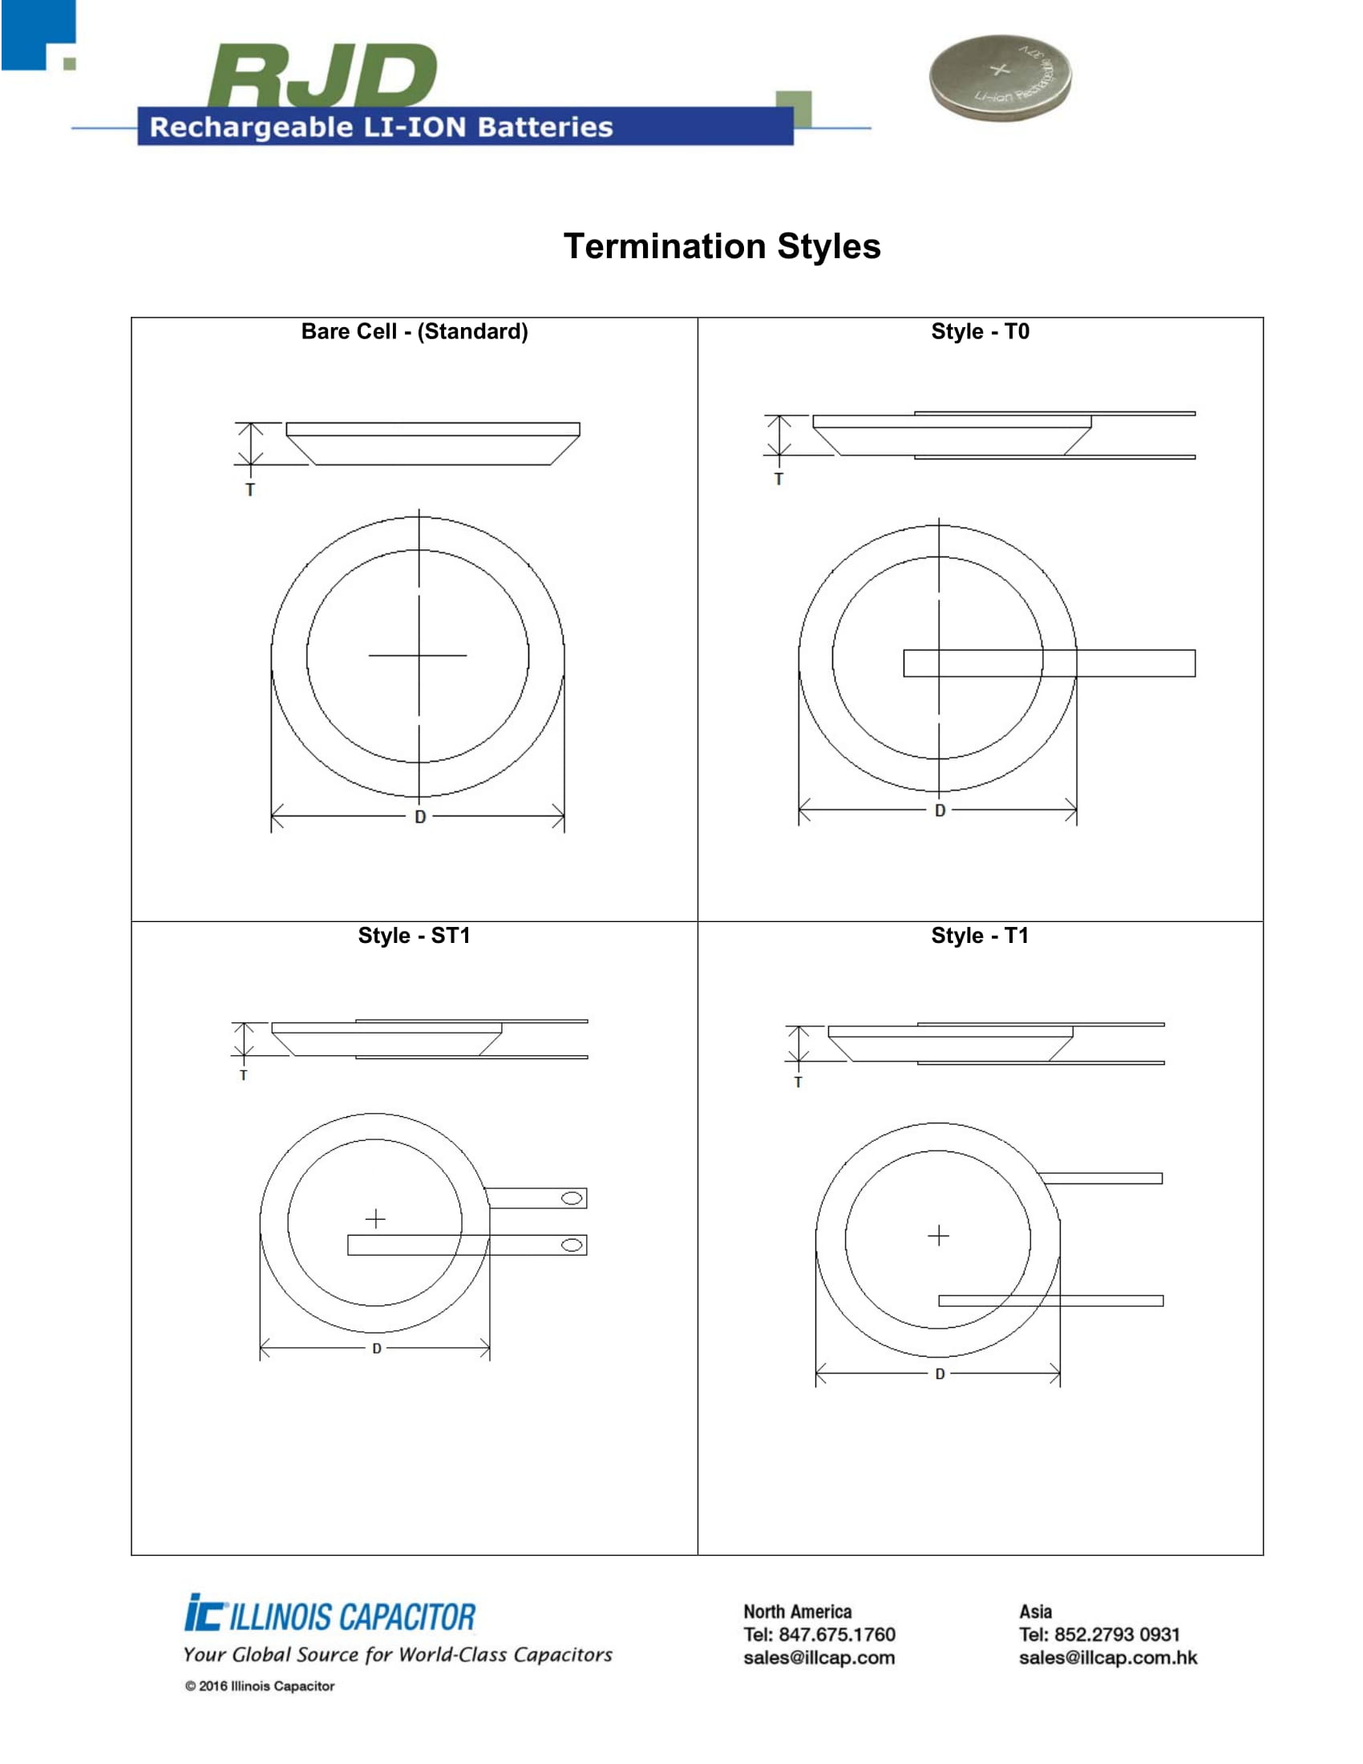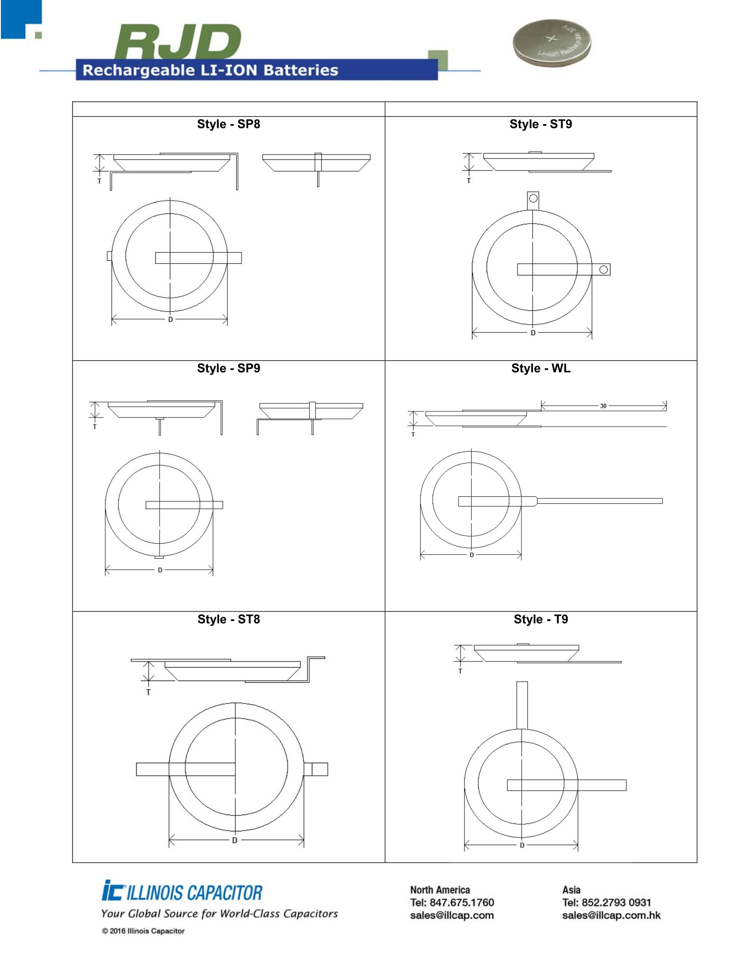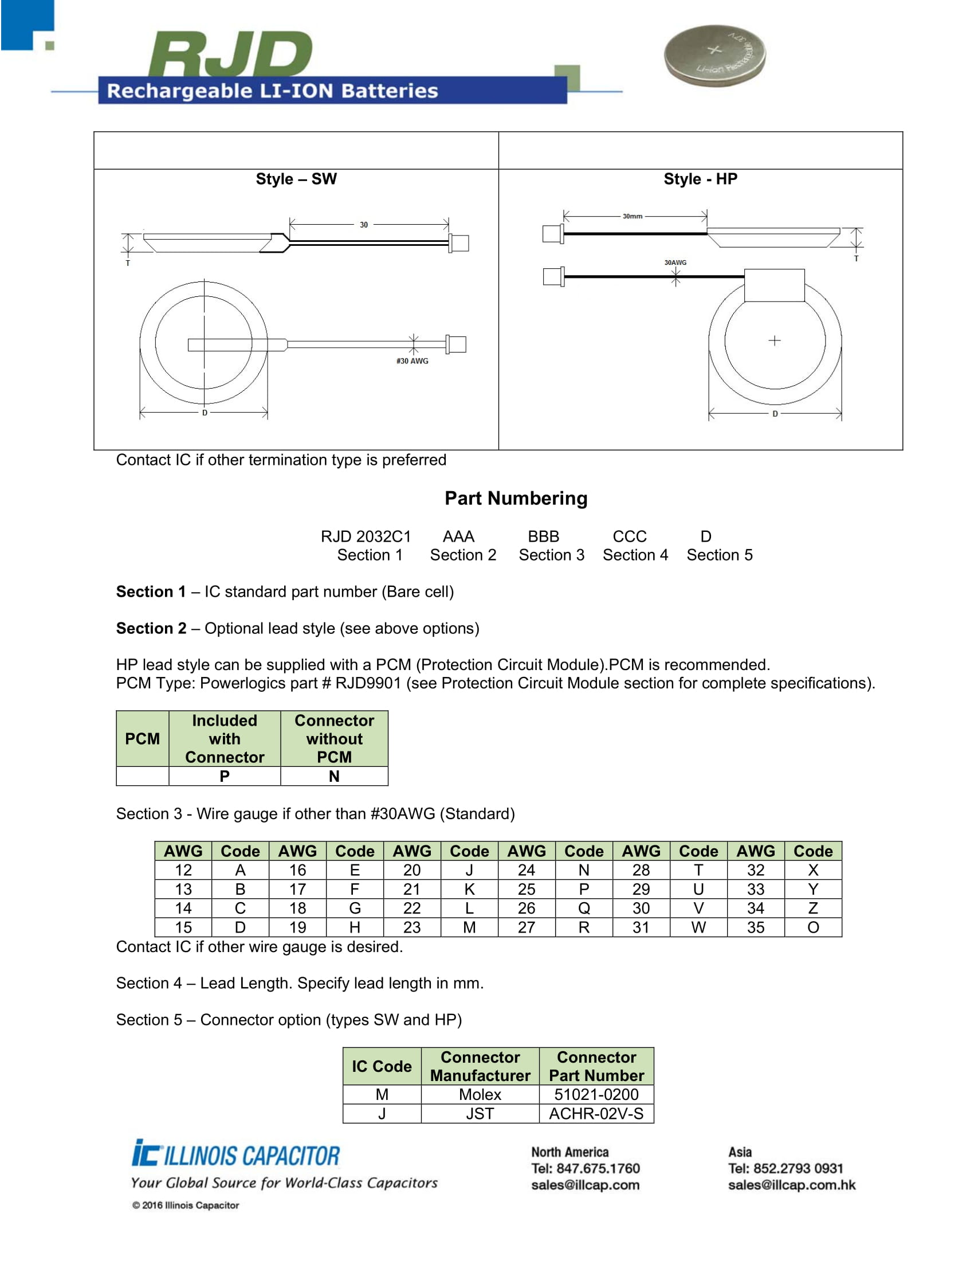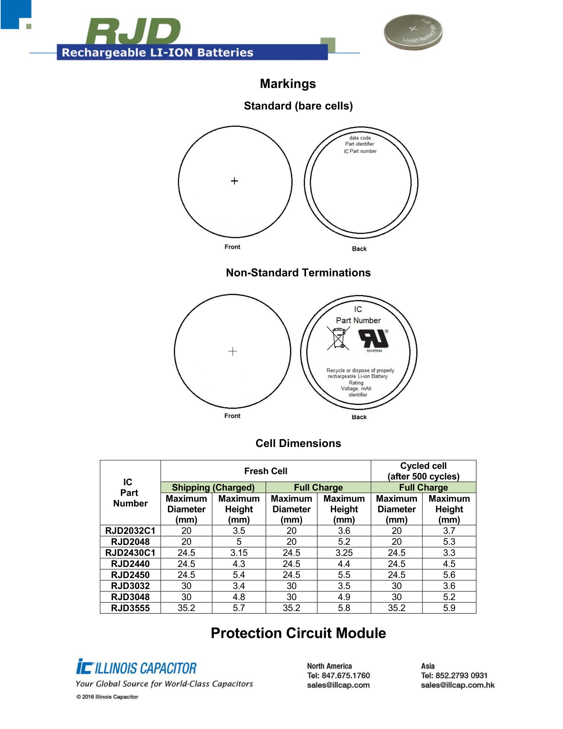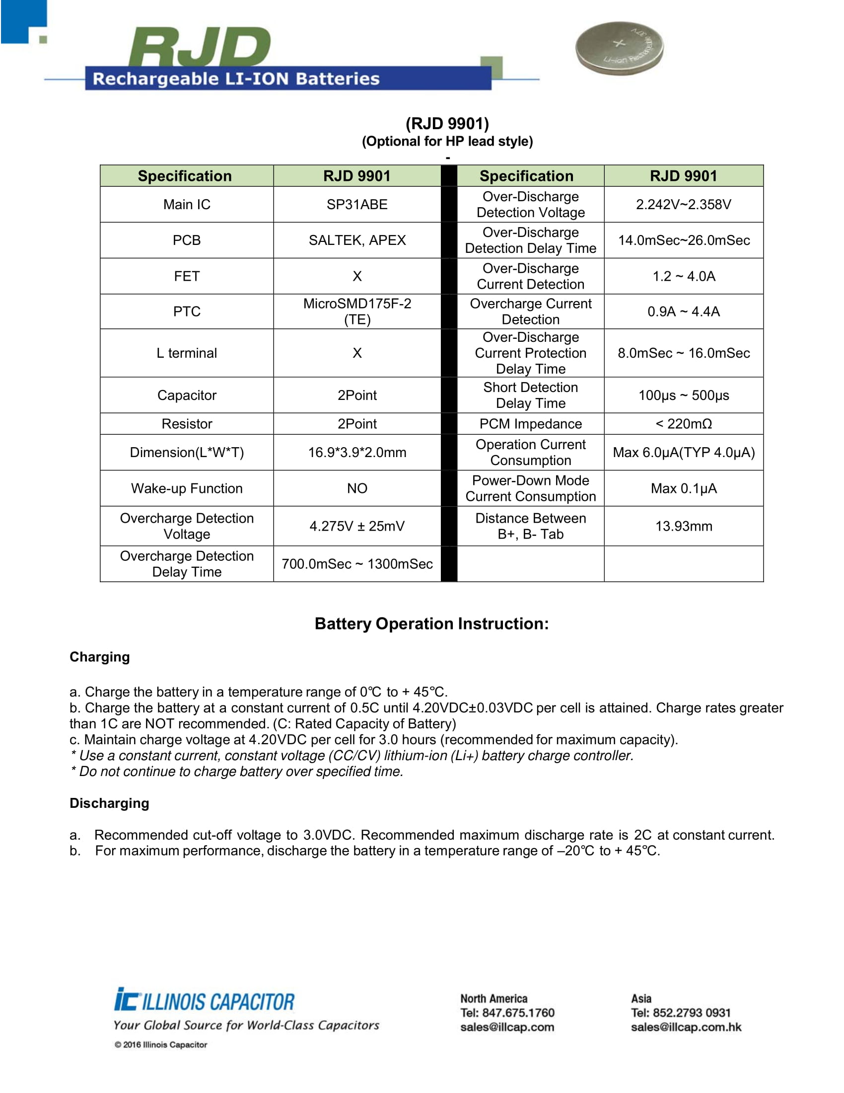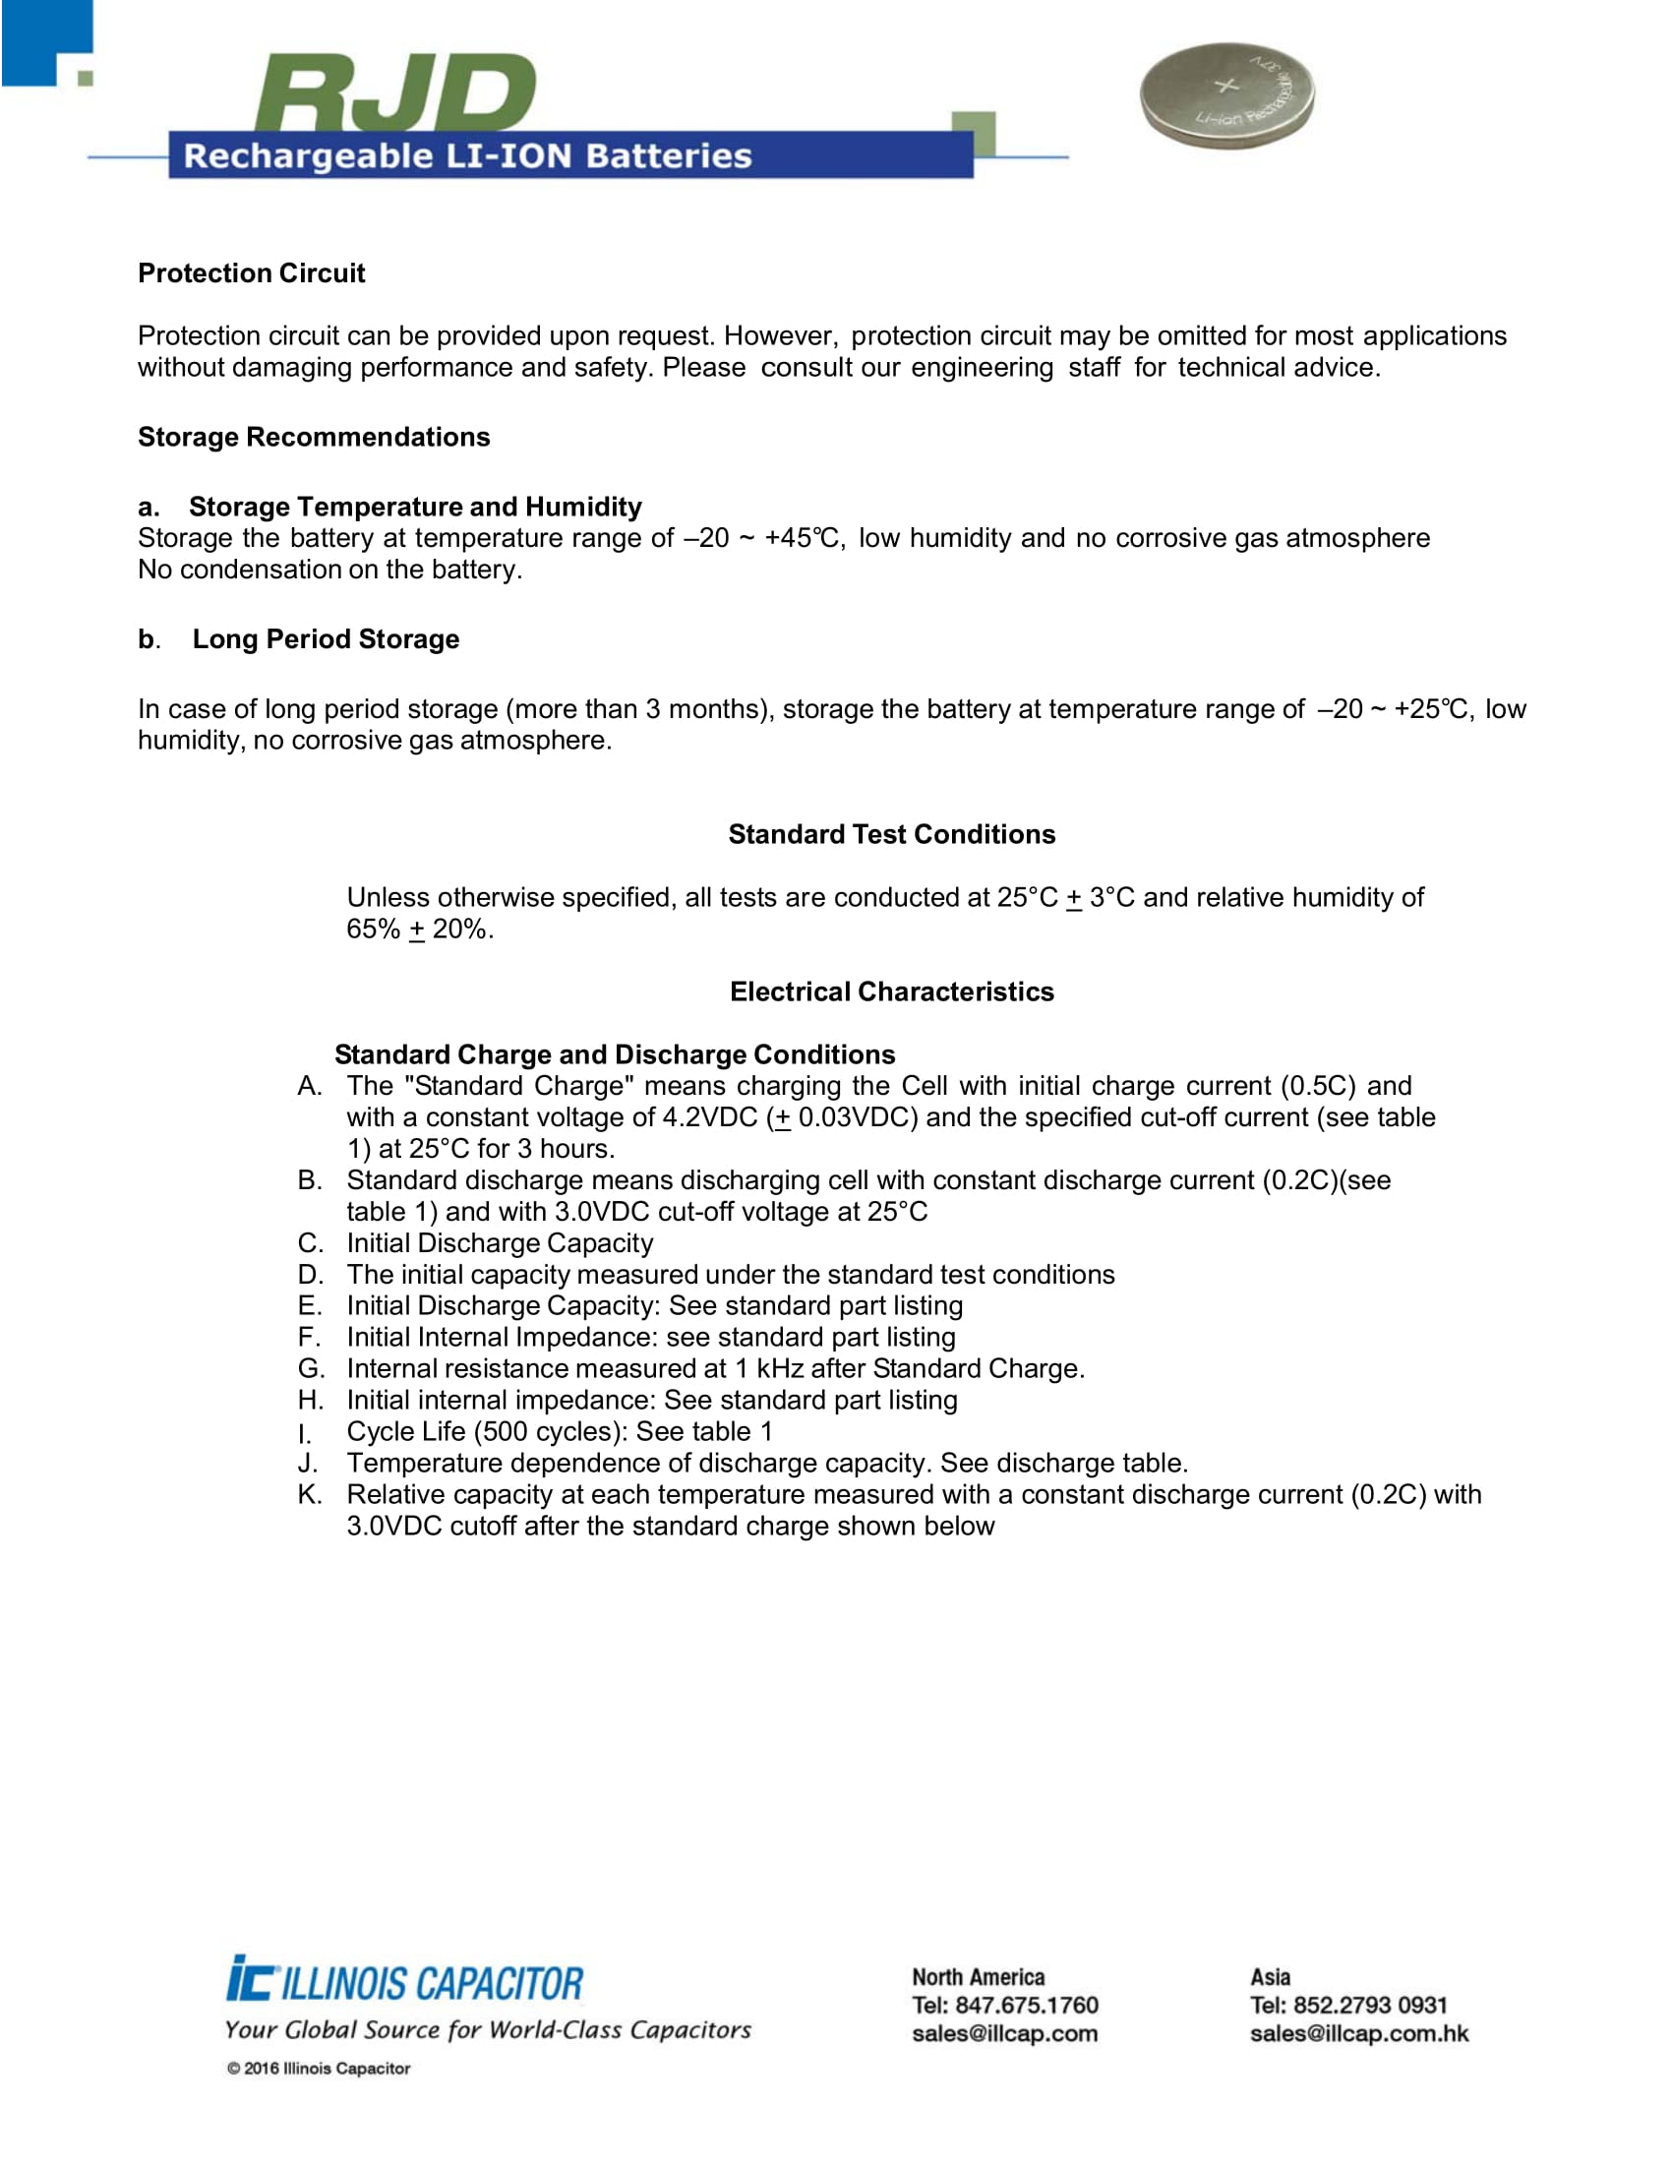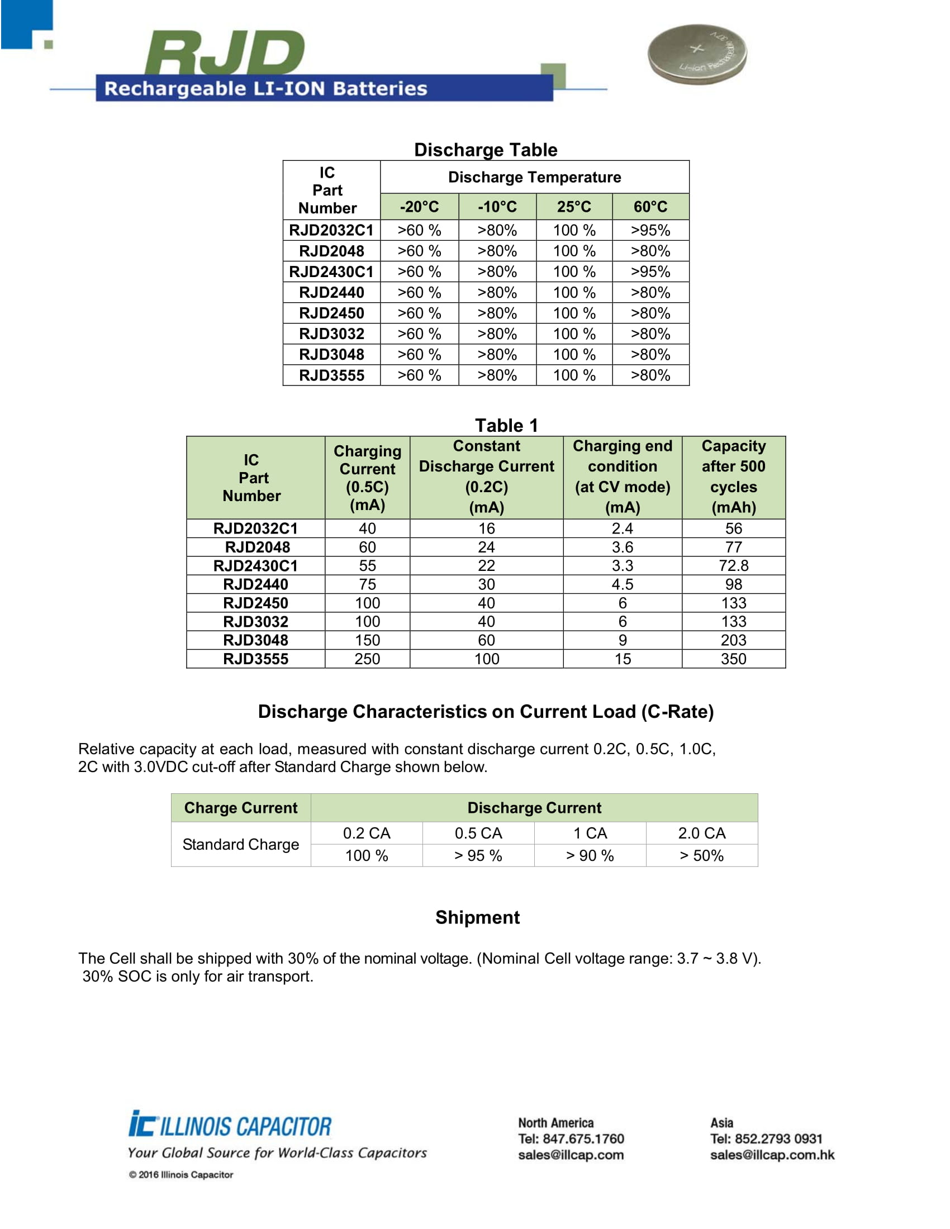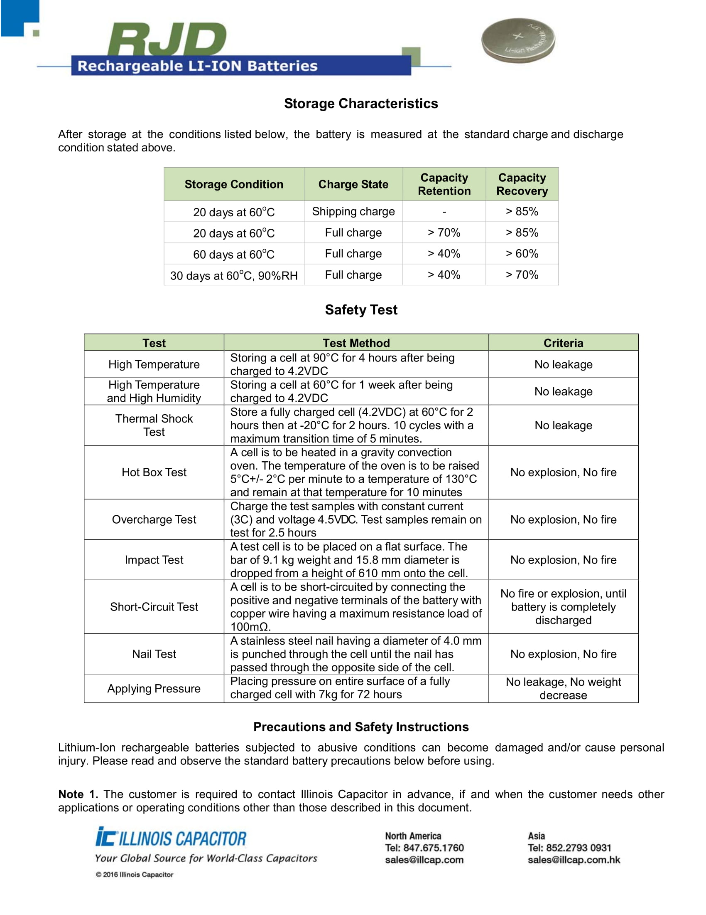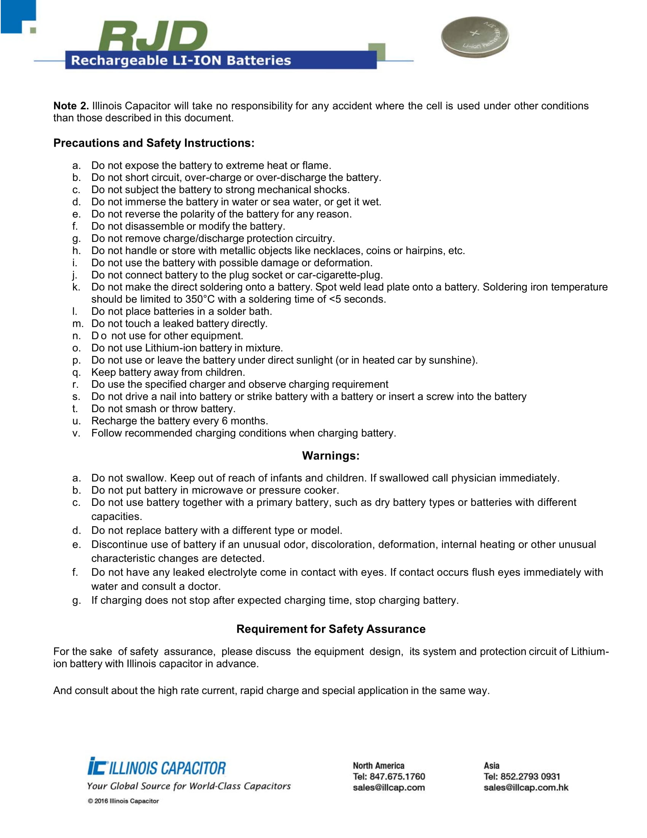

**Microphone (Prototype)**

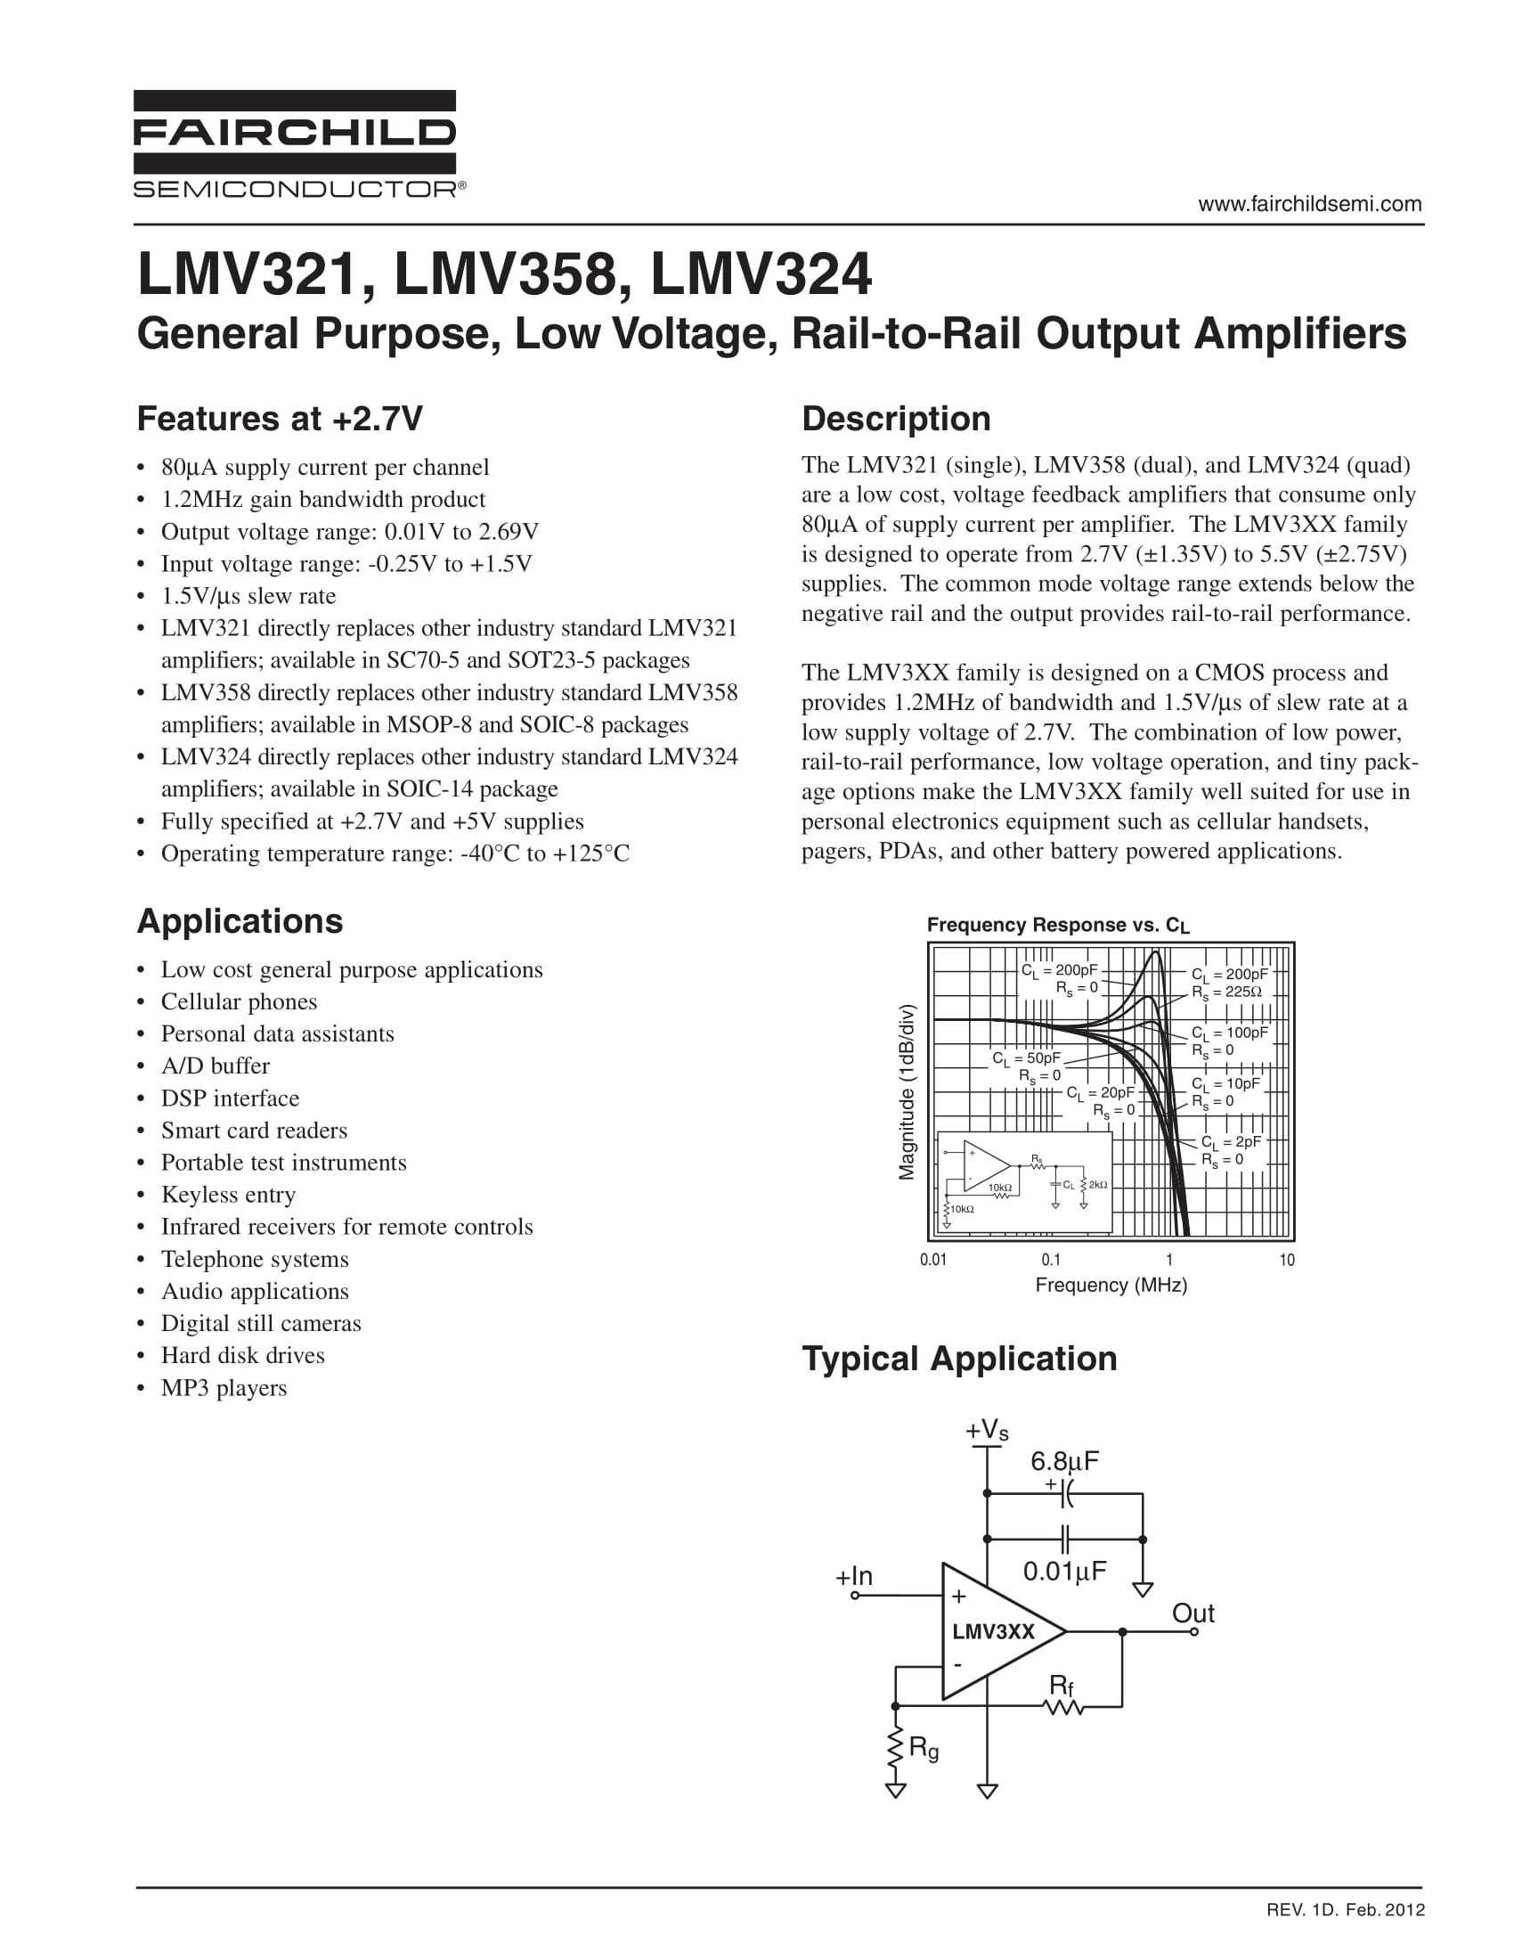

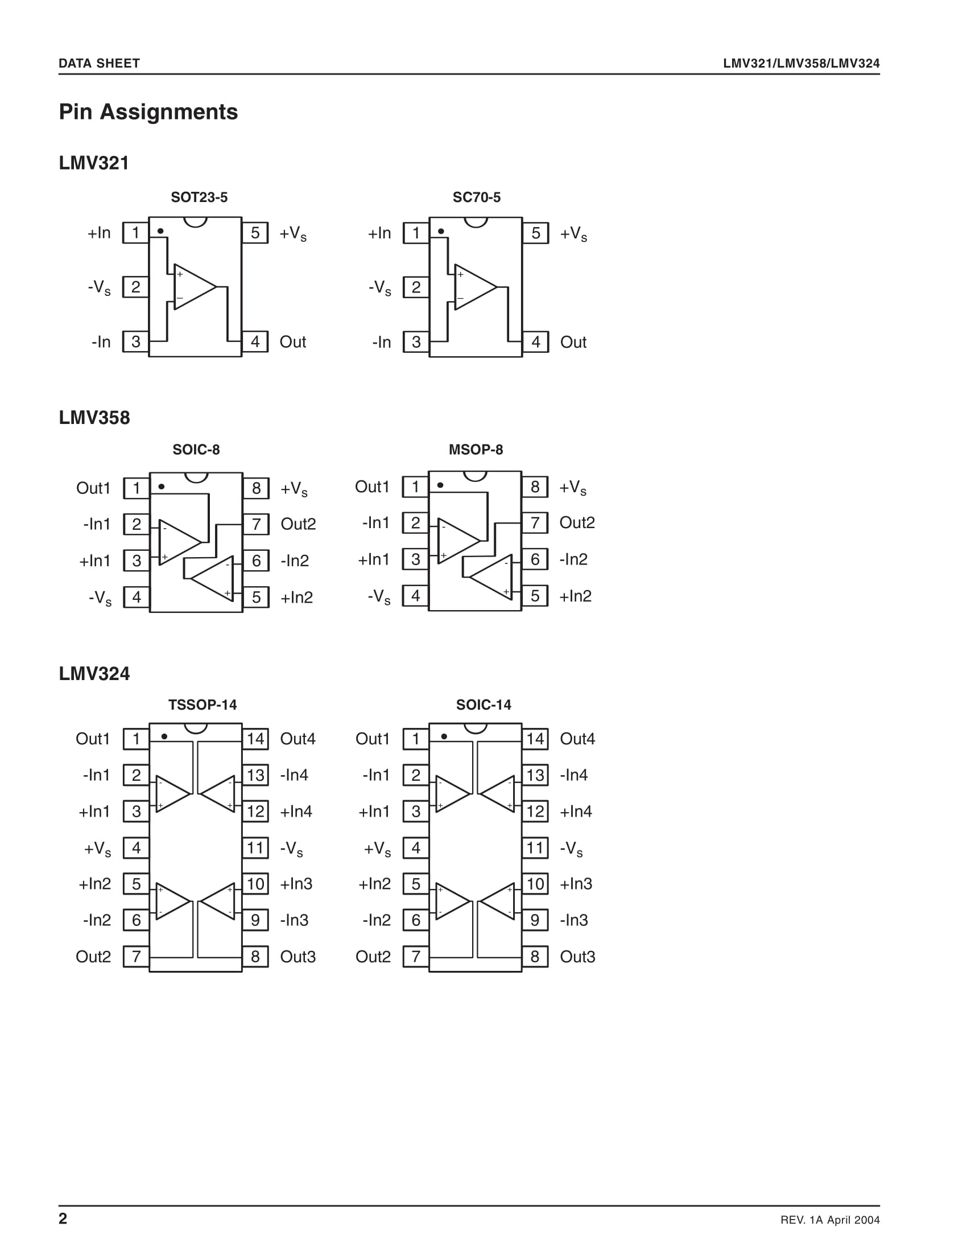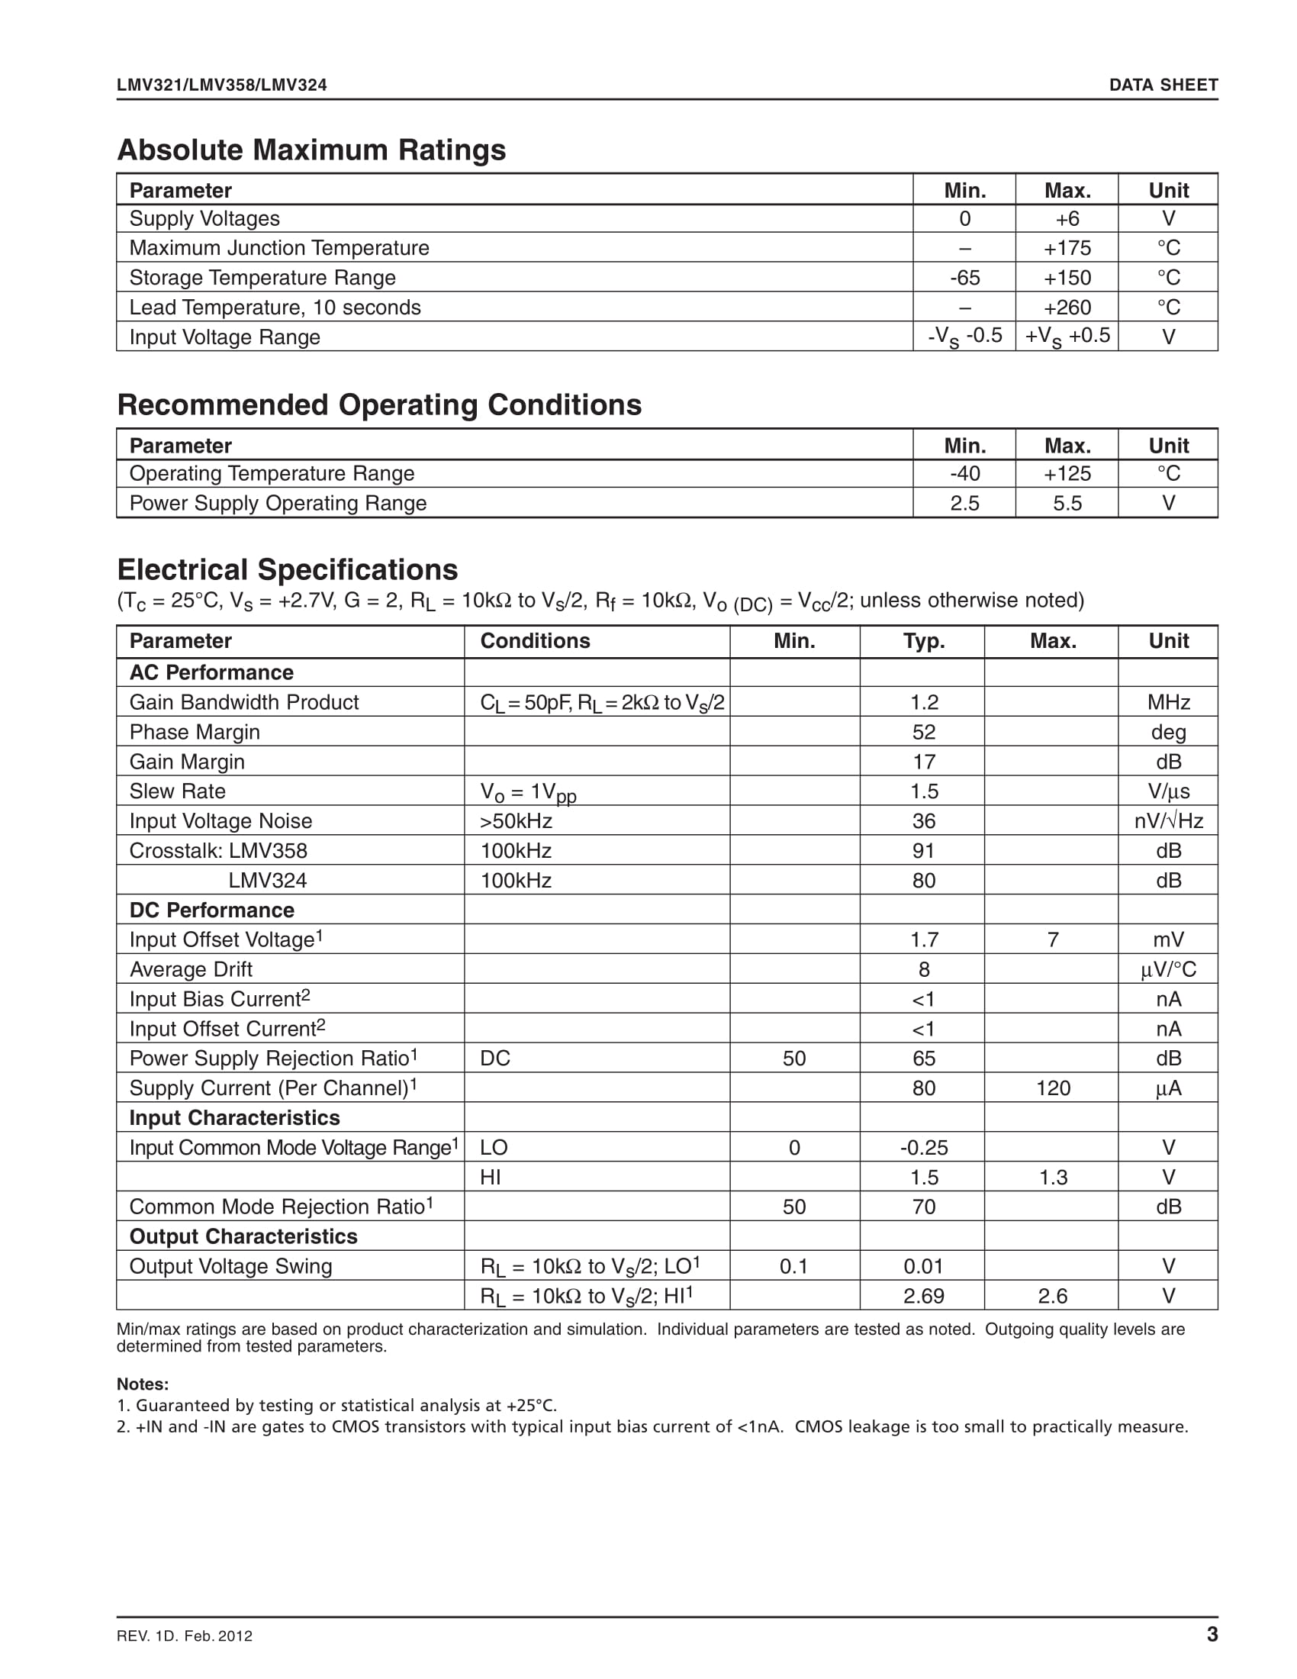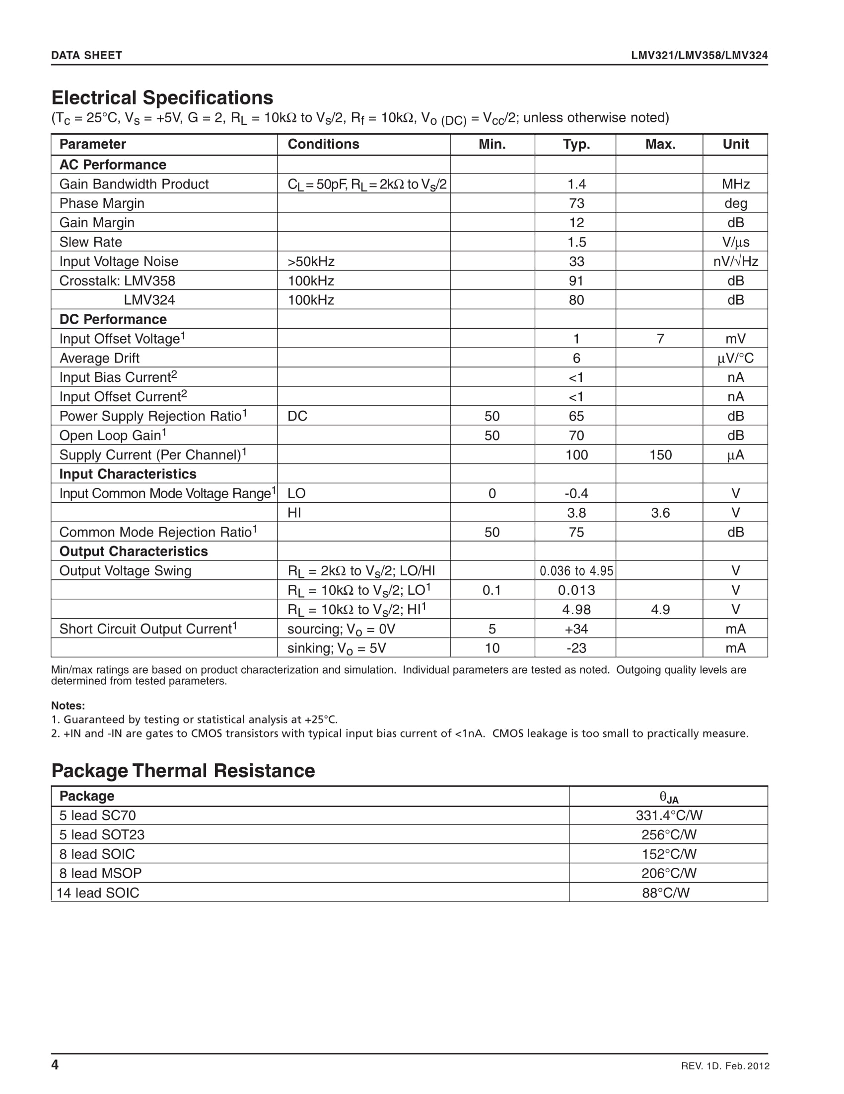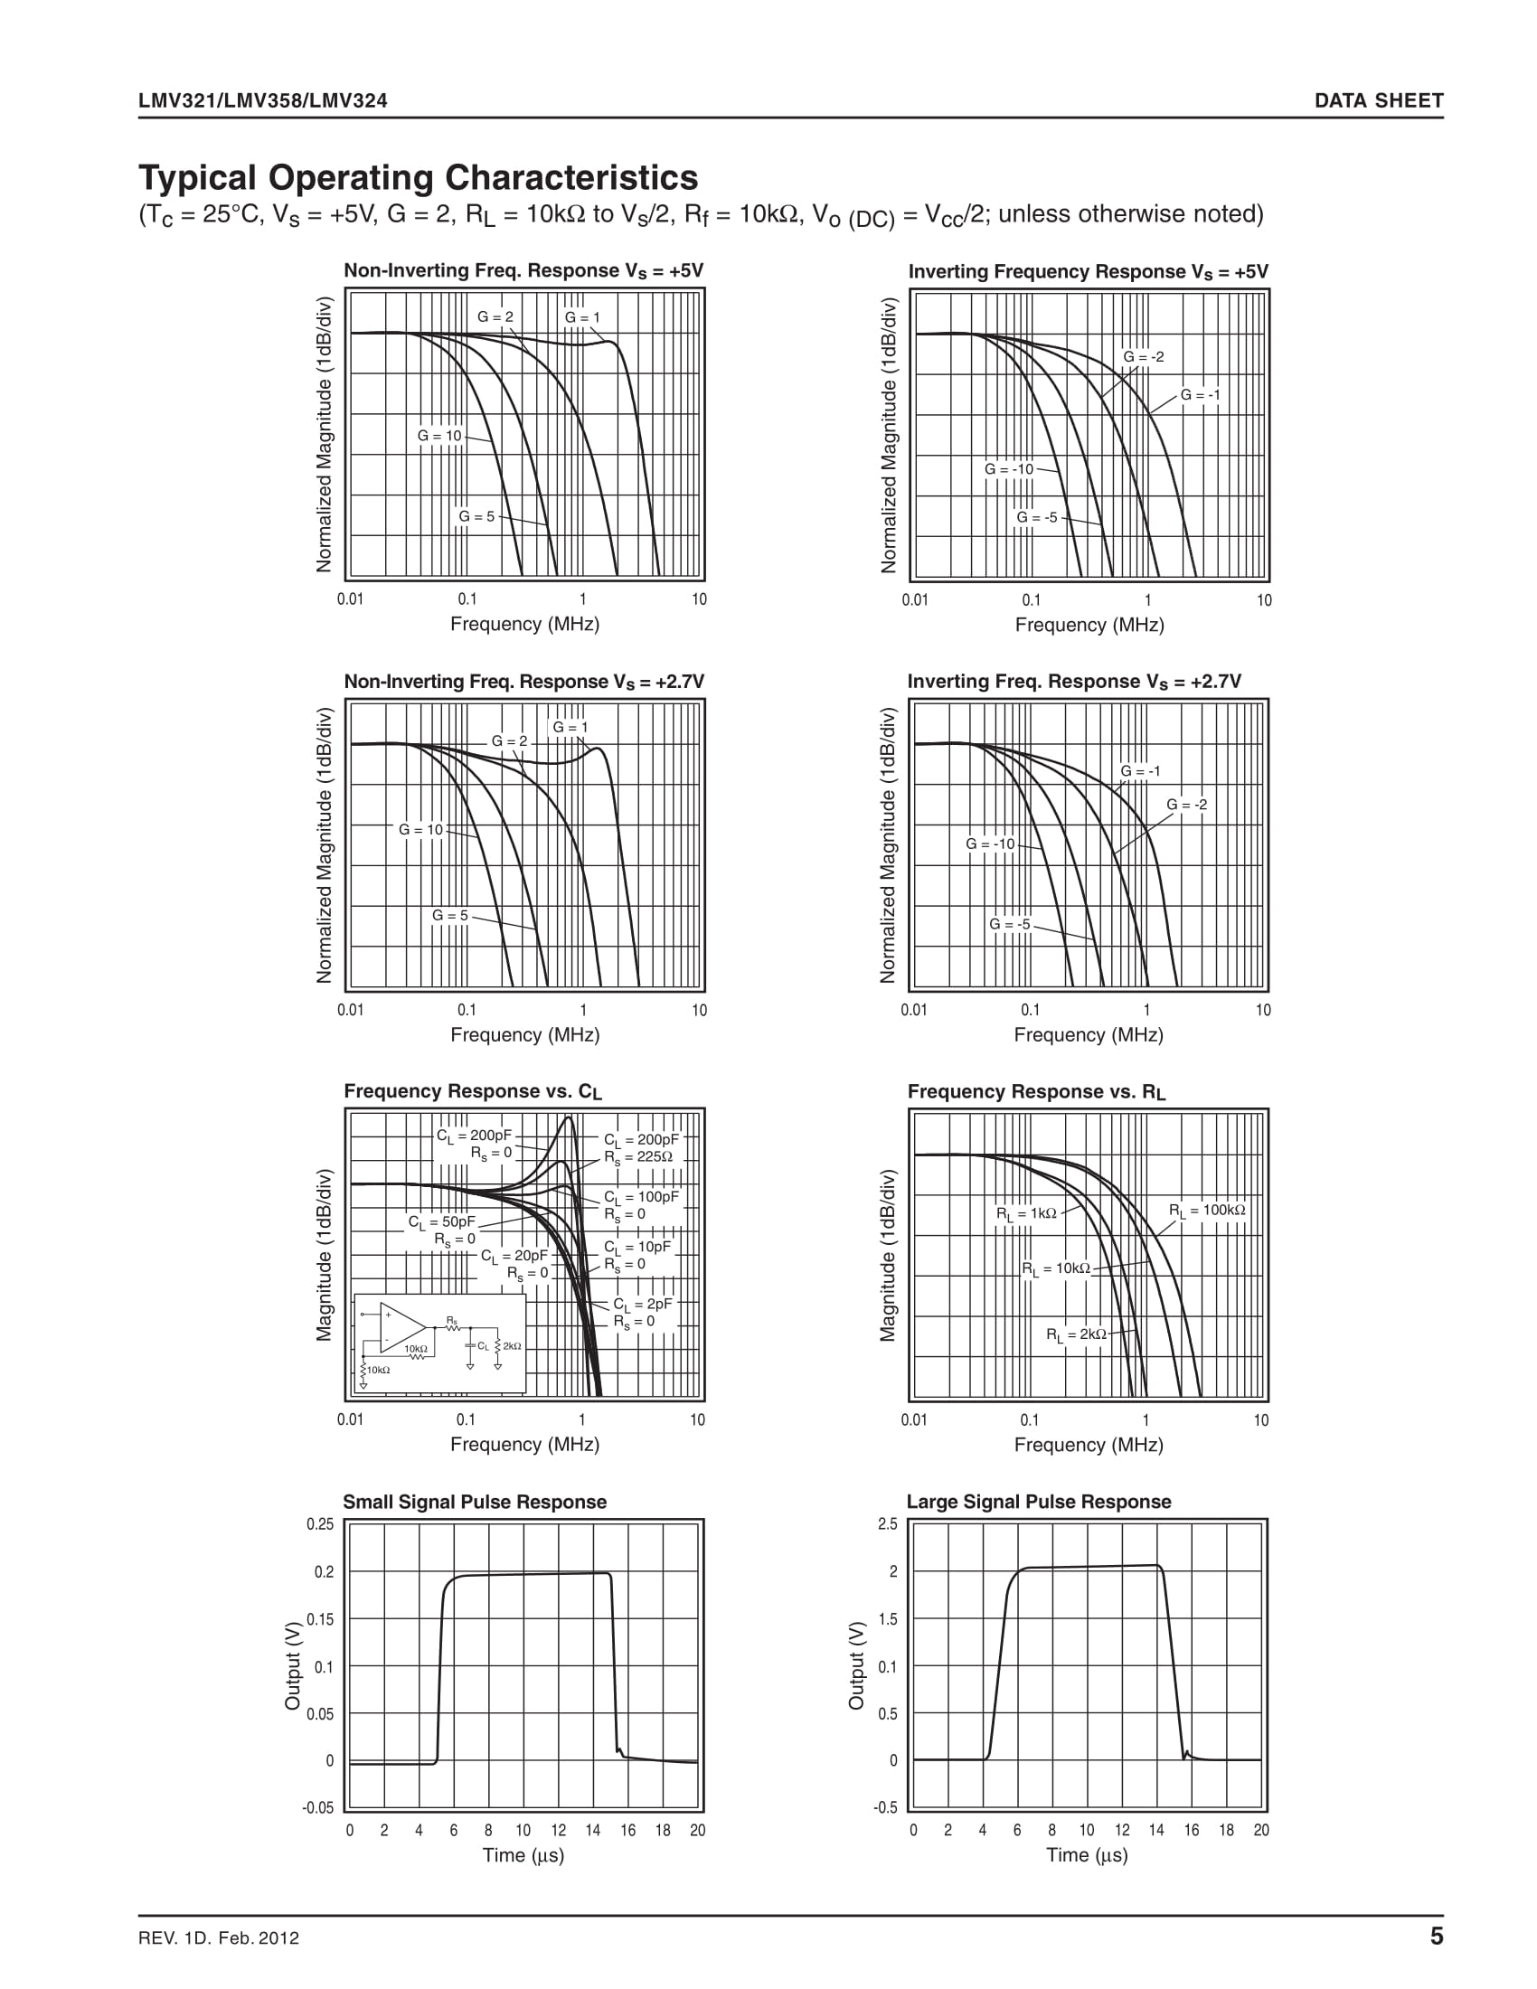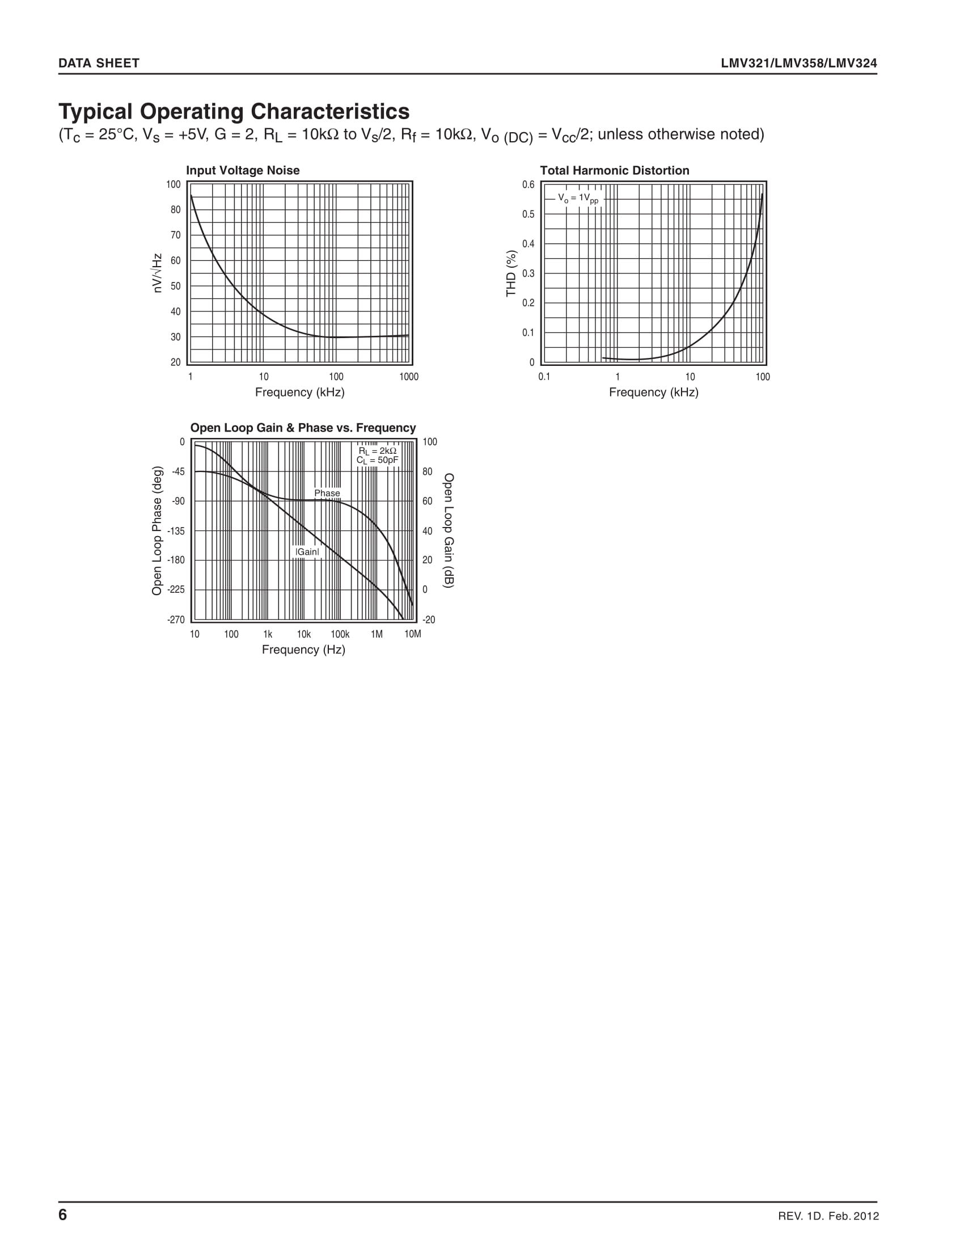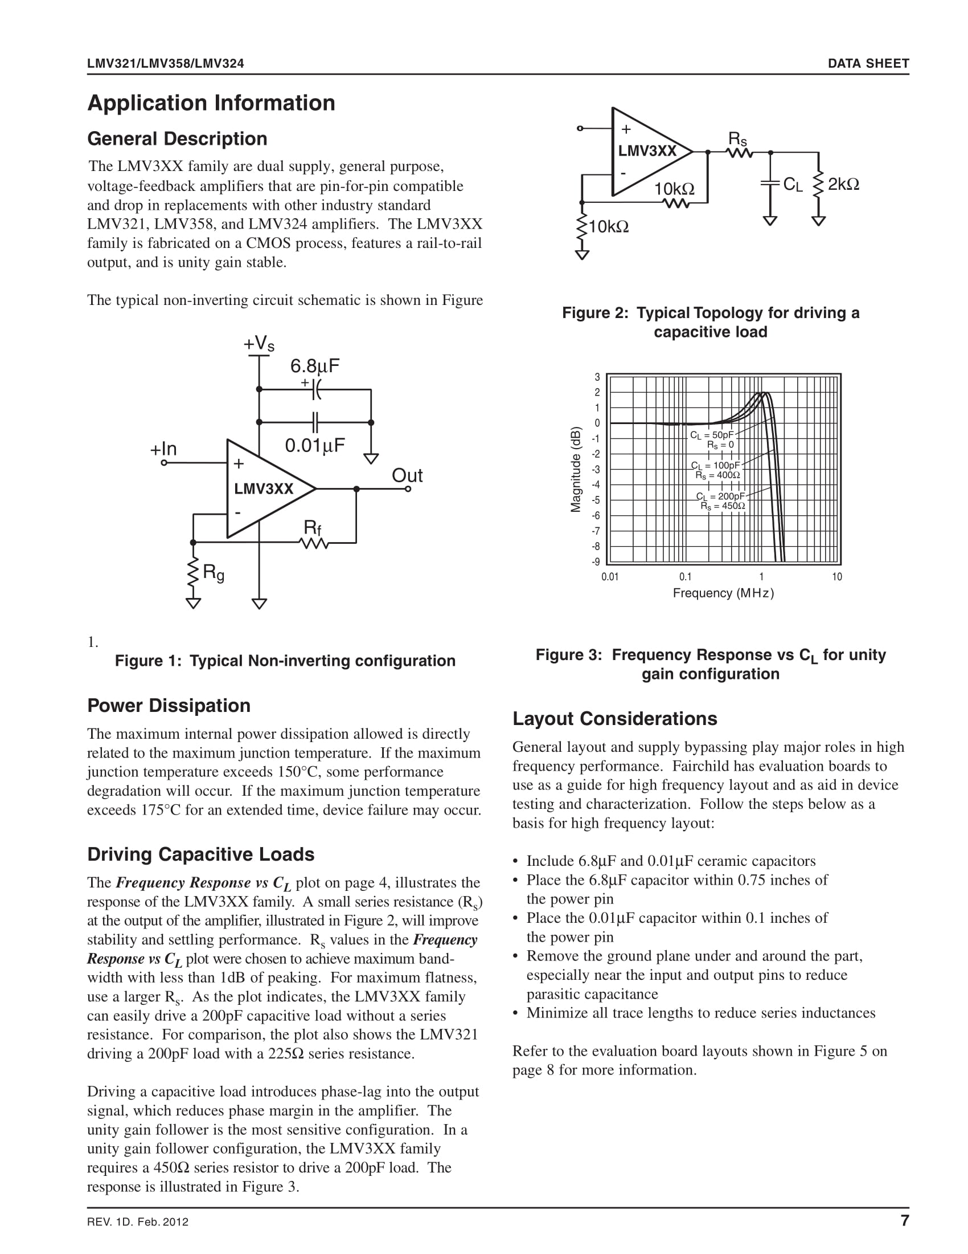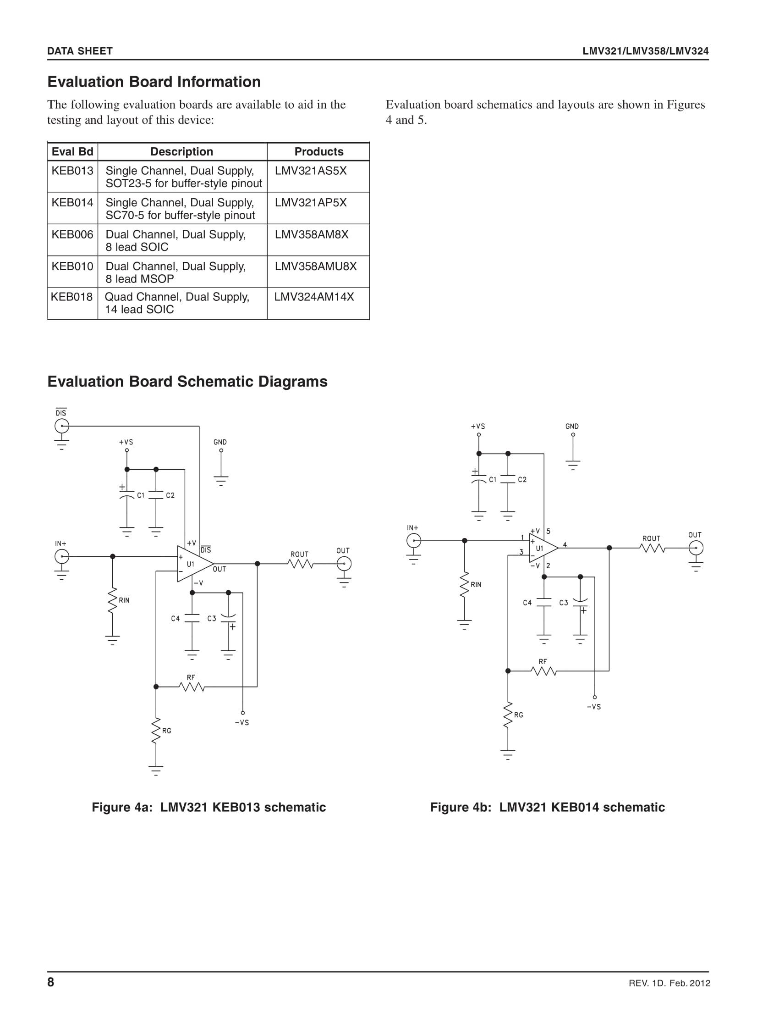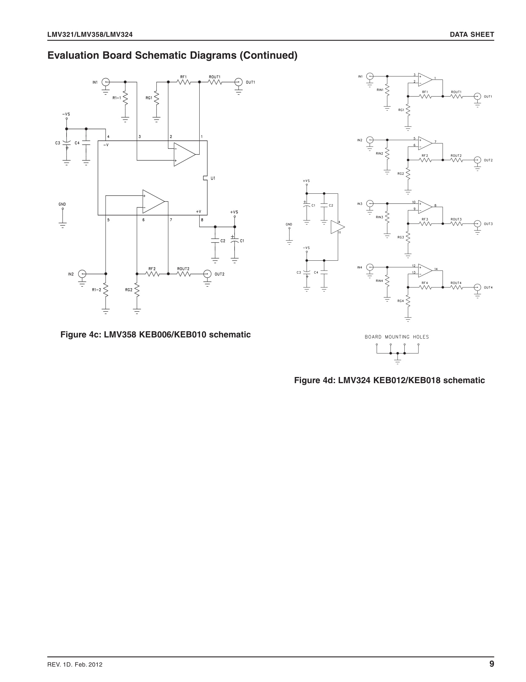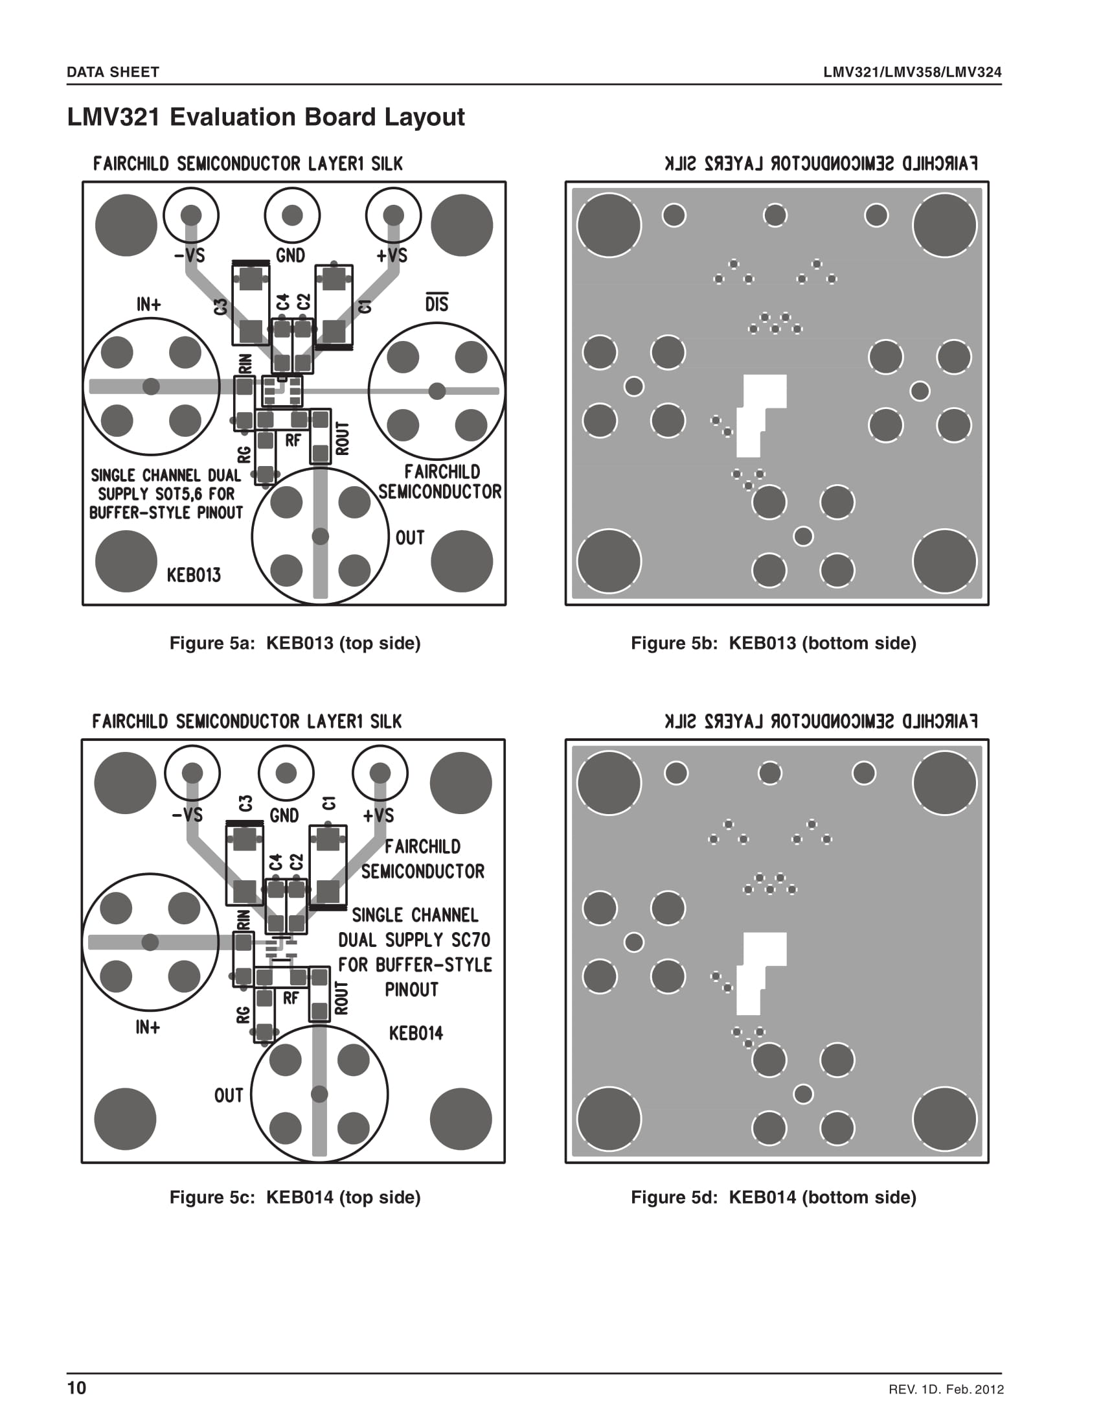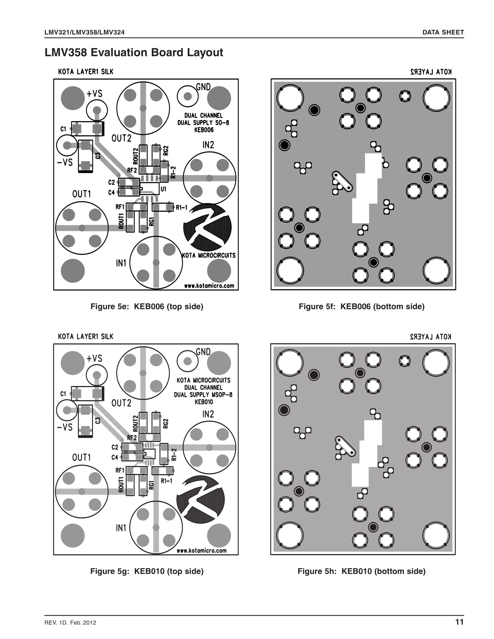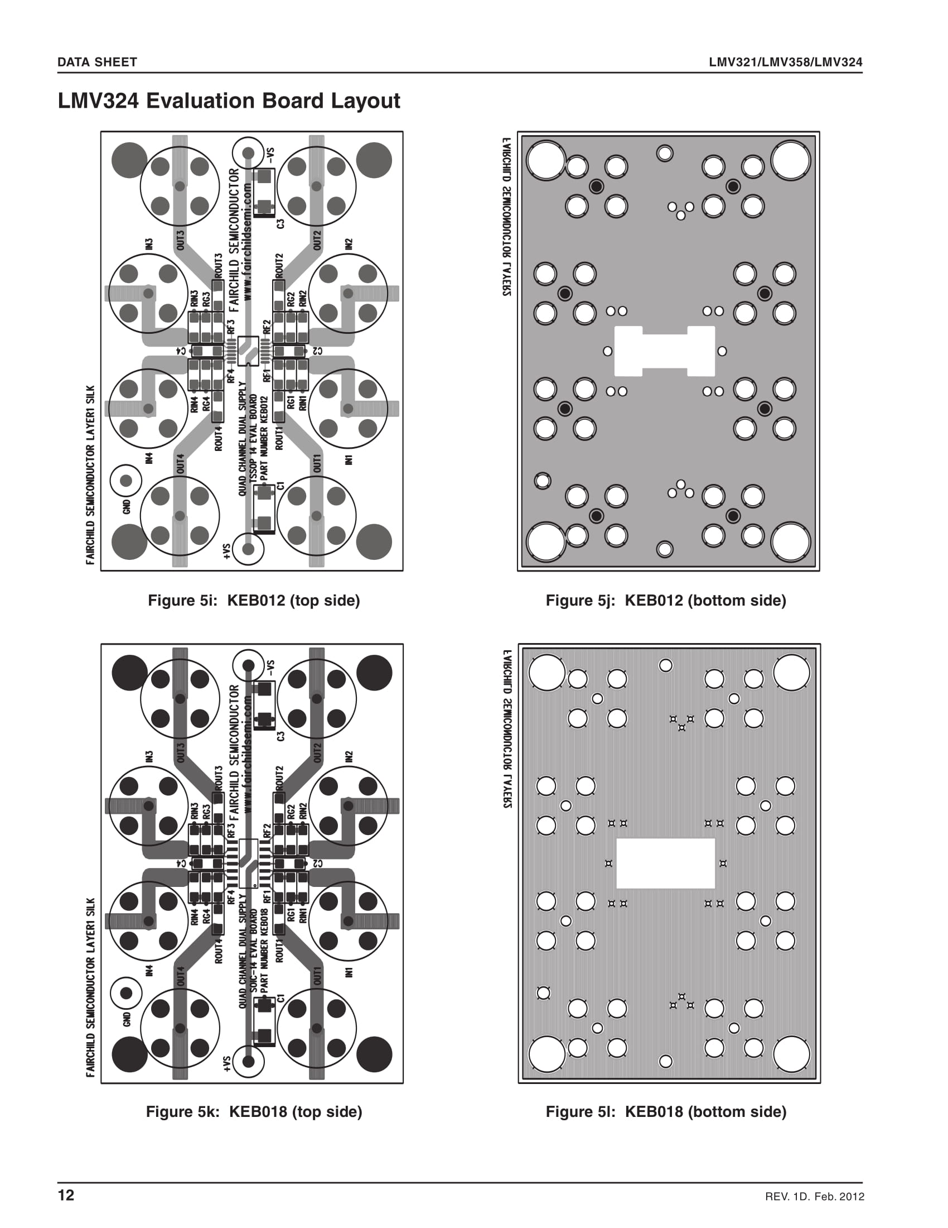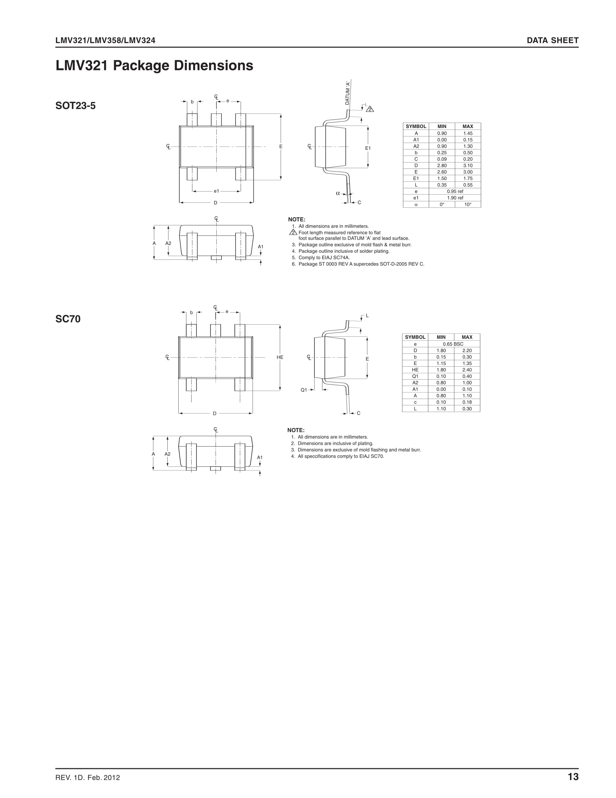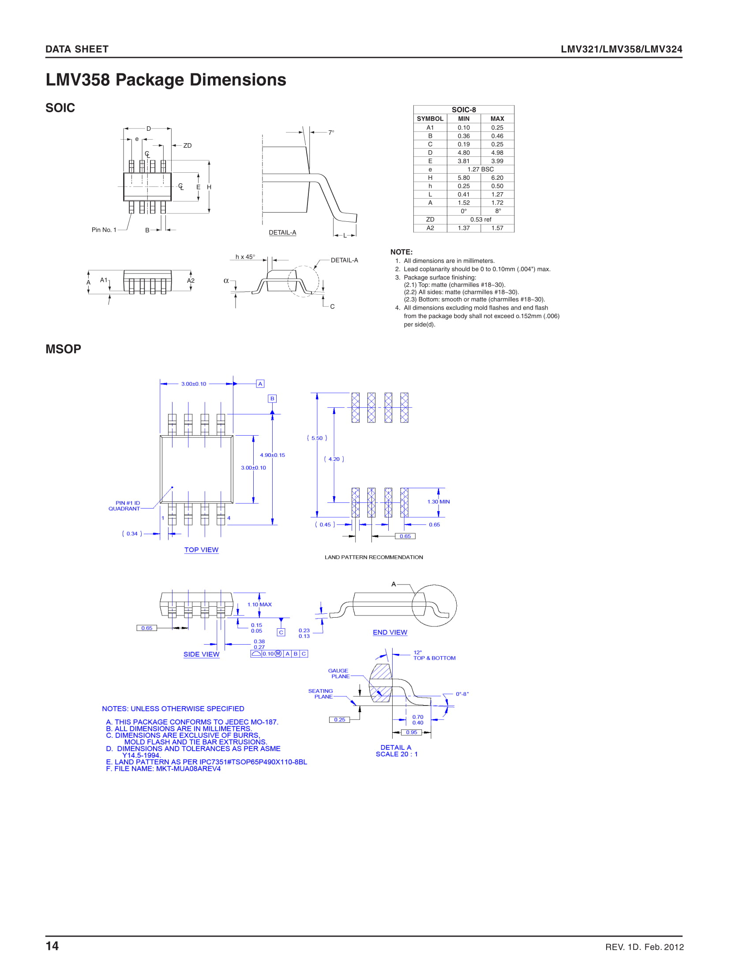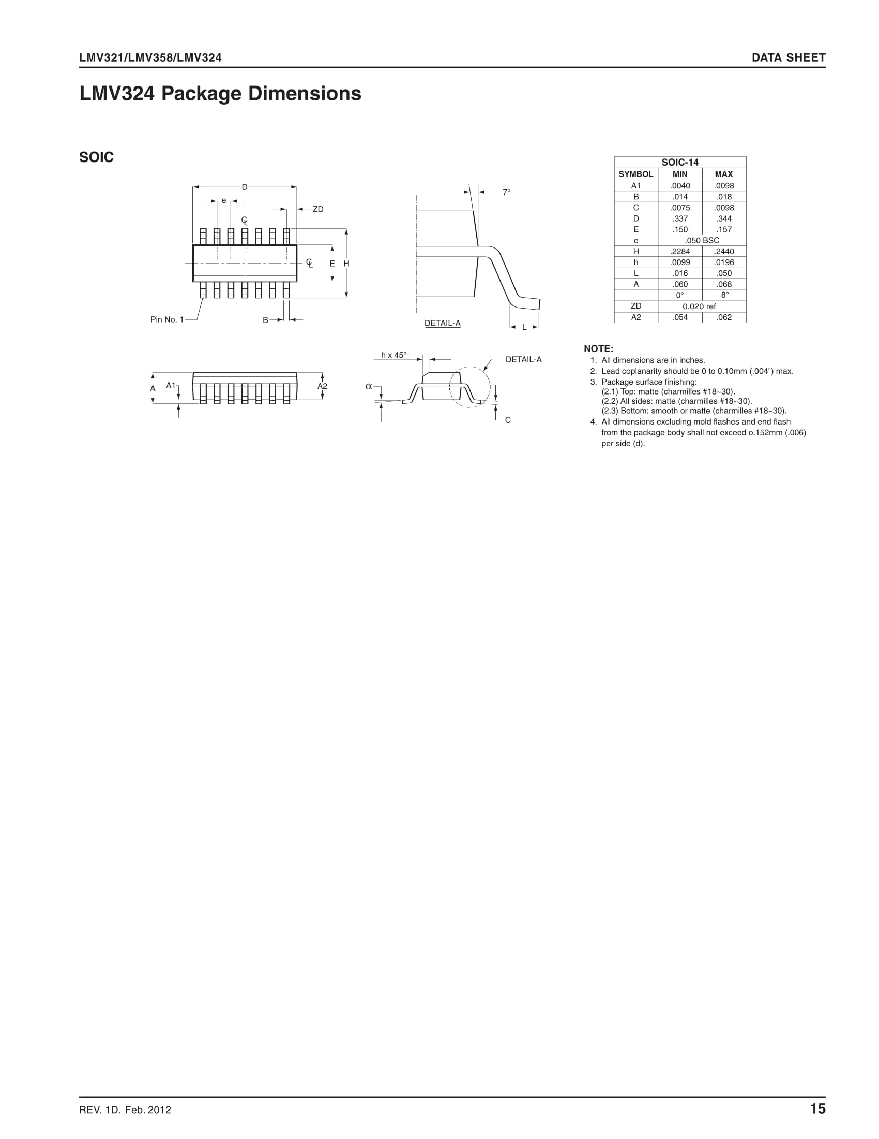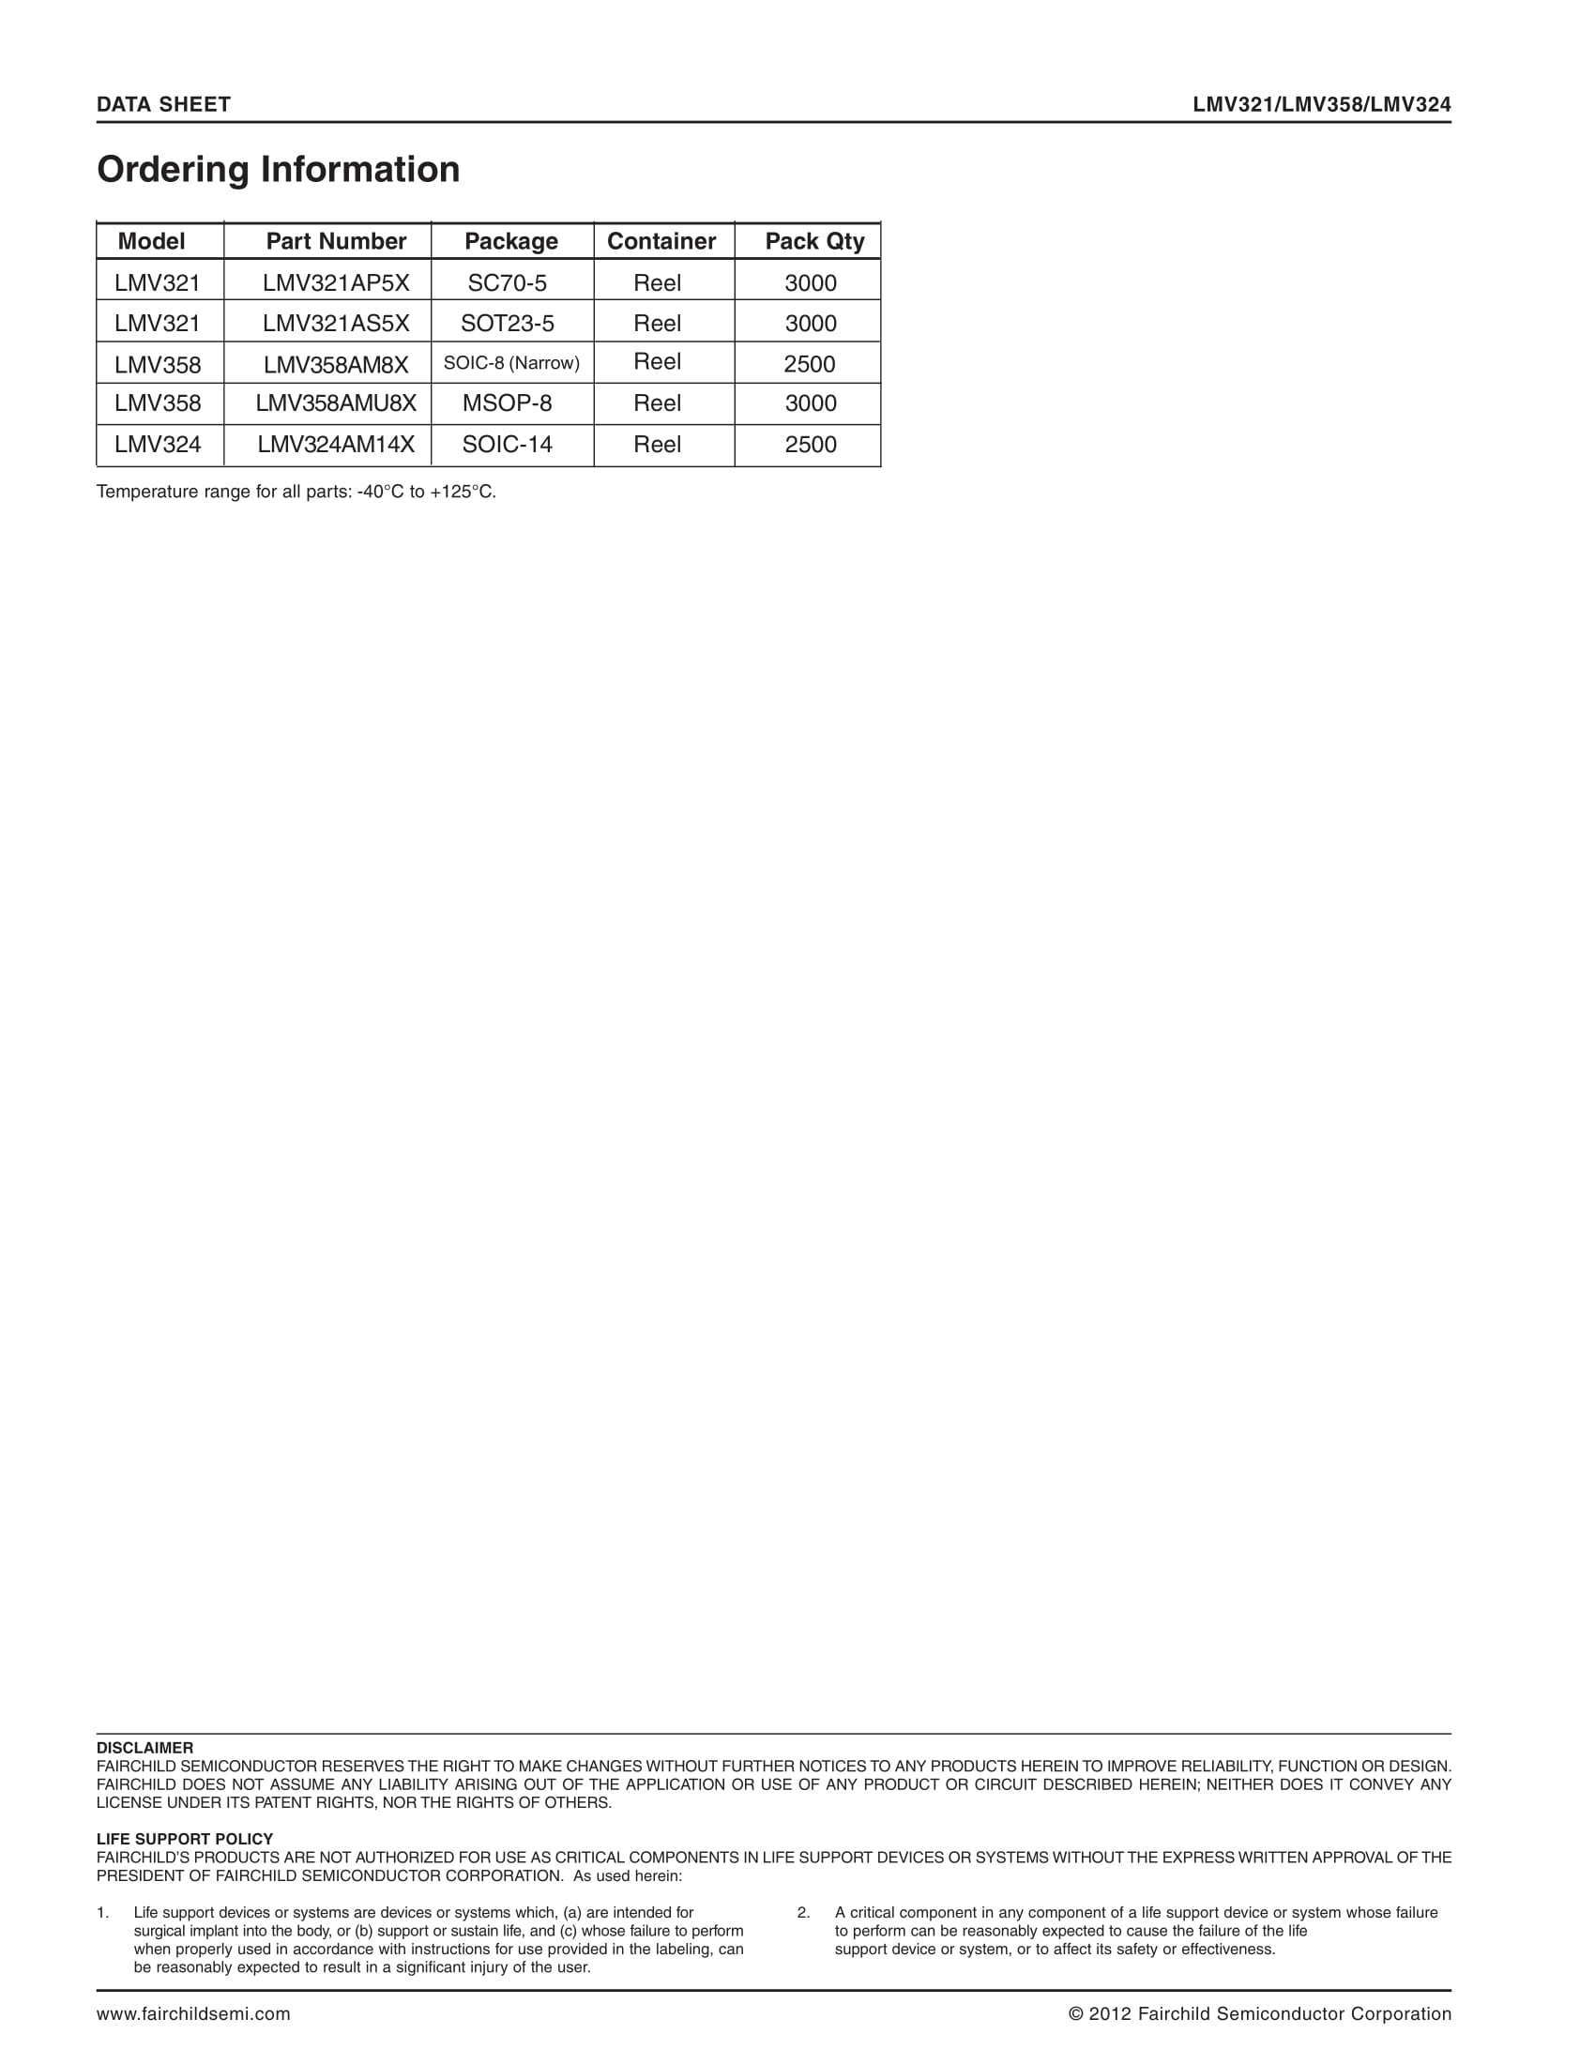

**Microphone Circuit (Prototype)**

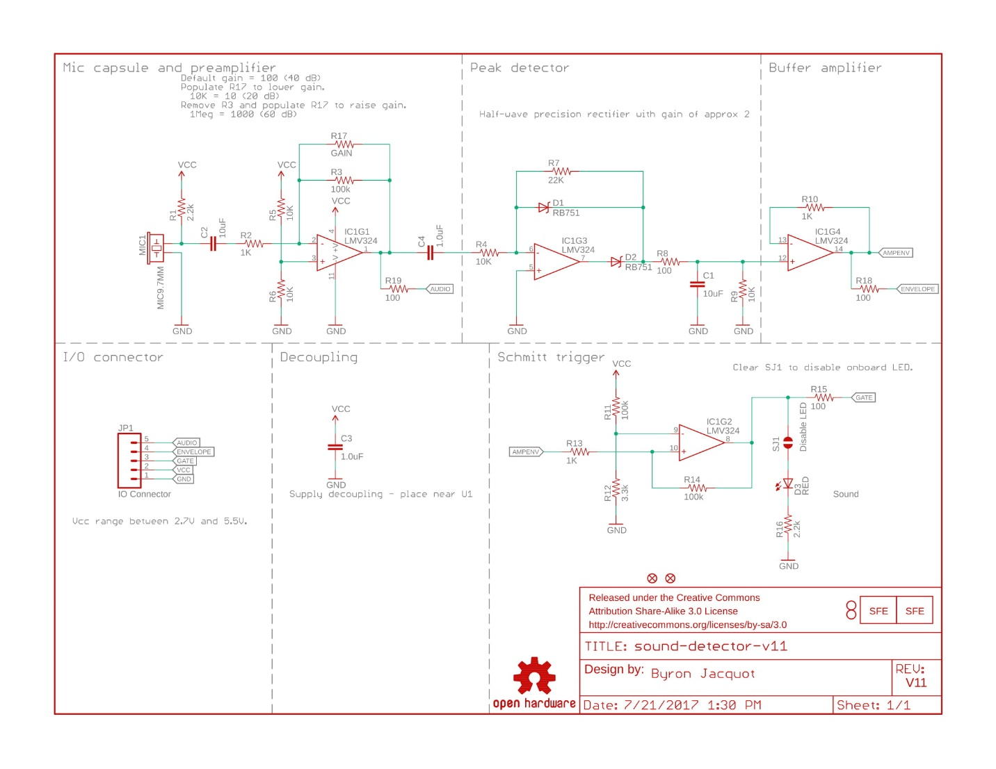

**Microphone (Final/ PCB Design)**

